БЕЛОРУССКИЙ ГОСУДАРСТВЕННЫЙ УНИВЕРСИТЕТ

ИНФОРМАТИКИ И РАДИОЭЛЕКТРОНИКИ

Кафедра систем управления

ОТЧЕТ ПО ЛАБОРАТОРНЫМ РАБОТАМ

По предмету: ИОСУ

Разработка БД

3 вариант «Отдел доставки почтового отделения»

Проверила: Крупская М.А.

Выполнил: ст. гр. 022401

Арбузов Г.Н.

Минск 2023

**Лабораторная работа №1**

**Создание и заполнение базы данных в СУБД Oracle**

**_Задача:** Создать собственную базу данных по полученному варианту (варианты заданий приведены в прил. 2), при этом выполнить следующие требования:

* создать таблицы, указав автоинкрементные столбцы с помощью синтаксиса GENERATED и ограничения NOT NULL, где необходимо;
* придумать и создать ограничения (CHECK, UNIQUE), добавить их в схему с помощью инструкции ALTER TABLE;
* создать индексы, синонимы, обосновать их необходимость;
* внести данные в таблицы, хотя бы в одной из таблиц использовать для заполнения инструкцию INSERT ALL.

**_Код:**

**CREATE TABLE Manufacturers(Manufact_code INTEGER generated by default as identity(nocache),**

**MNF_name VARCHAR2(30) NOT NULL,**

**MNF_office_address VARCHAR2(40) NOT NULL,**

**MNF_ceo_phone CHAR(17) NOT NULL,**

**PRIMARY KEY(Manufact_code),**

**CONSTRAINT MNF_uni_dir_phone UNIQUE(MNF_ceo_phone));**

**ALTER TABLE Manufacturers**

**ADD CONSTRAINT MNF_dir_phone**

**CHECK(REGEXP_LIKE(MNF_ceo_phone, '^\+375\(\d{2}\)\d{3}-\d{2}-\d{2}$'));**

**CREATE TABLE Education_levels(EDCT_LVL_code INTEGER generated by default as identity(nocache),**

**EDCT_LVL_educational_background VARCHAR2(40) NOT NULL,**

**PRIMARY KEY(EDCT_LVL_code),**

**CONSTRAINT EDCT_LVF_educ_back UNIQUE(EDCT_LVL_educational_background));**

**CREATE TABLE Positions(Position_code INTEGER generated by default as identity(nocache),**

**PST_name VARCHAR2(30) NOT NULL,**

**PST_min_level_of_education_code INTEGER NOT NULL,**

**PST_min_salary INTEGER NOT NULL,**

**PST_employee_availability VARCHAR2(3) NOT NULL,**

**PST_driver_license VARCHAR2(3) NOT NULL,**

**PST_english_A2_required VARCHAR2(3) NOT NULL,**

**PRIMARY KEY(Position_code),**

**CONSTRAINT PST_avail_of_empl**

**CHECK(PST_employee_availability IN('Yes','No')),**

**CONSTRAINT PST_drive_license**

**CHECK(PST_driver_license IN('Yes','No')),**

**CONSTRAINT PST_english_req**

**CHECK(PST_english_A2_required IN('Yes','No')),**

**CONSTRAINT PST_min_lvl_educ**

**FOREIGN KEY(PST_min_level_of_education_code)**

**REFERENCES Education_levels(EDCT_LVL_code) ON DELETE CASCADE);**

**CREATE TABLE Vehicles_sellers(Seller_code INTEGER generated by default as identity(nocache),**

**SLR_phone CHAR(17) NOT NULL,**

**PRIMARY KEY(Seller_code),**

**CONSTRAINT SLR_phone_num**

**CHECK(REGEXP_LIKE(SLR_phone, '^\+375\(\d{2}\)\d{3}-\d{2}-\d{2}$')),**

**CONSTRAINT SLR_uni_phone UNIQUE(SLR_phone));**

**CREATE TABLE Orders(Order_num INTEGER generated by default as identity(nocache),**

**ORD_sender_name VARCHAR2(40) NOT NULL,**

**ORD_sender_address VARCHAR2(50) NOT NULL,**

**ORD_sender_phone CHAR(17) NOT NULL,**

**ORD_sending_office INTEGER NOT NULL,**

**ORD_employee_placing_the_order_num INTEGER NOT NULL,**

**ORD_package_weight DECIMAL(20,3) NOT NULL,**

**ORD_package_scope DECIMAL(20,3) NOT NULL,**

**ORD_package_receipt_date DATE NOT NULL,**

**ORD_declared_value_amount DECIMAL(30,3),**

**ORD_cash_on_dlvry_amount DECIMAL(30,3),**

**ORD_fragile VARCHAR2(3) NOT NULL,**

**ORD_completeness_check VARCHAR2(3) NOT NULL,**

**ORD_arrival_date DATE,**

**ORD_recipient_name VARCHAR2(40) NOT NULL,**

**ORD_recipient_address VARCHAR2(50) NOT NULL,**

**ORD_recipient_phone CHAR(17) NOT NULL,**

**ORD_receiving_office INTEGER NOT NULL,**

**ORD_shipping_cost DECIMAL(30,3) NOT NULL,**

**ORD_deliv_type_code INTEGER NOT NULL,**

**ORD_cash_payment VARCHAR2(3) NOT NULL,**

**PRIMARY KEY(Order_num),**

**CONSTRAINT ORD_sending_officce**

**FOREIGN KEY(ORD_sending_office)**

**REFERENCES Branch(Branch_num) ON DELETE CASCADE,**

**CONSTRAINT ORD_receiving_office_num**

**FOREIGN KEY(ORD_receiving_office)**

**REFERENCES Branch(Branch_num) ON DELETE CASCADE,**

**CONSTRAINT ORD_delivery_type_code**

**FOREIGN KEY(ORD_deliv_type_code)**

**REFERENCES Delivery_type(DLV_code) ON DELETE CASCADE,**

**CONSTRAINT ORD_completeness_checking**

**CHECK(ORD_completeness_check IN('Yes','No')),**

**CONSTRAINT ORD_cash_or_visa_payment**

**CHECK(ORD_cash_payment IN('Yes','No')),**

**CONSTRAINT ORD_fragile_package**

**CHECK(ORD_fragile IN('Yes','No')),**

**CONSTRAINT ORD_employ_placing_order_num**

**FOREIGN KEY(ORD_employee_placing_the_order_num)**

**REFERENCES Staff(Staff_num) ON DELETE CASCADE,**

**CONSTRAINT ORD_recipient_phone_num**

**CHECK(REGEXP_LIKE(ORD_recipient_phone, '^\+375\(\d{2}\)\d{3}-\d{2}-\d{2}$')),**

**CONSTRAINT ORD_sender_phone_num**

**CHECK(REGEXP_LIKE(ORD_sender_phone, '^\+375\(\d{2}\)\d{3}-\d{2}-\d{2}$')));**

**CREATE TABLE Delivery_type(DLV_code INTEGER generated by default as identity(nocache),**

**DLV_delivery_method VARCHAR2(25) NOT NULL,**

**PRIMARY KEY(DLV_code),**

**CONSTRAINT DLV_unique_deliv_method UNIQUE(DLV_delivery_method));**

**CREATE TABLE Basket(Basket_code INTEGER generated by default as identity(nocache),**

**Departure_num INTEGER NOT NULL,**

**Order_num INTEGER NOT NULL,**

**CONSTRAINT Basket_departure_num_constr**

**FOREIGN KEY(Departure_num)**

**REFERENCES Departure(Departure_num) ON DELETE CASCADE,**

**CONSTRAINT Basket_order_num_constr**

**FOREIGN KEY(Order_num)**

**REFERENCES Orders(Order_num)ON DELETE CASCADE);**

**CREATE TABLE Vehicle(Vehicle_code INTEGER generated by default as identity(nocache),**

**VIN VARCHAR2(20) NOT NULL,**

**VHC_model VARCHAR2(30) NOT NULL,**

**VHC_gear_code INTEGER NOT NULL,**

**VHC_manufact_code INTEGER NOT NULL,**

**VHC_max_load_capacity DECIMAL(30,3) NOT NULL,**

**VHC_release_year DATE NOT NULL,**

**VHC_inspection_date DATE NOT NULL,**

**VHC_seller_code INTEGER NOT NULL,**

**PRIMARY KEY(Vehicle_code),**

**CONSTRAINT VHC_sellers_code**

**FOREIGN KEY(VHC_seller_code)**

**REFERENCES Vehicles_sellers(Seller_code)ON DELETE CASCADE,**

**CONSTRAINT VHC_manufacture_code**

**FOREIGN KEY(VHC_manufact_code)**

**REFERENCES Manufacturers(Manufact_code)ON DELETE CASCADE,**

**CONSTRAINT VHC_gearbox_code**

**FOREIGN KEY(VHC_gear_code)**

**REFERENCES Gearbox(GEAR_code)ON DELETE CASCADE,**

**CONSTRAINT VHC_unique_vin UNIQUE(VIN));**

**CREATE TABLE Gearbox(GEAR_code INTEGER generated by default as identity(nocache),**

**GEAR_type VARCHAR2(20) NOT NULL,**

**PRIMARY KEY(GEAR_code));**

**ALTER TABLE Gearbox**

**ADD CONSTRAINT GEAR_unique_type UNIQUE(GEAR_type);**

**CREATE TABLE Branch(Branch_num INTEGER generated by default as identity(nocache),**

**BR_max_storage_capacity DECIMAL(8,2) NOT NULL,**

**BR_principal_employee_name VARCHAR2(30) NOT NULL,**

**BR_principal_employee_phone CHAR(17) NOT NULL,**

**BR_address VARCHAR2(50) NOT NULL,**

**BR_employee_num INTEGER,**

**BR_ceo_director INTEGER NOT NULL,**

**PRIMARY KEY(Branch_num),**

**CONSTRAINT BR_princ_employee_phone_num**

**CHECK(REGEXP_LIKE(BR_principal_employee_phone, '^\+375\(\d{2}\)\d{3}-\d{2}-\d{2}$')));**

**ALTER TABLE Branch**

**ADD CONSTRAINT BR_ceo**

**FOREIGN KEY(BR_ceo_director)**

**REFERENCES Staff(Staff_num)ON DELETE CASCADE;**

**CREATE TABLE Staff(Staff_num INTEGER generated by default as identity(nocache),**

**STF_name VARCHAR2(30) NOT NULL,**

**STF_birth_date DATE NOT NULL,**

**STF_address VARCHAR2(50) NOT NULL,**

**STF_position_code INTEGER NOT NULL,**

**STF_email VARCHAR2(30) NOT NULL,**

**STF_passport_details VARCHAR2(30) NOT NULL,**

**STF_branch_num INTEGER NOT NULL,**

**STF_phone_num CHAR(17) NOT NULL,**

**PRIMARY KEY(Staff_num),**

**CONSTRAINT STF_position__code**

**FOREIGN KEY(STF_position_code)**

**REFERENCES Positions(Position_code)ON DELETE CASCADE,**

**CONSTRAINT STF_branch_number**

**FOREIGN KEY(STF_branch_num)**

**REFERENCES Branch(Branch_num)ON DELETE CASCADE,**

**CONSTRAINT STF_phone_num**

**CHECK(REGEXP_LIKE(STF_phone_num, '^\+375\(\d{2}\)\d{3}-\d{2}-\d{2}$')));**

**CREATE TABLE Departure(Departure_num INTEGER generated by default as identity(nocache),**

**Vehicle_code INTEGER NOT NULL,**

**DPTR_sending_office_address VARCHAR2(50) NOT NULL,**

**DPTR_staff_num INTEGER NOT NULL,**

**DPTR_driver_departure_date DATE NOT NULL,**

**PRIMARY KEY(Departure_num),**

**CONSTRAINT DPTR_vehicle_code**

**FOREIGN KEY(Vehicle_code)**

**REFERENCES Vehicle(Vehicle_code)ON DELETE CASCADE);**

**ALTER TABLE Departure**

**ADD CONSTRAINT DPTR_staff_number**

**FOREIGN KEY(DPTR_staff_num)**

**REFERENCES Staff(Staff_num)ON DELETE CASCADE;**

**begin**

**insert into Education_levels(EDCT_LVL_educational_background) values('Specialized medium');**

**insert into Education_levels(EDCT_LVL_educational_background) values('General average');**

**insert into Education_levels(EDCT_LVL_educational_background) values('Higher education');**

**end;**

**/**

**begin**

**insert into Manufacturers(MNF_name,MNF_office_address,MNF_ceo_phone) values('Volkswagen','Proyezd Kalvariyskiy 1, Minsk', '+375(44)141-12-12');**

**insert into Manufacturers(MNF_name,MNF_office_address,MNF_ceo_phone) values('Mercedes','Prospekte Pobeditelei 8, Minsk', '+375(44)331-33-12');**

**insert into Manufacturers(MNF_name,MNF_office_address,MNF_ceo_phone) values('Audi','Prospekte Pobeditelei 65, Minsk', '+375(44)531-23-12');**

**end;**

**/**

**begin**

**INSERT ALL**

**INTO Positions VALUES (1, 'Employee', 1, 800, 'No', 'No', 'No')**

**INTO Positions VALUES (2, 'Branch chief employee', 3, 1500, 'Yes', 'No', 'Yes')**

**INTO Positions VALUES (3, 'Courier', 2, 1000, 'No', 'Yes', 'Yes')**

**INTO Positions VALUES (4, 'Truck driver', 2, 900, 'No', 'Yes', 'No')**

**INTO Positions VALUES (5, 'Branch network CEO', 3, 2000, 'Yes', 'No', 'Yes')**

**SELECT * FROM dual;**

**end;**

**/**

**begin**

**insert into Vehicles_sellers(SLR_phone) values('+375(29)132-15-12');**

**insert into Vehicles_sellers(SLR_phone) values('+375(44)135-16-96');**

**insert into Vehicles_sellers(SLR_phone) values('+375(44)123-12-53');**

**end;**

**/**

**begin**

**insert into Delivery_type(DLV_delivery_method) values('Courier');**

**insert into Delivery_type(DLV_delivery_method) values('Truck');**

**end;**

**/**

**begin**

**insert into Gearbox(GEAR_type) values('Automatic');**

**insert into Gearbox(GEAR_type) values('Mechanic');**

**end;**

**/**

**begin**

**insert into Branch(BR_max_storage_capacity,BR_principal_employee_name,BR_principal_employee_phone,BR_address,BR_employee_num,BR_ceo_director) values(20,'Zheldin A.A.','+375(25)542-35-11','Minsk, Chernyshevskogo street 20,3',4,16);**

**insert into Branch(BR_max_storage_capacity,BR_principal_employee_name,BR_principal_employee_phone,BR_address,BR_employee_num,BR_ceo_director) values(26,'Chernyak A.A.','+375(44)142-12-41','Minsk, 1 Berezova str.',4,16);**

**insert into Branch(BR_max_storage_capacity,BR_principal_employee_name,BR_principal_employee_phone,BR_address,BR_employee_num,BR_ceo_director) values(30,'Tikhonov F.P.','+375(25)008-70-12','Minsk, Jasminovaya str. 21',4,16);**

**insert into Branch(BR_max_storage_capacity,BR_principal_employee_name,BR_principal_employee_phone,BR_address,BR_employee_num,BR_ceo_director) values(100,'Medvedev A.F.','+375(44)533-22-12','Minsk, Domashnaya str. 22',3,16);**

**end;**

**/**

**begin**

**insert into Staff(STF_name,STF_birth_date,STF_address,STF_position_code,STF_email,STF_passport_details,STF_branch_num,STF_phone_num) values('Dedischev P.A.',DATE '2000-10-01','Minsk, Nezavisimosti Ave. 31,1',1,'dedishef2000@gmail.com','HB2331252',1,'+375(44)535-66-12');**

**insert into Staff(STF_name,STF_birth_date,STF_address,STF_position_code,STF_email,STF_passport_details,STF_branch_num,STF_phone_num) values('Zheldin A.A.',DATE '1990-02-24','Minsk, Chernyshevskogo street 20,3',2,'zheldin1990@gmail.com','HB1208912',1,'+375(25)542-35-11');**

**insert into Staff(STF_name,STF_birth_date,STF_address,STF_position_code,STF_email,STF_passport_details,STF_branch_num,STF_phone_num) values('Golubev D.V.',DATE '1978-02-01','Minsk, Manukevicha street 20,3',1,'golubeddddd@gmail.com','HB2304234',1,'+375(44)808-70-92');**

**insert into Staff(STF_name,STF_birth_date,STF_address,STF_position_code,STF_email,STF_passport_details,STF_branch_num,STF_phone_num) values('Petrova V.A.',DATE '2002-01-02','Minsk, Petrusya Brovka str. 20,3',3,'petrova3212@gmail.com','HB1121242',1,'+375(25)112-44-12');**

**insert into Staff(STF_name,STF_birth_date,STF_address,STF_position_code,STF_email,STF_passport_details,STF_branch_num,STF_phone_num) values('Lyadov O.V.',DATE '1990-02-27','Minsk, Leonida Beda str. 12,2',1,'lyyyaadov@gmail.com','HB1231001',2,'+375(44)110-09-97');**

**insert into Staff(STF_name,STF_birth_date,STF_address,STF_position_code,STF_email,STF_passport_details,STF_branch_num,STF_phone_num) values('Markov V.V.',DATE '1988-02-14','Minsk, Bratskaya str. 20',1,'markov1988@gmail.com','HB2233332',2,'+375(25)444-22-11');**

**insert into Staff(STF_name,STF_birth_date,STF_address,STF_position_code,STF_email,STF_passport_details,STF_branch_num,STF_phone_num) values('Chernyak A.A.',DATE '2000-10-20','Minsk, 1 Berezova str.',2,'chernyykkkk@gmail.com','HB0901232',2,'+375(44)142-12-41');**

**insert into Staff(STF_name,STF_birth_date,STF_address,STF_position_code,STF_email,STF_passport_details,STF_branch_num,STF_phone_num) values('Kirikovsky Y.A.',DATE '1981-02-16','Minsk, Vostochnaya str. 11, 1',3,'kirikirikiri81@gmail.com','HB2309099',2,'+375(25)392-37-77');**

**insert into Staff(STF_name,STF_birth_date,STF_address,STF_position_code,STF_email,STF_passport_details,STF_branch_num,STF_phone_num) values('Sokolov A.F.',DATE '1998-02-12','Minsk, Dachnaya str. 24,1',1,'sokosokolov@gmail.com','HB2304234',3,'+375(44)090-12-12');**

**insert into Staff(STF_name,STF_birth_date,STF_address,STF_position_code,STF_email,STF_passport_details,STF_branch_num,STF_phone_num) values('Mikhailov D.V.',DATE '1988-10-24','Minsk, Yesenina str. 12,4',1,'mihhhhaylov@gmail.com','HB8084151',3,'+375(25)987-12-31');**

**insert into Staff(STF_name,STF_birth_date,STF_address,STF_position_code,STF_email,STF_passport_details,STF_branch_num,STF_phone_num) values('Vasiliev D.D.',DATE '2001-11-01','Minsk, Yermaka str. 23',3,'vasssssssilyev@gmail.com','HB0801241',3,'+375(44)987-81-23');**

**insert into Staff(STF_name,STF_birth_date,STF_address,STF_position_code,STF_email,STF_passport_details,STF_branch_num,STF_phone_num) values('Tikhonov F.P.',DATE '2000-02-25','Minsk, Jasminovaya str. 21',2,'tyhonov2000@gmail.com','HB8293412',3,'+375(25)008-70-12');**

**insert into Staff(STF_name,STF_birth_date,STF_address,STF_position_code,STF_email,STF_passport_details,STF_branch_num,STF_phone_num) values('Medvedev A.F.',DATE '2001-01-16','Minsk, Domashnaya str. 22',2,'medveddddd@gmail.com','HB2080811',4,'+375(44)533-22-12');**

**insert into Staff(STF_name,STF_birth_date,STF_address,STF_position_code,STF_email,STF_passport_details,STF_branch_num,STF_phone_num) values('Ponomarev A.V.',DATE '1994-02-24','Gomel, 1 Kuibysheva str.',1,'pono1994pon@gmail.com','HB8972342',4,'+375(25)119-99-00');**

**insert into Staff(STF_name,STF_birth_date,STF_address,STF_position_code,STF_email,STF_passport_details,STF_branch_num,STF_phone_num) values('Shevchenko D.A.',DATE '1990-12-15','Minsk, Gvardeyskaya str. 34',3,'shEva2000@gmail.com','HB0808999',4,'+375(44)110-98-09');**

**insert into Staff(STF_name,STF_birth_date,STF_address,STF_position_code,STF_email,STF_passport_details,STF_branch_num,STF_phone_num) values('Zhmurkin S.A.',DATE '1989-01-14','Minsk, Pervomayskaya str. 12',5,'zhmurrrr89@gmail.com','HB8333123',4,'+375(44)097-80-91');**

**end;**

**/**

**begin**

**insert into VEHICLE(VIN,VHC_model,VHC_gear_code,VHC_manufact_code,VHC_max_load_capacity,VHC_release_year,VHC_inspection_date,VHC_seller_code) values('WBAGB330402182616','Caddy',1,1,1000,DATE '2005-10-24',DATE '2023-01-10',1);**

**insert into VEHICLE(VIN,VHC_model,VHC_gear_code,VHC_manufact_code,VHC_max_load_capacity,VHC_release_year,VHC_inspection_date,VHC_seller_code) values('WSDFB330423423422','Caddy',1,1,1000,DATE '2000-12-10',DATE '2023-01-13',1);**

**insert into VEHICLE(VIN,VHC_model,VHC_gear_code,VHC_manufact_code,VHC_max_load_capacity,VHC_release_year,VHC_inspection_date,VHC_seller_code) values('GAHDS234232325325','Caddy',1,1,1500,DATE '2010-11-12',DATE '2023-02-12',1);**

**insert into VEHICLE(VIN,VHC_model,VHC_gear_code,VHC_manufact_code,VHC_max_load_capacity,VHC_release_year,VHC_inspection_date,VHC_seller_code) values('DSFAW767357342311','Sprinter',1,2,3000,DATE '2012-05-23',DATE '2023-05-02',1);**

**end;**

**/**

**begin**

**insert into Departure(Vehicle_code,DPTR_sending_office_address,DPTR_staff_num,DPTR_driver_departure_date) values(1, 'Minsk, Chernyshevskogo street 20,3', 4, DATE '2023-03-31');**

**insert into Departure(Vehicle_code,DPTR_sending_office_address,DPTR_staff_num,DPTR_driver_departure_date) values(3, 'Minsk, Chernyshevskogo street 20,3', 4, DATE '2023-04-04');**

**insert into Departure(Vehicle_code,DPTR_sending_office_address,DPTR_staff_num,DPTR_driver_departure_date) values(4, 'Minsk, Chernyshevskogo street 20,3', 4, DATE '2023-04-20');**

**insert into Departure(Vehicle_code,DPTR_sending_office_address,DPTR_staff_num,DPTR_driver_departure_date) values(1, 'Minsk, Domashnaya str. 22', 8, DATE '2023-03-16');**

**end;**

**/**

**begin**

**insert into Orders(ORD_sender_name,ORD_sender_address,ORD_sender_phone,ORD_sending_office,ORD_employee_placing_the_order_num,ORD_package_weight,ORD_package_scope,ORD_package_receipt_date,ORD_declared_value_amount,ORD_cash_on_dlvry_amount,ORD_fragile,ORD_completeness_check,ORD_arrival_date,ORD_recipient_name,ORD_recipient_address,ORD_recipient_phone,ORD_receiving_office,ORD_shipping_cost,ORD_deliv_type_code,ORD_cash_payment) values('Arbuzov G.N.', 'Minsk, Pobediteley Ave. 47','+375(44)512-12-12',2,5,500,0.01,DATE '2023-03-30',20,50,'Yes','No',NULL,'Mishin P.P.','Vitebsk, Marochkina str. 23','+375(44)551-21-23',3,518.40,1,'Yes');**

**insert into Orders(ORD_sender_name,ORD_sender_address,ORD_sender_phone,ORD_sending_office,ORD_employee_placing_the_order_num,ORD_package_weight,ORD_package_scope,ORD_package_receipt_date,ORD_declared_value_amount,ORD_cash_on_dlvry_amount,ORD_fragile,ORD_completeness_check,ORD_arrival_date,ORD_recipient_name,ORD_recipient_address,ORD_recipient_phone,ORD_receiving_office,ORD_shipping_cost,ORD_deliv_type_code,ORD_cash_payment) values('Meshkova U.U.','Minsk, Zvyozdnaya str. 21','+375(44)998-09-12',2,3,800,0.03,DATE '2023-03-29',40,60,'No','Yes',NULL,'Zhukov F.F.','Minsk, Zybitskaya str. 34','+375(44)333-98-71',2,345.60,2,'No');**

**insert into Orders(ORD_sender_name,ORD_sender_address,ORD_sender_phone,ORD_sending_office,ORD_employee_placing_the_order_num,ORD_package_weight,ORD_package_scope,ORD_package_receipt_date,ORD_declared_value_amount,ORD_cash_on_dlvry_amount,ORD_fragile,ORD_completeness_check,ORD_arrival_date,ORD_recipient_name,ORD_recipient_address,ORD_recipient_phone,ORD_receiving_office,ORD_shipping_cost,ORD_deliv_type_code,ORD_cash_payment) values('Karginov F.V.','Minsk, Irkutskaya str. 10','+375(44)090-98-88',1,1,100,0.005,DATE '2023-03-30',10,20,'No','No',NULL,'Konyaev A.A.','Vitebsk, Korvata str. 53','+375(44)111-80-88',3,150.00,1,'No');**

**insert into Orders(ORD_sender_name,ORD_sender_address,ORD_sender_phone,ORD_sending_office,ORD_employee_placing_the_order_num,ORD_package_weight,ORD_package_scope,ORD_package_receipt_date,ORD_declared_value_amount,ORD_cash_on_dlvry_amount,ORD_fragile,ORD_completeness_check,ORD_arrival_date,ORD_recipient_name,ORD_recipient_address,ORD_recipient_phone,ORD_receiving_office,ORD_shipping_cost,ORD_deliv_type_code,ORD_cash_payment) values('Zubayraev A.A.','Minsk, Izmailova str. 23','+375(44)123-11-11',1,1,800,0.01,DATE '2023-01-04',29,40,'No','Yes',NULL,'Suleymanov V.V.','Vitebsk, Severnaya str. 12','+375(44)123-11-21',3,172.80,1,'Yes');**

**insert into Orders(ORD_sender_name,ORD_sender_address,ORD_sender_phone,ORD_sending_office,ORD_employee_placing_the_order_num,ORD_package_weight,ORD_package_scope,ORD_package_receipt_date,ORD_declared_value_amount,ORD_cash_on_dlvry_amount,ORD_fragile,ORD_completeness_check,ORD_arrival_date,ORD_recipient_name,ORD_recipient_address,ORD_recipient_phone,ORD_receiving_office,ORD_shipping_cost,ORD_deliv_type_code,ORD_cash_payment) values('Pavlovich T.I.','Minsk, 87 Karbysheva str.','+375(44)999-77-12',1,3,200,0.004,DATE '2023-04-04',40,50,'No','Yes',NULL,'Grishin A.K.','Minsk, Serova str. 81','+375(44)119-89-87',4,20.00,2,'Yes');**

**insert into Orders(ORD_sender_name,ORD_sender_address,ORD_sender_phone,ORD_sending_office,ORD_employee_placing_the_order_num,ORD_package_weight,ORD_package_scope,ORD_package_receipt_date,ORD_declared_value_amount,ORD_cash_on_dlvry_amount,ORD_fragile,ORD_completeness_check,ORD_arrival_date,ORD_recipient_name,ORD_recipient_address,ORD_recipient_phone,ORD_receiving_office,ORD_shipping_cost,ORD_deliv_type_code,ORD_cash_payment) values('Semenchik T.A.','Minsk, 1 Kirov str.','+375(44)442-12-42',2,5,500,0.002,DATE '2023-03-10',100,2000,'No','No',NULL,'Petrov A.A.','Minsk 81 Michurinskaya str.','+375(44)111-22-31',3,86.40,1,'Yes');**

**insert into Orders(ORD_sender_name,ORD_sender_address,ORD_sender_phone,ORD_sending_office,ORD_employee_placing_the_order_num,ORD_package_weight,ORD_package_scope,ORD_package_receipt_date,ORD_declared_value_amount,ORD_cash_on_dlvry_amount,ORD_fragile,ORD_completeness_check,ORD_arrival_date,ORD_recipient_name,ORD_recipient_address,ORD_recipient_phone,ORD_receiving_office,ORD_shipping_cost,ORD_deliv_type_code,ORD_cash_payment) values('Tishchenko F.F.','Minsk, 2, Kommunisticheskaya str.','+375(44)687-64-21',2,6,1000,0.001,DATE '2023-03-04',50,100,'Yes','No',NULL,'Kovalenko U.F.','Minsk, Zhemchuzhnaya str. 42','+375(44)982-17-20',3,172.80,2,'No');**

**insert into Orders(ORD_sender_name,ORD_sender_address,ORD_sender_phone,ORD_sending_office,ORD_employee_placing_the_order_num,ORD_package_weight,ORD_package_scope,ORD_package_receipt_date,ORD_declared_value_amount,ORD_cash_on_dlvry_amount,ORD_fragile,ORD_completeness_check,ORD_arrival_date,ORD_recipient_name,ORD_recipient_address,ORD_recipient_phone,ORD_receiving_office,ORD_shipping_cost,ORD_deliv_type_code,ORD_cash_payment) values('Zhukov F.A.','Minsk, 12 Krylovicha str.','+375(44)522-12-15',2,5,400,0.001,DATE '2023-03-05',100,1000,'No','Yes',NULL,'Melnikov J.V.','Minsk 34, Kuleshova str.','+375(44)412-31-24',3,69.12,1,'No');**

**end;**

**/**

**begin**

**insert into Basket (Departure_num, Order_num) values(1,3);**

**insert into Basket (Departure_num, Order_num) values(2,5);**

**insert into Basket (Departure_num, Order_num) values(2,1);**

**insert into Basket (Departure_num, Order_num) values(3,2);**

**insert into Basket (Departure_num, Order_num) values(3,4);**

**insert into Basket (Departure_num, Order_num) values(3,6);**

**insert into Basket (Departure_num, Order_num) values(4,7);**

**end;**

**/**

**-----------------------------------SYNONYM-----------------------------------**

**//////TABLE AVTOMOBILI OF USER SYNONYM_WORKSPACE**

**CREATE TABLE AVTOMOBILI(avto INTEGER generated by default as identity(nocache),**

**avto_name VARCHAR2(25) NOT NULL,**

**PRIMARY KEY(avto));**

**begin**

**insert into AVTOMOBILI(avto_name) values('lamborghini');**

**insert into AVTOMOBILI(avto_name) values('porshe');**

**end;**

**/**

**GRANT SELECT ON AVTOMOBILI TO iosu_labs;**

**//////**

**CREATE SYNONYM tachki for SYSTEM.AVTOMOBILI;**

**-----------------------------------INDEX-----------------------------------**

**CREATE INDEX STF_name_i**

**ON Staff(STF_name);**

**_Результат:**

**Таблицы:**

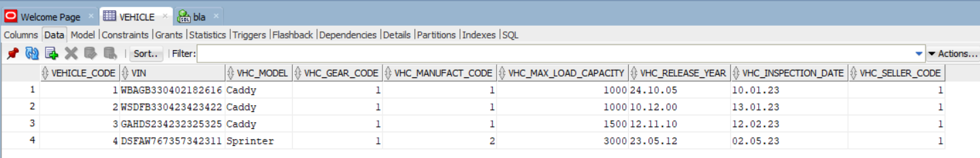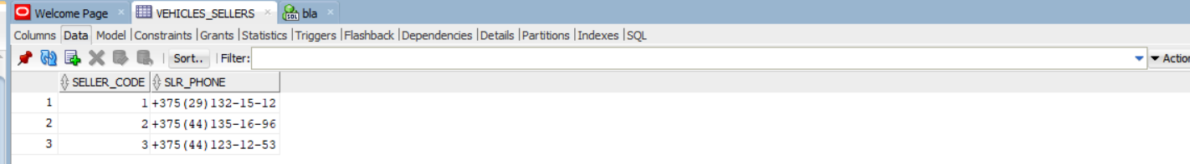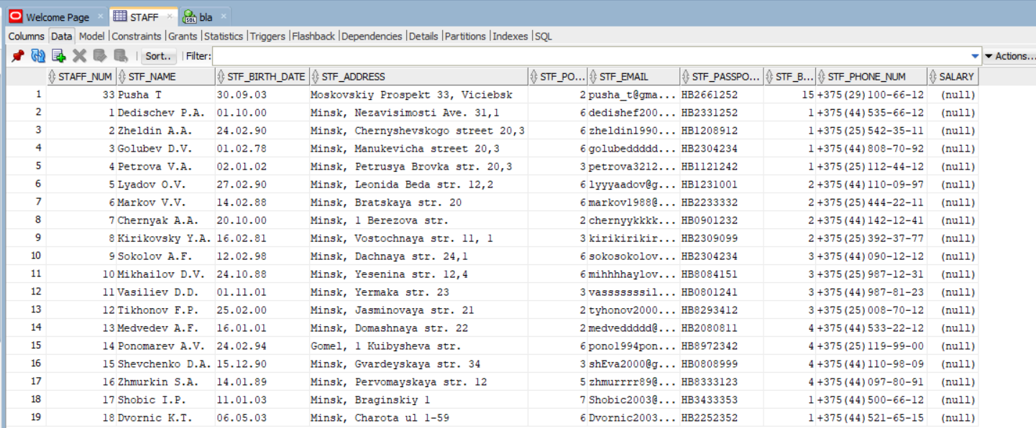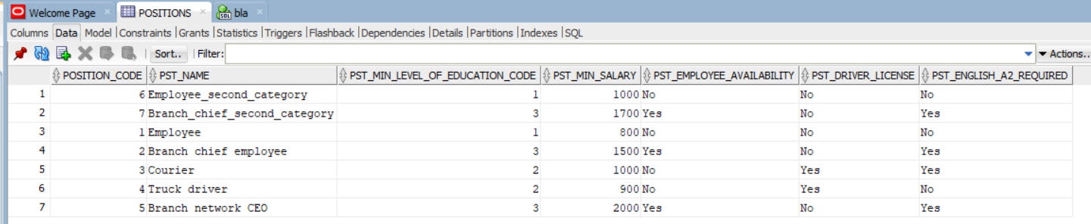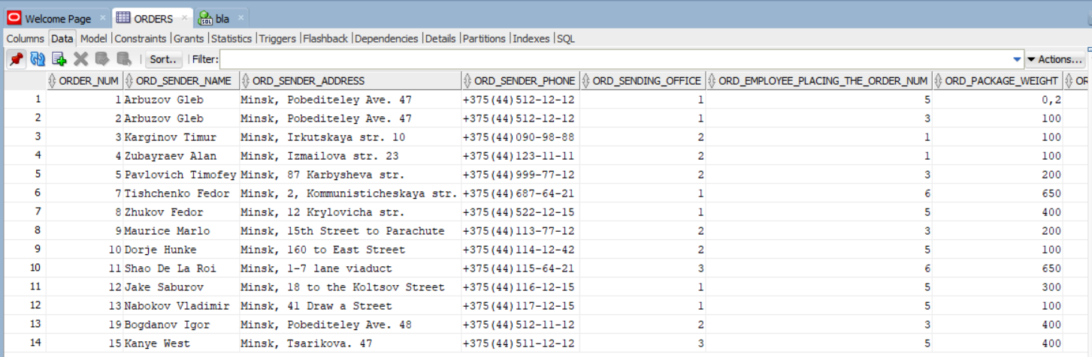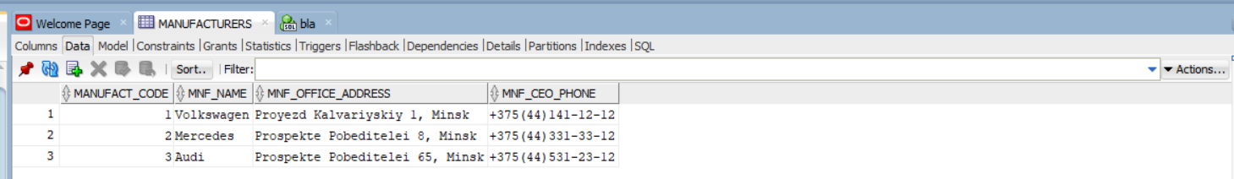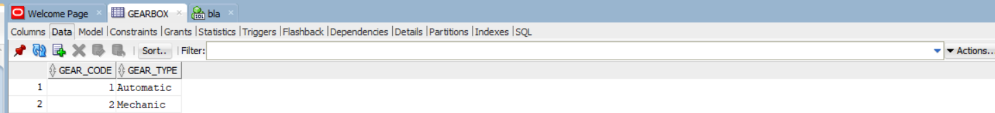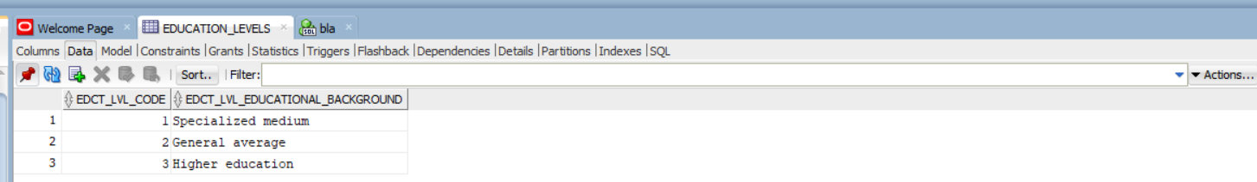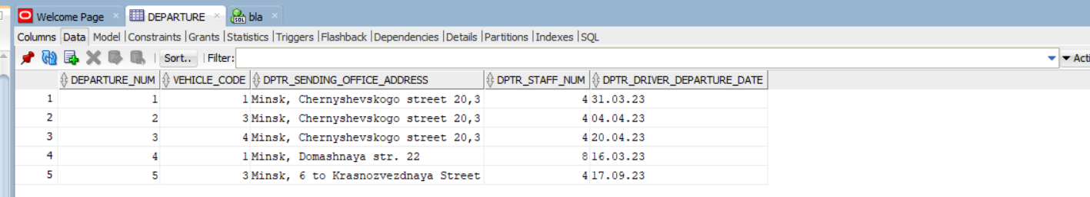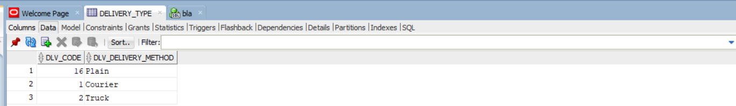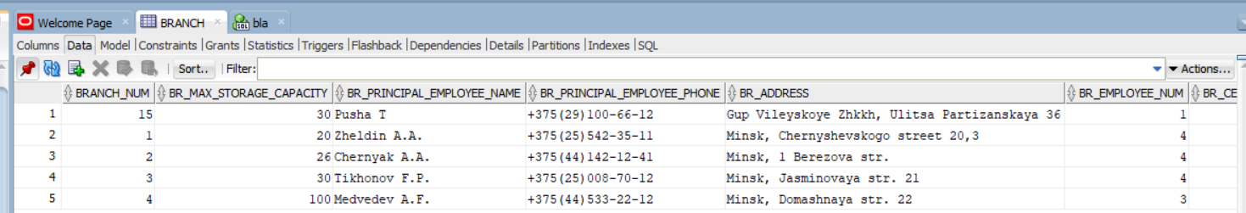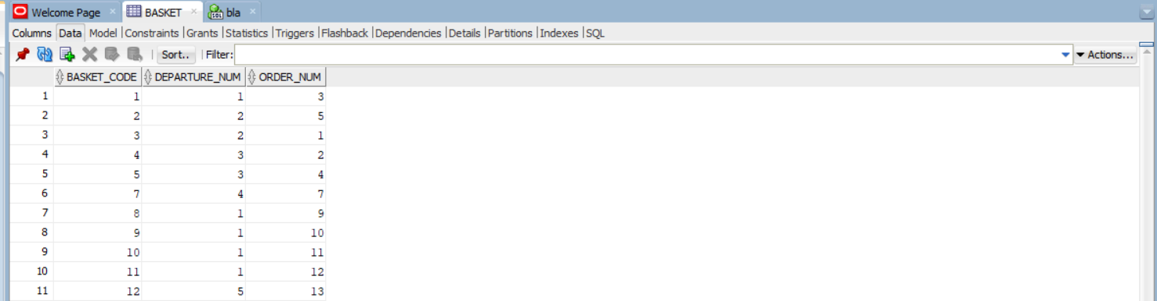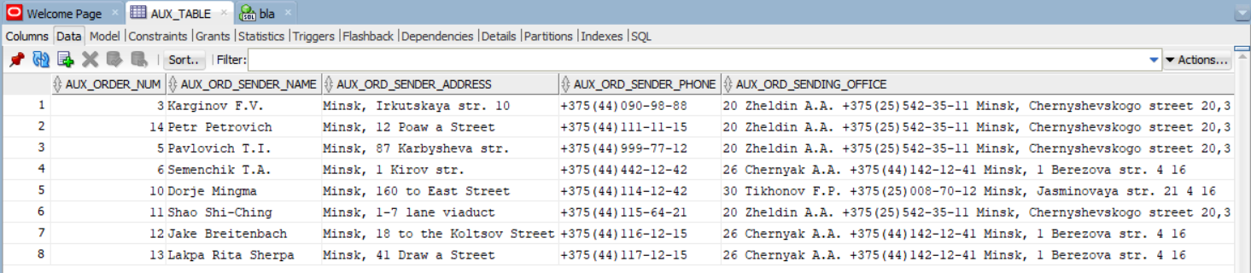

**Индекс:**

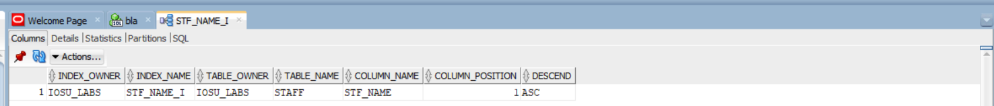

**Синоним:**

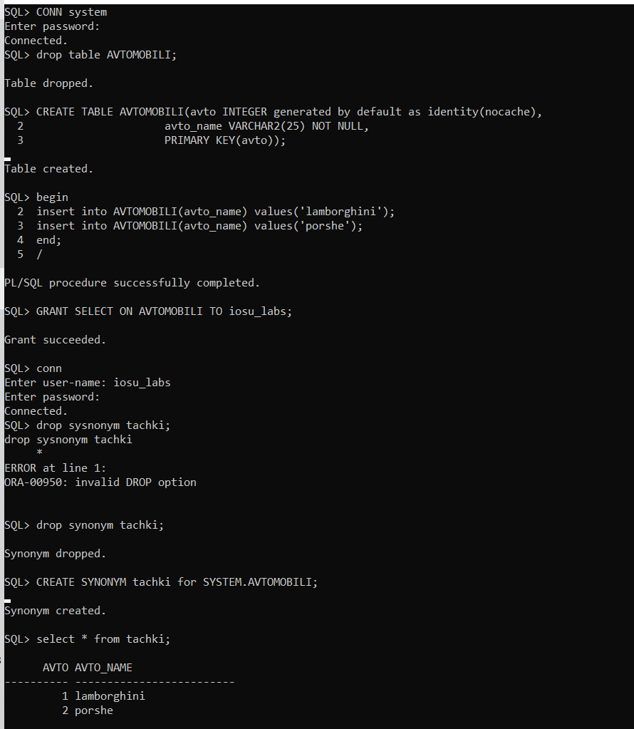

**Лабораторная работа №2**

**Создание запросов**

Написать запросы по индивидуальной базе данных: условный запрос, итоговый запрос, параметрический запрос, запрос на объединение, итоговый запрос с использованием группировки по части поля с типом дата. Варианты заданий приведены в прил. 3, все результаты запросов также должны быть отсортированы и содержать не менее 5 записей. В отчет обязательно включается формулировка запроса, код запроса на SQL и результат его выполнения.

**_Задача:**

*3.1 УСЛОВНЫЙ:*

*Отправители, входящие в первое отправление*

**_Код:**

**insert into Orders(ORD_sender_name,ORD_sender_address,ORD_sender_phone,ORD_sending_office,ORD_employee_placing_the_order_num,ORD_package_weight,ORD_package_scope,ORD_package_receipt_date,ORD_declared_value_amount,ORD_cash_on_dlvry_amount,ORD_fragile,ORD_completeness_check,ORD_arrival_date,ORD_recipient_name,ORD_recipient_address,ORD_recipient_phone,ORD_receiving_office,ORD_shipping_cost,ORD_deliv_type_code,ORD_cash_payment) values('Maurice Wilson','Minsk, 15th Street to Parachute','+375(44)113-77-12',1,3,200,0.011,DATE '2023-09-12',44,50,'No','Yes',NULL,'Apa Sherpa','Minsk, 2 to Baikal Str','+375(44)120-89-87',4,25.00,2,'Yes');**

**insert into Orders(ORD_sender_name,ORD_sender_address,ORD_sender_phone,ORD_sending_office,ORD_employee_placing_the_order_num,ORD_package_weight,ORD_package_scope,ORD_package_receipt_date,ORD_declared_value_amount,ORD_cash_on_dlvry_amount,ORD_fragile,ORD_completeness_check,ORD_arrival_date,ORD_recipient_name,ORD_recipient_address,ORD_recipient_phone,ORD_receiving_office,ORD_shipping_cost,ORD_deliv_type_code,ORD_cash_payment) values('Dorje Mingma','Minsk, 160 to East Street','+375(44)114-12-42',3,5,100,0.012,DATE '2023-09-10',23,400,'No','No',NULL,'Phurba Tashi Sherpa','Minsk, 2 to Starinovskaya Street','+375(44)121-22-31',2,96.40,1,'Yes');**

**insert into Orders(ORD_sender_name,ORD_sender_address,ORD_sender_phone,ORD_sending_office,ORD_employee_placing_the_order_num,ORD_package_weight,ORD_package_scope,ORD_package_receipt_date,ORD_declared_value_amount,ORD_cash_on_dlvry_amount,ORD_fragile,ORD_completeness_check,ORD_arrival_date,ORD_recipient_name,ORD_recipient_address,ORD_recipient_phone,ORD_receiving_office,ORD_shipping_cost,ORD_deliv_type_code,ORD_cash_payment) values('Shao Shi-Ching','Minsk, 1-7 lane viaduct','+375(44)115-64-21',1,6,800,0.023,DATE '2023-09-09',520,1000,'Yes','No',NULL,'Dorje Gyalgen Sherpa','Minsk, 22 st to Tomsk','+375(44)122-17-20',3,12.80,2,'No');**

**insert into Orders(ORD_sender_name,ORD_sender_address,ORD_sender_phone,ORD_sending_office,ORD_employee_placing_the_order_num,ORD_package_weight,ORD_package_scope,ORD_package_receipt_date,ORD_declared_value_amount,ORD_cash_on_dlvry_amount,ORD_fragile,ORD_completeness_check,ORD_arrival_date,ORD_recipient_name,ORD_recipient_address,ORD_recipient_phone,ORD_receiving_office,ORD_shipping_cost,ORD_deliv_type_code,ORD_cash_payment) values('Jake Breitenbach','Minsk, 18 to the Koltsov Street','+375(44)116-12-15',2,5,900,0.021,DATE '2023-09-11',100,1000,'No','Yes',NULL,'Mingma Tsiri Sherpa','Minsk, 33 st to Baikal','+375(44)124-31-24',3,19.12,1,'No');**

**insert into Basket (Departure_num, Order_num) values(1,9);**

**insert into Basket (Departure_num, Order_num) values(1,10);**

**insert into Basket (Departure_num, Order_num) values(1,11);**

**insert into Basket (Departure_num, Order_num) values(1,12);**

**select basket.Departure_num, Orders.ORD_sender_name**

**from basket**

**inner join Orders**

**on Basket.Order_num = Orders.Order_num and Basket.Departure_num = 1**

**order by 2;**

**_Результат:**

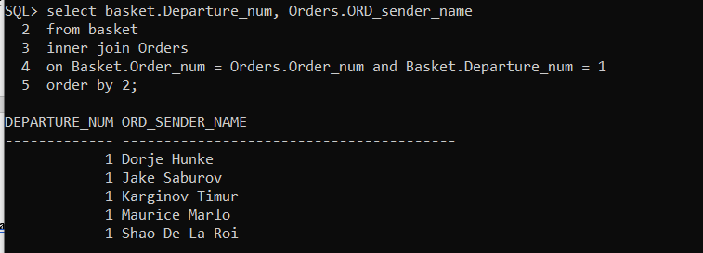

**_Задача:**

*3.2 ИТОГОВЫЙ:*

*Количество заказов на каждое отправление*

**_Код:**

**insert into Orders(ORD_sender_name,ORD_sender_address,ORD_sender_phone,ORD_sending_office,ORD_employee_placing_the_order_num,ORD_package_weight,ORD_package_scope,ORD_package_receipt_date,ORD_declared_value_amount,ORD_cash_on_dlvry_amount,ORD_fragile,ORD_completeness_check,ORD_arrival_date,ORD_recipient_name,ORD_recipient_address,ORD_recipient_phone,ORD_receiving_office,ORD_shipping_cost,ORD_deliv_type_code,ORD_cash_payment) values('Lakpa Rita Sherpa','Minsk, 41 Draw a Street','+375(44)117-12-15',2,5,100,0.001,DATE '2023-09-11',104,300,'No','Yes',NULL,'Kenton Cool','Minsk, 43 st to Starobin','+375(44)126-31-24',3,10.12,1,'No');**

**insert into Departure(Vehicle_code,DPTR_sending_office_address,DPTR_staff_num,DPTR_driver_departure_date) values(3, 'Minsk, 6 to Krasnozvezdnaya Street', 4, DATE '2023-09-17');**

**insert into Basket (Departure_num, Order_num) values(5,13);**

**select basket.Departure_num, count(basket.order_num) orders_amount**

**from basket**

**group by basket.Departure_num**

**order by 1;**

**_Результат:**

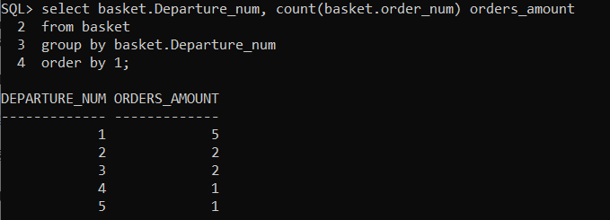

**_Задача:**

*3.3 ПАРАМЕТРИЧЕСКИЙ:*

*Заказы дешевле заданной стоимости*

**_Код:**

**select orders.\***

**from orders**

**where orders.ORD_shipping_cost < &the_shipping_cost_limit**

**order by 1;**

**_Результат:**

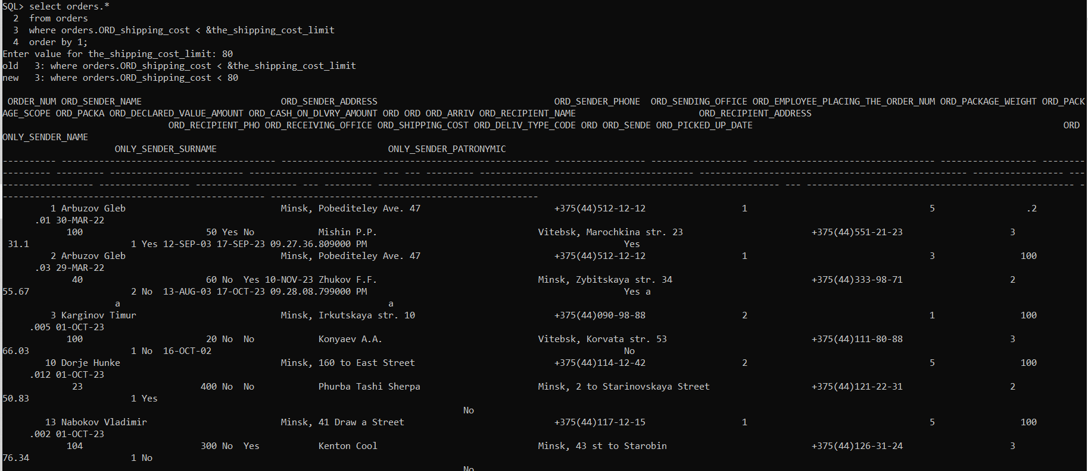

**_Задача:**

*3.4 запрос на объединение.*

*Вывести общий список отправителей и курьеров*

**_Код:**

**select t1.Courier_name as Person, t1.PST_name as role_name, departure_amount as departure_or_orders_amount from**

**(select distinct staff.STF_name as Courier_name, Positions.PST_name, count(Departure.Departure_num) as departure_amount**

**from Departure**

**inner join staff on Departure.DPTR_staff_num = staff.Staff_num**

**inner join Positions on staff.STF_position_code = positions.Position_code**

**group by staff.STF_name,Positions.PST_name) t1**

**union select t2.ORD_sender_name,'Sender',t2.order_amount from**

**(select distinct orders.ORD_sender_name, count(orders.Order_num) as order_amount**

**from orders**

**group by ORD_sender_name) t2**

**order by role_name;**

**_Результат:**

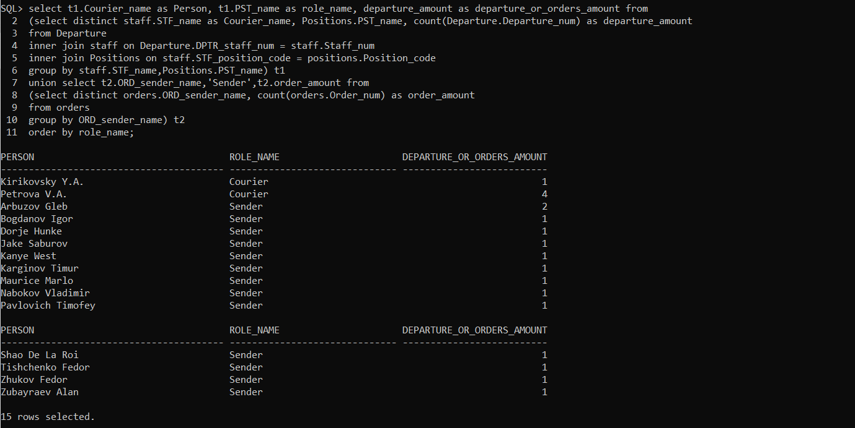

**_Задача:**

*3.5 итоговый запрос с использованием группировки по части поля с типом дата*

*суммарное количество заказов, оформленных по понедельнику, когда в целом были оформлены заказы*

**_Код:**

**select to_char(orders.ORD_package_receipt_date, 'D') as weekday, count(orders.order_num)**

**from orders**

**where to_char(orders.ORD_package_receipt_date, 'D') = '1'**

**group by to_char(orders.ORD_package_receipt_date, 'D')**

**order by 1;**

**_Результат:**

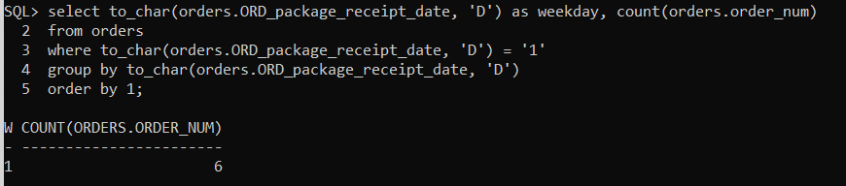

**_Задача:**

*4.1 С внутренним соединением таблиц, используя стандартный синтаксис SQL (JOIN…ON, JOIN…USING или NATURAL JOIN), который не применялся в предыдущих запросах:список сотрудников со списком номеров отделений, к которым эти сотрудники принадлежат*

**_Код:**

***select distinct departure.Vehicle_code, departure.DPTR_sending_office_address***

***from departure***

***join basket***

***using (departure_num)***

***order by 1;***

**_Результат:**

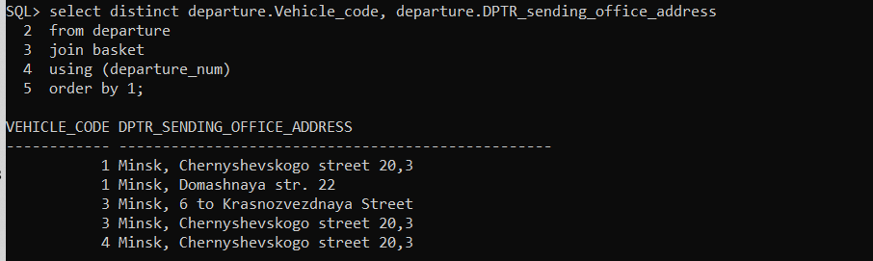

**_Задача:**

*4.2 с внешним соединением таблиц, используя FULL JOIN, LEFT JOIN или RIGHT JOIN, при этом обязательным является наличие в БД данных, которые будут выводиться именно с выбранным оператором внешнего соединения*

*Всевозможные типы кпп - присущие автомобилям в текущем автопарке*

**_Код:**

**select gearbox.GEAR_type, Vehicle.VHC_model**

**from Gearbox**

**left outer join Vehicle**

**on gearbox.GEAR_code = vehicle.VHC_gear_code**

**order by 1;**

**_Результат:**

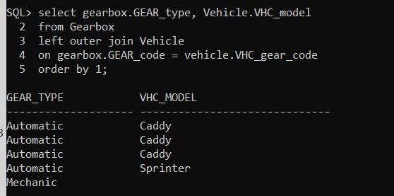

**_Задача:**

*4.3 с использованием предиката IN с подзапросом*

*Вывести все должности, где необходимо высшее и среднее образование*

**_Код:**

**select positions.PST_name**

**from positions**

**where positions.PST_min_level_of_education_code**

**IN (select Education_levels.EDCT_LVL_code**

**from Education_levels**

**where Education_levels.EDCT_LVL_educational_background = 'Higher education' or Education_levels.EDCT_LVL_educational_background = 'General average');**

**_Результат:**

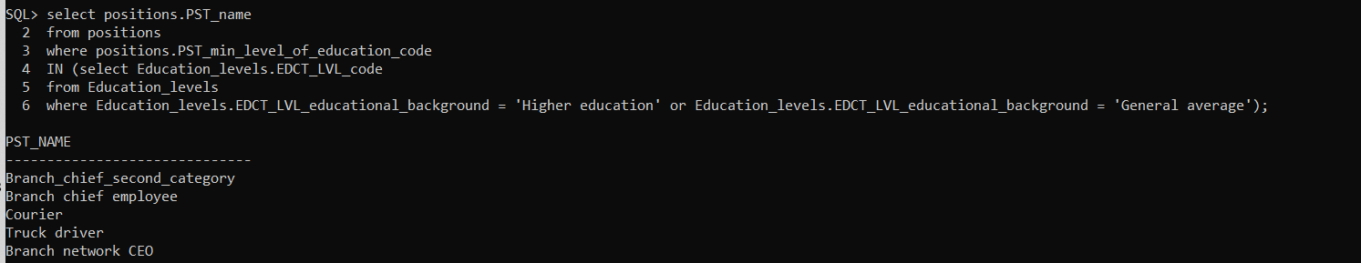

**_Задача:**

*4.4 с использованием предиката ANY/ALL с подзапросом*

*Вывести всех сотрудников, чья зп больше чем средняя зп всех отделений*

**_Код:**

**select t1.STF_name as employee_name, t1.PST_min_salary as salary, t2.STF_branch_num as branch_num, t2.avg_salary as avg_salary from**

**(select staff.STF_name, positions.PST_min_salary, staff.STF_branch_num**

**from Staff**

**inner join Positions**

**on staff.STF_position_code = positions.Position_code) t1,**

**(select staff.STF_branch_num, avg(Positions.PST_min_salary) as avg_salary**

**from Staff**

**inner join Positions on staff.STF_position_code = positions.Position_code**

**inner join branch on staff.STF_branch_num = branch.Branch_num**

**group by staff.STF_branch_num) t2**

**where (t1.PST_min_salary > all t2.avg_salary) and t1.stf_branch_num = t2.STF_branch_num**

**order by 3;**

**_Результат:**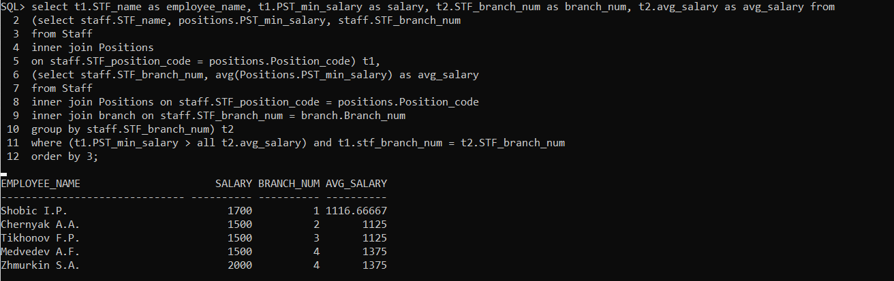

**_Задача:**

*4.5 с использованием предиката EXISTS/NOT EXISTS с подзапросом*

*Вывести список работников, которые участвуют в процессе получения посылки от отправителя*

**_Код:**

**select staff.STF_name from Staff**

**where exists (select 1 from Orders**

**where orders.ORD_employee_placing_the_order_num = staff.Staff_num);**

**_Результат:**

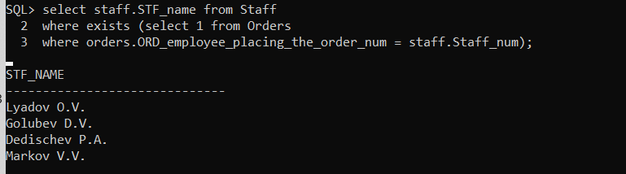

**_Задача:**

*Обновить одной командой информацию о зарплате сотрудников, уменьшив зарплату*

*курьеров на 5 %, а зарплату работников увеличив на 7 %.*

**_Код:**

**update Positions set PST_min_salary =**

**case**

**when PST_name = 'Courier' then (PST_min_salary*0.95)**

**when PST_name = 'Branch chief employee' then (PST_min_salary + PST_min_salary*0.07)**

**when PST_name = 'Truck driver' then (PST_min_salary + PST_min_salary*0.07)**

**when PST_name = 'Branch network CEO' then (PST_min_salary + PST_min_salary*0.07)**

**when PST_name = 'Employee' then (PST_min_salary + PST_min_salary*0.07)**

**when PST_name = 'Employee_second_category' then (PST_min_salary + PST_min_salary*0.07)**

**when PST_name = 'Branch_chief_second_category' then (PST_min_salary + PST_min_salary*0.07)**

**end;**

**/**

**_Результат:**

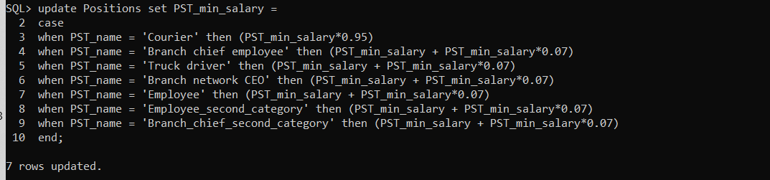

**Лабораторная работа №3**

**Создание и использование представлений**

**_Задача:**

* 1. горизонтальное обновляемое представление с условием (WHERE);

**_Код:**

**create or replace view view2_first AS**

**select * from staff**

**where staff.stf_position_code in**

**(select position_code from positions**

**where positions.pst_name = 'Courier' or positions.pst_name = 'Employee')**

**WITH CHECK OPTION;**

**_Результат:**

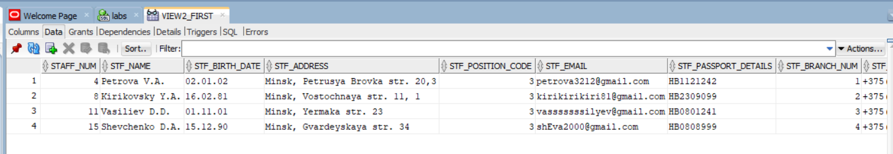

**_Задача:**

* 1. проверить обновляемость горизонтального представления с фразой WITH CHECK OPTION при помощи одной из инструкций UPDATE, DELETE, INSERT (привести примеры выполняющихся и не выполняющихся инструкций, объяснить);

**_Код:**

**insert into view2_first(STF_name,STF_birth_date,STF_address,STF_position_code,STF_email,STF_passport_details,STF_branch_num,STF_phone_num)**

**values('Dvornic K.T.',DATE '2003-05-06','Minsk, Charota ul 1-59',1,'Dvornic2003@gmail.com','HB2252352',1,'+375(44)521-65-15');**

**_Результат:**



**_Задача:**

* 1. Создать вертикальное или смешанное необновляемое представление, предназначенное для работы с основной таблицей БД (в представлении должны содержаться сведения из основной дочерней таблицы и/или корзины (если есть), но вместо внешних ключей использовать связанные данные родительских таблиц, понятные конечному пользователю представления);

**_Код:**

**create or replace view view2_third AS**

**select distinct orders.order_num as order_number,**

**orders.ORD_package_receipt_date,**

**orders.ord_sender_name as order_sender_name,**

**branch.BR_address as sending_office_address,**

**delivery_type.dlv_delivery_method as delivery_method,**

**staff.stf_name as placing_the_order_employee_name**

**from orders**

**inner join branch on orders.ORD_sending_office = branch.branch_num**

**inner join delivery_type on orders.ORD_deliv_type_code = delivery_type.DLV_code**

**inner join staff on orders.ORD_employee_placing_the_order_num = staff.Staff_num**

**where to_char(orders.ORD_package_receipt_date, 'MM') = '03';**

**_Результат:**

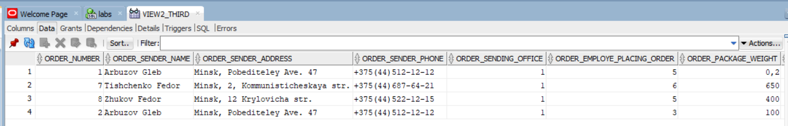

**_Задача:**

* 1. доказать необновляемость представления из предыдущего пункта, проверив возможность выполнения инструкций UPDATE, DELETE, INSERT над представлением. Сохранить полученный результат (сообщение об ошибке или об успешном выполнении), объяснить причины;

**_Код:**

**delete from view2_third**

**where order_number = 1;**

**_Результат:**

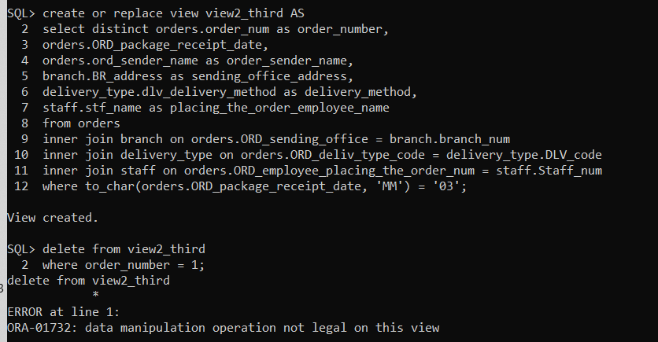

**_Задача:**

* 1. cоздать обновляемое представление для работы с одной из родительских таблиц индивидуальной БД и через него разрешить работу с данными только в рабочие дни (с понедельника по пятницу) и в рабочие часы (с 9:00 до 17:00) с учетом часового пояса.

**_Код:**

**CREATE OR REPLACE VIEW view2_fifth AS**

**SELECT \***

**FROM staff**

**WHERE (TO_CHAR(SYSDATE, 'D') BETWEEN '1' AND '5')**

**AND (TO_CHAR(SYSDATE, 'HH24:MI') BETWEEN '09:00' AND '17:00')**

**WITH CHECK OPTION;**

**select * from view2_fifth;**

**_Результат:**

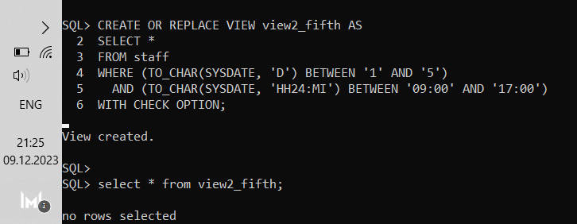

**Лабораторная работа № 4**

# процедурЫ, функциИ и пакетЫ PL/SQL

**_Задача:**

*1. Создать процедуру.*

*ВЫВЕСТИ ВСЮ ИНФУ О РАБОТНИКЕ С ID = 1.*

**_Код:**

**create or replace procedure staff_info(in_staff_num number)**

**is**

**p_info staff%rowtype;**

**begin**

**select * into p_info**

**from staff**

**where staff_num = in_staff_num;**

**dbms_output.put_line(p_info.stf_name || ' ' ||**

**p_info.stf_birth_date || ' ' || p_info.stf_address || ' ' || p_info.stf_position_code || ' ' ||**

**p_info.stf_email || ' ' || p_info.stf_passport_details || ' ' ||**

**p_info.stf_branch_num || ' ' || p_info.stf_phone_num || ' ');**

**exception**

**when others then**

**dbms_output.put_line(SQLERRM);**

**END;**

**/**

**_Результат:**

**BEGIN**

**staff_info(1);**

**end;**

**/**

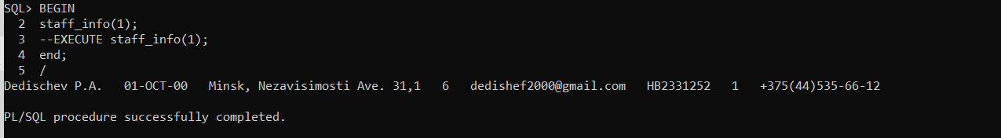

**_Задача:**

*2. Создать функцию.*

*При создании следует выполнить следующие минимальные требования к синтаксису:*

* *использовать явный курсор или курсорную переменную, а также атрибуты курсора;*
* *использовать пакет DBMS_OUTPUT для вывода результатов работы в SQL*Plus;*
* *предусмотреть секцию обработки исключительных ситуаций, причем обязательно использовать как предустановленные исключительные ситуации, так и собственные (например, стоит контролировать наличие в БД значений, передаваемых в процедуры и функции как параметры);*

*посчитать возраст сотрудника с опредленным фио и вывести инфу о всех сотрудниках компании, которые старше этого сотрудника*

**_Код:**

**create or replace function get_staff_age(**

**staff_name staff.STF_name%TYPE,**

**dateval date default sysdate**

**)**

**return VARCHAR2**

**is**

**result interval year to month;**

**s_birth_date staff.STF_birth_date%type;**

**begin**

**select STF_birth_date into s_birth_date from staff**

**where staff.STF_name = staff_name;**

**result := (dateval - s_birth_date) year to month;**

**return result;**

**end;**

**/**

**_Результат:**

**SELECT STF_name, stf_birth_date, get_staff_age (STF_name)**

**FROM staff**

**WHERE (sysdate - stf_birth_date) YEAR TO MONTH > get_staff_age ('Dedischev P.A.');**

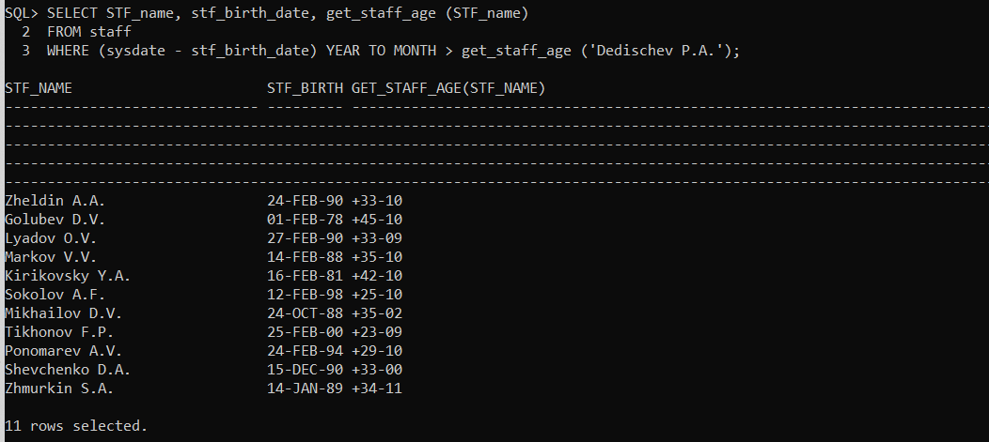

**_Задача:**

*Создать процедуру в oracle, копирующую строки с информацией о заказах за текущий месяц, во вспомогательную таблицу используя явный курсор или курсорную переменную, а также атрибуты курсора, которая использует пакет DBMS_OUTPUT для вывода результатов работы в SQL*Plus, а также, которая предусматривает секцию обработки исключительных ситуаций, причем обязательно использовать как предустановленные исключительные ситуации, так и собственные (например, стоит*

*контролировать наличие в БД значений, передаваемых в процедуры и функции как параметры.*

*обработка искл.ситуация будет заключаться в том, что если id заказа будет повторяться, то будет появляться сообщение*

**_Код:**

**CREATE TABLE aux_table(aux_Order_num INTEGER CONSTRAINT aux_order_number UNIQUE,**

**aux_ORD_sender_name VARCHAR2(40) NOT NULL,**

**aux_ORD_sender_address VARCHAR2(50) NOT NULL,**

**aux_ORD_sender_phone CHAR(17) NOT NULL,**

**aux_ORD_sending_office VARCHAR2(255) NOT NULL,**

**aux_ORD_employee_placing_the_order_num VARCHAR2(255) NOT NULL,**

**aux_ORD_package_weight DECIMAL(20,3) NOT NULL,**

**aux_ORD_package_scope DECIMAL(20,3) NOT NULL,**

**aux_ORD_package_receipt_date DATE NOT NULL,**

**aux_ORD_declared_value_amount DECIMAL(30,3),**

**aux_ORD_cash_on_dlvry_amount DECIMAL(30,3),**

**aux_ORD_fragile VARCHAR2(3) NOT NULL,**

**aux_ORD_completeness_check VARCHAR2(3) NOT NULL,**

**aux_ORD_arrival_date DATE,**

**aux_ORD_recipient_name VARCHAR2(40) NOT NULL,**

**aux_ORD_recipient_address VARCHAR2(50) NOT NULL,**

**aux_ORD_recipient_phone CHAR(17) NOT NULL,**

**aux_ORD_receiving_office VARCHAR2(255) NOT NULL,**

**aux_ORD_shipping_cost DECIMAL(30,3) NOT NULL,**

**aux_ORD_deliv_type_code VARCHAR2(255) NOT NULL,**

**aux_ORD_cash_payment VARCHAR2(3) NOT NULL**

**);**

**CREATE OR REPLACE PROCEDURE copy_orders_to_aux_table**

**AS**

**cursor orders_cursor is**

**select \***

**from orders**

**where ORD_package_receipt_date BETWEEN TRUNC(SYSDATE, 'MONTH') AND SYSDATE;**

**p_Order_num INTEGER;**

**p_ORD_sender_name VARCHAR2(40);**

**p_ORD_sender_address VARCHAR2(50);**

**p_ORD_sender_phone CHAR(17);**

**p_ORD_sending_office VARCHAR2(255);**

**p_ORD_employee_placing_the_order_num VARCHAR2(255);**

**p_ORD_package_weight DECIMAL(20,3);**

**p_ORD_package_scope DECIMAL(20,3);**

**p_ORD_package_receipt_date DATE;**

**p_ORD_declared_value_amount DECIMAL(30,3);**

**p_ORD_cash_on_dlvry_amount DECIMAL(30,3);**

**p_ORD_fragile VARCHAR2(3);**

**p_ORD_completeness_check VARCHAR2(3);**

**p_ORD_arrival_date DATE;**

**p_ORD_recipient_name VARCHAR2(40);**

**p_ORD_recipient_address VARCHAR2(50);**

**p_ORD_recipient_phone CHAR(17);**

**p_ORD_receiving_office VARCHAR2(255);**

**p_ORD_shipping_cost DECIMAL(30,3);**

**p_ORD_deliv_type_code VARCHAR2(255);**

**p_ORD_cash_payment VARCHAR2(3);**

**p_ORD_SENDER_BIRTH_DAY DATE;**

**p_ORD_PICKED_UP_DATE TIMESTAMP(6);**

**p_ORD_PICKED_UP VARCHAR2(3);**

**p_ONLY_SENDER_NAME VARCHAR2(50);**

**p_ONLY_SENDER_SURNAME VARCHAR2(50);**

**p_ONLY_SENDER_PATRONYMIC VARCHAR2(50);**

**exp_unique_id exception;**

**PRAGMA EXCEPTION_INIT (exp_unique_id, -00001);**

**begin**

**OPEN orders_cursor;**

**--OPEN orders_cursor;**

**loop**

**begin**

**fetch orders_cursor into p_Order_num,p_ORD_sender_name,**

**p_ORD_sender_address,p_ORD_sender_phone,p_ORD_sending_office,**

**p_ORD_employee_placing_the_order_num,p_ORD_package_weight,**

**p_ORD_package_scope,p_ORD_package_receipt_date,**

**p_ORD_declared_value_amount,p_ORD_cash_on_dlvry_amount,**

**p_ORD_fragile,p_ORD_completeness_check,p_ORD_arrival_date,**

**p_ORD_recipient_name,p_ORD_recipient_address,**

**p_ORD_recipient_phone,p_ORD_receiving_office,p_ORD_shipping_cost,**

**p_ORD_deliv_type_code,p_ORD_cash_payment, p_ORD_SENDER_BIRTH_DAY,**

**p_ORD_PICKED_UP_DATE, p_ORD_PICKED_UP, p_ONLY_SENDER_NAME, p_ONLY_SENDER_SURNAME,**

**p_ONLY_SENDER_PATRONYMIC;**

**exit when orders_cursor%NOTFOUND;**

**insert into aux_table(aux_Order_num,aux_ORD_sender_name,**

**aux_ORD_sender_address,aux_ORD_sender_phone,aux_ORD_sending_office,**

**aux_ORD_employee_placing_the_order_num,aux_ORD_package_weight,**

**aux_ORD_package_scope,aux_ORD_package_receipt_date,**

**aux_ORD_declared_value_amount,aux_ORD_cash_on_dlvry_amount,**

**aux_ORD_fragile,aux_ORD_completeness_check,aux_ORD_arrival_date,**

**aux_ORD_recipient_name,aux_ORD_recipient_address,**

**aux_ORD_recipient_phone,aux_ORD_receiving_office,**

**aux_ORD_shipping_cost,aux_ORD_deliv_type_code,aux_ORD_cash_payment, aux_ORD_SENDER_BIRTH_DAY,**

**aux_ORD_PICKED_UP_DATE, aux_ORD_PICKED_UP, aux_ONLY_SENDER_NAME, aux_ONLY_SENDER_SURNAME,**

**aux_ONLY_SENDER_PATRONYMIC)**

**values (p_Order_num, p_ORD_sender_name, p_ORD_sender_address,**

**p_ORD_sender_phone, p_ORD_sending_office, p_ORD_employee_placing_the_order_num,**

**p_ORD_package_weight, p_ORD_package_scope, p_ORD_package_receipt_date,**

**p_ORD_declared_value_amount, p_ORD_cash_on_dlvry_amount,**

**p_ORD_fragile, p_ORD_completeness_check,p_ORD_arrival_date,**

**p_ORD_recipient_name, p_ORD_recipient_address, p_ORD_recipient_phone,**

**p_ORD_receiving_office, p_ORD_shipping_cost, p_ORD_deliv_type_code,**

**p_ORD_cash_payment, p_ORD_SENDER_BIRTH_DAY, p_ORD_PICKED_UP_DATE, p_ORD_PICKED_UP, p_ONLY_SENDER_NAME, p_ONLY_SENDER_SURNAME,**

**p_ONLY_SENDER_PATRONYMIC);**

**exception**

**WHEN exp_unique_id THEN**

**DBMS_OUTPUT.PUT_LINE ('Ошибка №' || sqlcode || ' заказ с номером ' || p_Order_num || ' уже существует');**

**when others then**

**DBMS_OUTPUT.PUT_LINE('Ошибка: ' || SQLERRM);**

**end;**

**end loop;**

**close orders_cursor;**

**update aux_table**

**set aux_ORD_sending_office = (**

**select (to_char(BR_max_storage_capacity) || ' ' || BR_principal_employee_name || ' ' || BR_principal_employee_phone || ' ' || BR_address || ' ' || to_char(BR_employee_num) || ' ' || to_char(BR_ceo_director))**

**from branch**

**where branch.branch_num = to_number(aux_table.aux_ORD_sending_office) and VALIDATE_CONVERSION(aux_table.aux_ORD_sending_office as NUMBER) = 1**

**) where VALIDATE_CONVERSION(aux_ORD_sending_office as NUMBER) = 1;**

**update aux_table**

**set aux_ORD_employee_placing_the_order_num = (**

**select (STF_name || ' ' || STF_birth_date || ' ' || STF_address || ' ' || to_char(STF_position_code) || ' ' || STF_email || ' ' || STF_passport_details || ' ' || to_char(STF_branch_num) || ' ' || STF_phone_num)**

**from staff**

**where staff.Staff_num = to_number(aux_table.aux_ORD_employee_placing_the_order_num) and VALIDATE_CONVERSION(aux_table.aux_ORD_employee_placing_the_order_num as NUMBER) = 1**

**) where VALIDATE_CONVERSION(aux_ORD_employee_placing_the_order_num as NUMBER) = 1;**

**update aux_table**

**set aux_ORD_receiving_office = (**

**select (to_char(BR_max_storage_capacity) || ' ' || BR_principal_employee_name || ' ' || BR_principal_employee_phone || ' ' || BR_address || ' ' || to_char(BR_employee_num) || ' ' || to_char(BR_ceo_director))**

**from branch**

**where branch.branch_num = to_number(aux_table.aux_ORD_receiving_office) and VALIDATE_CONVERSION(aux_table.aux_ORD_receiving_office as NUMBER) = 1**

**) where VALIDATE_CONVERSION(aux_ORD_receiving_office as NUMBER) = 1;**

**update aux_table**

**set aux_ORD_deliv_type_code = (**

**select DLV_delivery_method**

**from Delivery_type**

**where Delivery_type.DLV_code = to_number(aux_table.aux_ORD_deliv_type_code) and VALIDATE_CONVERSION(aux_table.aux_ORD_deliv_type_code as NUMBER) = 1**

**) where VALIDATE_CONVERSION(aux_ORD_deliv_type_code as NUMBER) = 1;**

**DBMS_OUTPUT.PUT_LINE('The lines have been copied successfully');**

**exception**

**WHEN NO_DATA_FOUND THEN**

**DBMS_OUTPUT.PUT_LINE('За текущий месяцев не было сделано ни одного заказа');**

**WHEN CURSOR_ALREADY_OPEN THEN**

**DBMS_OUTPUT.PUT_LINE('Ошибка №' || sqlcode || '. Курсор уже открыт');**

**when others then**

**DBMS_OUTPUT.PUT_LINE('Ошибка: ' || SQLERRM);**

**END;**

**/**

**_Результат:**

**EXECUTE copy_orders_to_aux_table;**

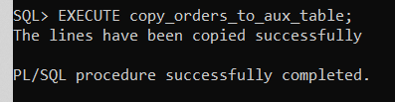 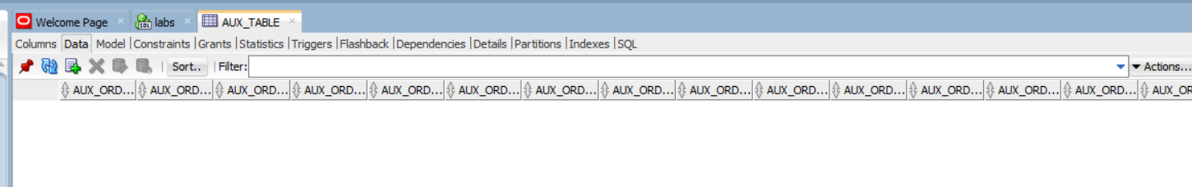

За текущий месяц не было заказов

**_Задача:**

*Написать функцию, которая выводит информацию о отправителях, которые оформили количество заказов за указанный год больше, чем указано во входном параметре.*

*Возвращать общее количество подписчиков.*

* *используя явный курсор или курсорную переменную, а также атрибуты курсора;*
* *используя пакет DBMS_OUTPUT для вывода результатов работы в SQL*Plus;*
* *предусмотреть секцию обработки исключительных ситуаций, причем обязательно использовать как предустановленные*
* *исключительные ситуации, так и собственные (например, стоит контролировать наличие в БД значений, передаваемых в процедуры и функции как параметры*

**_Код:**

**CREATE OR REPLACE FUNCTION subscribers_with_more_subscriptions(year IN NUMBER, threshold IN NUMBER) RETURN NUMBER IS**

**CURSOR subscriber_cursor IS**

**SELECT ORD_sender_name, ORD_sender_address, ORD_sender_phone, COUNT(order_num) AS orders_count**

**FROM orders**

**WHERE EXTRACT(YEAR FROM ORD_package_receipt_date) = year**

**GROUP BY ORD_sender_name, ORD_sender_address, ORD_sender_phone**

**HAVING COUNT(order_num) > threshold;**

**f_ORD_sender_name VARCHAR2(40);**

**f_ORD_sender_address VARCHAR2(50);**

**f_ORD_sender_phone CHAR(17);**

**orders_count NUMBER;**

**total_subscribers NUMBER := 0;**

**correct_year exception;**

**PRAGMA EXCEPTION_INIT (correct_year, -20001);**

**correct_threshold exception;**

**PRAGMA EXCEPTION_INIT (correct_threshold, -20002);**

**BEGIN**

**IF year > EXTRACT(YEAR FROM sysdate) THEN**

**RAISE_APPLICATION_ERROR(-20001, 'Неверный год: ' || year);**

**END IF;**

**IF threshold < 0 THEN**

**RAISE_APPLICATION_ERROR(-20002, 'Пороговое значение заказов должно быть больше 0');**

**END IF;**

**-- если не открыть курсор, то будет внутренняя ошибка с номером ORA-01001 INVALID_CURSOR**

**OPEN subscriber_cursor;**

**-- Перебираем результаты курсора**

**LOOP**

**FETCH subscriber_cursor INTO f_ORD_sender_name, f_ORD_sender_address, f_ORD_sender_phone, orders_count;**

**EXIT WHEN subscriber_cursor%NOTFOUND;**

**-- Выводим результаты в SQL*Plus**

**DBMS_OUTPUT.PUT_LINE(**

**'Имя отправителя: ' || f_ORD_sender_name ||**

**', Адрес отправителя: ' || f_ORD_sender_address ||**

**', Телефон отправителя: ' || f_ORD_sender_phone ||**

**', количество заказов: ' || orders_count);**

**-- Увеличиваем счетчик общего количества подписчиков**

**total_subscribers := total_subscribers + 1;**

**END LOOP;**

**-- Закрываем курсор**

**CLOSE subscriber_cursor;**

**-- Возвращаем общее количество подписчиков**

**RETURN total_subscribers;**

**EXCEPTION**

**WHEN correct_year THEN**

**DBMS_OUTPUT.PUT_LINE(SQLERRM);**

**WHEN correct_threshold THEN**

**DBMS_OUTPUT.PUT_LINE(SQLERRM);**

**WHEN NO_DATA_FOUND THEN**

**DBMS_OUTPUT.PUT_LINE('В таблице orders нет данных за указанный год.');**

**when INVALID_CURSOR THEN**

**DBMS_OUTPUT.PUT_LINE('Вы не корректно работаете с курсором');**

**WHEN OTHERS THEN**

**DBMS_OUTPUT.PUT_LINE('An error occurred: ' || SQLCODE || ' - ' || SQLERRM);**

**END;**

**/**

**_Результат:**

**DECLARE**

**total_subscribers NUMBER;**

**BEGIN**

**total_subscribers := subscribers_with_more_subscriptions(2023, 0);**

**DBMS_OUTPUT.PUT_LINE('Количество подписчиков, оформивших хоть какое-то кол-во заказов за год 2023: ' || total_subscribers);**

**END;**

**/**

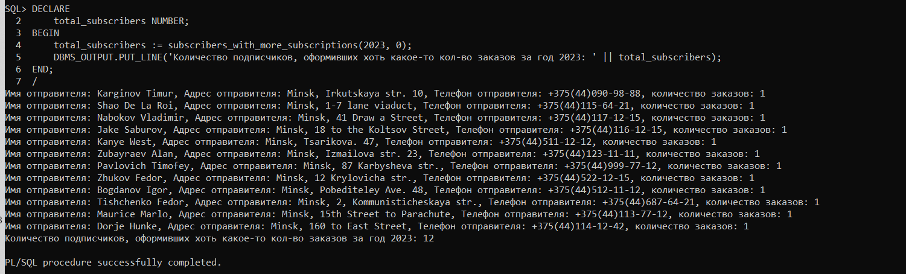

**_Задача:**

1. *Создать локальную программу, изменив код ранее написанной процедуры или функции.*

**_Код:**

**CREATE OR REPLACE FUNCTION local_subscribers_with_more_subscriptions(year IN NUMBER, threshold IN NUMBER) RETURN NUMBER IS**

**CURSOR subscriber_cursor IS**

**SELECT ORD_sender_name, ORD_sender_address, ORD_sender_phone, COUNT(order_num) AS orders_count**

**FROM orders**

**WHERE EXTRACT(YEAR FROM ORD_package_receipt_date) = year**

**GROUP BY ORD_sender_name, ORD_sender_address, ORD_sender_phone**

**HAVING COUNT(order_num) > threshold;**

**f_ORD_sender_name VARCHAR2(40);**

**f_ORD_sender_address VARCHAR2(50);**

**f_ORD_sender_phone CHAR(17);**

**orders_count NUMBER;**

**total_subscribers NUMBER := 0;**

**correct_year exception;**

**PRAGMA EXCEPTION_INIT (correct_year, -20001);**

**correct_threshold exception;**

**PRAGMA EXCEPTION_INIT (correct_threshold, -20002);**

**FUNCTION correct_year_checking (year in Number)**

**return Number**

**IS**

**result Number := 0;**

**BEGIN**

**IF year > EXTRACT(YEAR FROM sysdate) THEN**

**result := 1;**

**END IF;**

**RETURN result;**

**END correct_year_checking;**

**BEGIN**

**if correct_year_checking(year) = 1 then**

**RAISE_APPLICATION_ERROR(-20001, 'Неверный год: ' || year);**

**end if;**

**IF threshold < 0 THEN**

**RAISE_APPLICATION_ERROR(-20002, 'Пороговое значение заказов должно быть больше 0');**

**END IF;**

**-- если не открыть курсор, то будет внутренняя ошибка с номером ORA-01001 INVALID_CURSOR**

**OPEN subscriber_cursor;**

**-- Перебираем результаты курсора**

**LOOP**

**FETCH subscriber_cursor INTO f_ORD_sender_name, f_ORD_sender_address, f_ORD_sender_phone, orders_count;**

**EXIT WHEN subscriber_cursor%NOTFOUND;**

**-- Выводим результаты в SQL*Plus**

**DBMS_OUTPUT.PUT_LINE(**

**'Имя отправителя: ' || f_ORD_sender_name ||**

**', Адрес отправителя: ' || f_ORD_sender_address ||**

**', Телефон отправителя: ' || f_ORD_sender_phone ||**

**', количество заказов: ' || orders_count);**

**-- Увеличиваем счетчик общего количества подписчиков**

**total_subscribers := total_subscribers + 1;**

**END LOOP;**

**-- Закрываем курсор**

**CLOSE subscriber_cursor;**

**-- Возвращаем общее количество подписчиков**

**RETURN total_subscribers;**

**EXCEPTION**

**WHEN correct_year THEN**

**DBMS_OUTPUT.PUT_LINE(SQLERRM);**

**WHEN correct_threshold THEN**

**DBMS_OUTPUT.PUT_LINE(SQLERRM);**

**WHEN NO_DATA_FOUND THEN**

**DBMS_OUTPUT.PUT_LINE('В таблице orders нет данных за указанный год.');**

**when INVALID_CURSOR THEN**

**DBMS_OUTPUT.PUT_LINE('Вы не корректно работаете с курсором');**

**WHEN OTHERS THEN**

**DBMS_OUTPUT.PUT_LINE('An error occurred: ' || SQLCODE || ' - ' || SQLERRM);**

**END;**

**/**

**_Результат:**

**DECLARE**

**total_subscribers NUMBER;**

**BEGIN**

**total_subscribers := local_subscribers_with_more_subscriptions(2022, 0);**

**DBMS_OUTPUT.PUT_LINE('Количество подписчиков, оформивших хоть какое-то кол-во заказов за год 2022: ' || total_subscribers);**

**END;**

**/**

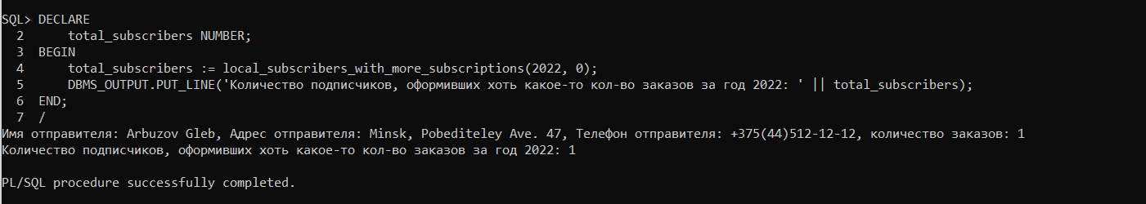

**_Задача:**

*4. Написать перегруженные программы, используя для этого ранее созданную процедуру или функцию.*

**_Код:**

**DECLARE**

**threshold_num VARCHAR2 (50) := '1';**

**threshold_varchar NUMBER := 1;**

**total_subscribers NUMBER;**

**FUNCTION local_subscribers_with_more_subscriptions(year IN NUMBER, threshold IN NUMBER) RETURN NUMBER IS**

**CURSOR subscriber_cursor IS**

**SELECT ORD_sender_name, ORD_sender_address, ORD_sender_phone, COUNT(order_num) AS orders_count**

**FROM orders**

**WHERE EXTRACT(YEAR FROM ORD_package_receipt_date) = year**

**GROUP BY ORD_sender_name, ORD_sender_address, ORD_sender_phone**

**HAVING COUNT(order_num) > threshold;**

**f_ORD_sender_name VARCHAR2(40);**

**f_ORD_sender_address VARCHAR2(50);**

**f_ORD_sender_phone CHAR(17);**

**orders_count NUMBER;**

**total_subscribers NUMBER := 0;**

**correct_year exception;**

**PRAGMA EXCEPTION_INIT (correct_year, -20001);**

**correct_threshold exception;**

**PRAGMA EXCEPTION_INIT (correct_threshold, -20002);**

**FUNCTION correct_year_checking (year in Number)**

**return Number**

**IS**

**result Number := 0;**

**BEGIN**

**IF year > EXTRACT(YEAR FROM sysdate) THEN**

**result := 1;**

**END IF;**

**RETURN result;**

**END correct_year_checking;**

**BEGIN**

**if correct_year_checking(year) = 1 then**

**RAISE_APPLICATION_ERROR(-20001, 'Неверный год: ' || year);**

**end if;**

**IF threshold < 0 THEN**

**RAISE_APPLICATION_ERROR(-20002, 'Пороговое значение заказов должно быть больше 0');**

**END IF;**

**-- если не открыть курсор, то будет внутренняя ошибка с номером ORA-01001 INVALID_CURSOR**

**OPEN subscriber_cursor;**

**-- Перебираем результаты курсора**

**LOOP**

**FETCH subscriber_cursor INTO f_ORD_sender_name, f_ORD_sender_address, f_ORD_sender_phone, orders_count;**

**EXIT WHEN subscriber_cursor%NOTFOUND;**

**-- Выводим результаты в SQL*Plus**

**DBMS_OUTPUT.PUT_LINE(**

**'Имя отправителя: ' || f_ORD_sender_name ||**

**', Адрес отправителя: ' || f_ORD_sender_address ||**

**', Телефон отправителя: ' || f_ORD_sender_phone ||**

**', количество заказов: ' || orders_count);**

**-- Увеличиваем счетчик общего количества подписчиков**

**total_subscribers := total_subscribers + 1;**

**END LOOP;**

**-- Закрываем курсор**

**CLOSE subscriber_cursor;**

**-- Возвращаем общее количество подписчиков**

**RETURN total_subscribers;**

**EXCEPTION**

**WHEN correct_year THEN**

**DBMS_OUTPUT.PUT_LINE(SQLERRM);**

**WHEN correct_threshold THEN**

**DBMS_OUTPUT.PUT_LINE(SQLERRM);**

**WHEN NO_DATA_FOUND THEN**

**DBMS_OUTPUT.PUT_LINE('В таблице orders нет данных за указанный год.');**

**when INVALID_CURSOR THEN**

**DBMS_OUTPUT.PUT_LINE('Вы не корректно работаете с курсором');**

**WHEN OTHERS THEN**

**DBMS_OUTPUT.PUT_LINE('An error occurred: ' || SQLCODE || ' - ' || SQLERRM);**

**END;**

**FUNCTION local_subscribers_with_more_subscriptions(year IN NUMBER, threshold IN VARCHAR2) RETURN NUMBER IS**

**CURSOR subscriber_cursor IS**

**SELECT ORD_sender_name, ORD_sender_address, ORD_sender_phone, COUNT(order_num) AS orders_count**

**FROM orders**

**WHERE EXTRACT(YEAR FROM ORD_package_receipt_date) = year**

**GROUP BY ORD_sender_name, ORD_sender_address, ORD_sender_phone**

**HAVING COUNT(order_num) > threshold;**

**threshold_num Number;**

**f_ORD_sender_name VARCHAR2(40);**

**f_ORD_sender_address VARCHAR2(50);**

**f_ORD_sender_phone CHAR(17);**

**orders_count NUMBER;**

**total_subscribers NUMBER := 0;**

**correct_year exception;**

**PRAGMA EXCEPTION_INIT (correct_year, -20001);**

**correct_threshold exception;**

**PRAGMA EXCEPTION_INIT (correct_threshold, -20002);**

**FUNCTION correct_year_checking (year in Number)**

**return Number**

**IS**

**result Number := 0;**

**BEGIN**

**IF year > EXTRACT(YEAR FROM sysdate) THEN**

**result := 1;**

**END IF;**

**RETURN result;**

**END correct_year_checking;**

**BEGIN**

**threshold_num := TO_NUMBER(threshold);**

**if correct_year_checking(year) = 1 then**

**RAISE_APPLICATION_ERROR(-20001, 'Неверный год: ' || year);**

**end if;**

**IF threshold < 0 THEN**

**RAISE_APPLICATION_ERROR(-20002, 'Пороговое значение заказов должно быть больше 0');**

**END IF;**

**-- если не открыть курсор, то будет внутренняя ошибка с номером ORA-01001 INVALID_CURSOR**

**OPEN subscriber_cursor;**

**-- Перебираем результаты курсора**

**LOOP**

**FETCH subscriber_cursor INTO f_ORD_sender_name, f_ORD_sender_address, f_ORD_sender_phone, orders_count;**

**EXIT WHEN subscriber_cursor%NOTFOUND;**

**-- Выводим результаты в SQL*Plus**

**DBMS_OUTPUT.PUT_LINE(**

**'Имя отправителя: ' || f_ORD_sender_name ||**

**', Адрес отправителя: ' || f_ORD_sender_address ||**

**', Телефон отправителя: ' || f_ORD_sender_phone ||**

**', количество заказов: ' || orders_count);**

**-- Увеличиваем счетчик общего количества подписчиков**

**total_subscribers := total_subscribers + 1;**

**END LOOP;**

**-- Закрываем курсор**

**CLOSE subscriber_cursor;**

**-- Возвращаем общее количество подписчиков**

**RETURN total_subscribers;**

**EXCEPTION**

**WHEN correct_year THEN**

**DBMS_OUTPUT.PUT_LINE(SQLERRM);**

**WHEN correct_threshold THEN**

**DBMS_OUTPUT.PUT_LINE(SQLERRM);**

**WHEN NO_DATA_FOUND THEN**

**DBMS_OUTPUT.PUT_LINE('В таблице orders нет данных за указанный год.');**

**when INVALID_CURSOR THEN**

**DBMS_OUTPUT.PUT_LINE('Вы не корректно работаете с курсором');**

**WHEN OTHERS THEN**

**DBMS_OUTPUT.PUT_LINE('An error occurred: ' || SQLCODE || ' - ' || SQLERRM);**

**END;**

**BEGIN**

**total_subscribers := local_subscribers_with_more_subscriptions(2022, threshold_num);**

**total_subscribers := local_subscribers_with_more_subscriptions(2022, threshold_varchar);**

**END;**

**/**

**_Результат:**

**_Задача:**

*5. Объединить все процедуры и функции, в том числе перегруженные, в пакет.*

**_Код:**

**CREATE OR REPLACE PACKAGE my_package IS**

**PROCEDURE copy_orders_to_aux_table;**

**FUNCTION local_subscribers_with_more_subscriptions(year IN NUMBER, threshold IN NUMBER) RETURN NUMBER;**

**FUNCTION local_subscribers_with_more_subscriptions(year IN NUMBER, threshold IN VARCHAR2) RETURN NUMBER ;**

**PRAGMA RESTRICT_REFERENCES (local_subscribers_with_more_subscriptions, WNDS);**

**END my_package;**

**/**

**CREATE OR REPLACE PACKAGE BODY my_package IS**

**PROCEDURE copy_orders_to_aux_table**

**AS**

**cursor orders_cursor is**

**select \***

**from orders**

**where ORD_package_receipt_date BETWEEN TRUNC(SYSDATE, 'MONTH') AND SYSDATE;**

**p_Order_num INTEGER;**

**p_ORD_sender_name VARCHAR2(40);**

**p_ORD_sender_address VARCHAR2(50);**

**p_ORD_sender_phone CHAR(17);**

**p_ORD_sending_office VARCHAR2(255);**

**p_ORD_employee_placing_the_order_num VARCHAR2(255);**

**p_ORD_package_weight DECIMAL(20,3);**

**p_ORD_package_scope DECIMAL(20,3);**

**p_ORD_package_receipt_date DATE;**

**p_ORD_declared_value_amount DECIMAL(30,3);**

**p_ORD_cash_on_dlvry_amount DECIMAL(30,3);**

**p_ORD_fragile VARCHAR2(3);**

**p_ORD_completeness_check VARCHAR2(3);**

**p_ORD_arrival_date DATE;**

**p_ORD_recipient_name VARCHAR2(40);**

**p_ORD_recipient_address VARCHAR2(50);**

**p_ORD_recipient_phone CHAR(17);**

**p_ORD_receiving_office VARCHAR2(255);**

**p_ORD_shipping_cost DECIMAL(30,3);**

**p_ORD_deliv_type_code VARCHAR2(255);**

**p_ORD_cash_payment VARCHAR2(3);**

**p_ORD_SENDER_BIRTH_DAY DATE;**

**p_ORD_PICKED_UP_DATE TIMESTAMP(6);**

**p_ORD_PICKED_UP VARCHAR2(3);**

**p_ONLY_SENDER_NAME VARCHAR2(50);**

**p_ONLY_SENDER_SURNAME VARCHAR2(50);**

**p_ONLY_SENDER_PATRONYMIC VARCHAR2(50);**

**exp_unique_id exception;**

**PRAGMA EXCEPTION_INIT (exp_unique_id, -00001);**

**begin**

**OPEN orders_cursor;**

**--OPEN orders_cursor;**

**loop**

**begin**

**fetch orders_cursor into p_Order_num,p_ORD_sender_name,**

**p_ORD_sender_address,p_ORD_sender_phone,p_ORD_sending_office,**

**p_ORD_employee_placing_the_order_num,p_ORD_package_weight,**

**p_ORD_package_scope,p_ORD_package_receipt_date,**

**p_ORD_declared_value_amount,p_ORD_cash_on_dlvry_amount,**

**p_ORD_fragile,p_ORD_completeness_check,p_ORD_arrival_date,**

**p_ORD_recipient_name,p_ORD_recipient_address,**

**p_ORD_recipient_phone,p_ORD_receiving_office,p_ORD_shipping_cost,**

**p_ORD_deliv_type_code,p_ORD_cash_payment, p_ORD_SENDER_BIRTH_DAY,**

**p_ORD_PICKED_UP_DATE, p_ORD_PICKED_UP, p_ONLY_SENDER_NAME, p_ONLY_SENDER_SURNAME,**

**p_ONLY_SENDER_PATRONYMIC;**

**exit when orders_cursor%NOTFOUND;**

**insert into aux_table(aux_Order_num,aux_ORD_sender_name,**

**aux_ORD_sender_address,aux_ORD_sender_phone,aux_ORD_sending_office,**

**aux_ORD_employee_placing_the_order_num,aux_ORD_package_weight,**

**aux_ORD_package_scope,aux_ORD_package_receipt_date,**

**aux_ORD_declared_value_amount,aux_ORD_cash_on_dlvry_amount,**

**aux_ORD_fragile,aux_ORD_completeness_check,aux_ORD_arrival_date,**

**aux_ORD_recipient_name,aux_ORD_recipient_address,**

**aux_ORD_recipient_phone,aux_ORD_receiving_office,**

**aux_ORD_shipping_cost,aux_ORD_deliv_type_code,aux_ORD_cash_payment, aux_ORD_SENDER_BIRTH_DAY,**

**aux_ORD_PICKED_UP_DATE, aux_ORD_PICKED_UP, aux_ONLY_SENDER_NAME, aux_ONLY_SENDER_SURNAME,**

**aux_ONLY_SENDER_PATRONYMIC)**

**values (p_Order_num, p_ORD_sender_name, p_ORD_sender_address,**

**p_ORD_sender_phone, p_ORD_sending_office, p_ORD_employee_placing_the_order_num,**

**p_ORD_package_weight, p_ORD_package_scope, p_ORD_package_receipt_date,**

**p_ORD_declared_value_amount, p_ORD_cash_on_dlvry_amount,**

**p_ORD_fragile, p_ORD_completeness_check,p_ORD_arrival_date,**

**p_ORD_recipient_name, p_ORD_recipient_address, p_ORD_recipient_phone,**

**p_ORD_receiving_office, p_ORD_shipping_cost, p_ORD_deliv_type_code,**

**p_ORD_cash_payment, p_ORD_SENDER_BIRTH_DAY, p_ORD_PICKED_UP_DATE, p_ORD_PICKED_UP, p_ONLY_SENDER_NAME, p_ONLY_SENDER_SURNAME,**

**p_ONLY_SENDER_PATRONYMIC);**

**exception**

**WHEN exp_unique_id THEN**

**DBMS_OUTPUT.PUT_LINE ('Ошибка №' || sqlcode || ' заказ с номером ' || p_Order_num || ' уже существует');**

**when others then**

**DBMS_OUTPUT.PUT_LINE('Ошибка: ' || SQLERRM);**

**end;**

**end loop;**

**close orders_cursor;**

**update aux_table**

**set aux_ORD_sending_office = (**

**select (to_char(BR_max_storage_capacity) || ' ' || BR_principal_employee_name || ' ' || BR_principal_employee_phone || ' ' || BR_address || ' ' || to_char(BR_employee_num) || ' ' || to_char(BR_ceo_director))**

**from branch**

**where branch.branch_num = to_number(aux_table.aux_ORD_sending_office) and VALIDATE_CONVERSION(aux_table.aux_ORD_sending_office as NUMBER) = 1**

**) where VALIDATE_CONVERSION(aux_ORD_sending_office as NUMBER) = 1;**

**update aux_table**

**set aux_ORD_employee_placing_the_order_num = (**

**select (STF_name || ' ' || STF_birth_date || ' ' || STF_address || ' ' || to_char(STF_position_code) || ' ' || STF_email || ' ' || STF_passport_details || ' ' || to_char(STF_branch_num) || ' ' || STF_phone_num)**

**from staff**

**where staff.Staff_num = to_number(aux_table.aux_ORD_employee_placing_the_order_num) and VALIDATE_CONVERSION(aux_table.aux_ORD_employee_placing_the_order_num as NUMBER) = 1**

**) where VALIDATE_CONVERSION(aux_ORD_employee_placing_the_order_num as NUMBER) = 1;**

**update aux_table**

**set aux_ORD_receiving_office = (**

**select (to_char(BR_max_storage_capacity) || ' ' || BR_principal_employee_name || ' ' || BR_principal_employee_phone || ' ' || BR_address || ' ' || to_char(BR_employee_num) || ' ' || to_char(BR_ceo_director))**

**from branch**

**where branch.branch_num = to_number(aux_table.aux_ORD_receiving_office) and VALIDATE_CONVERSION(aux_table.aux_ORD_receiving_office as NUMBER) = 1**

**) where VALIDATE_CONVERSION(aux_ORD_receiving_office as NUMBER) = 1;**

**update aux_table**

**set aux_ORD_deliv_type_code = (**

**select DLV_delivery_method**

**from Delivery_type**

**where Delivery_type.DLV_code = to_number(aux_table.aux_ORD_deliv_type_code) and VALIDATE_CONVERSION(aux_table.aux_ORD_deliv_type_code as NUMBER) = 1**

**) where VALIDATE_CONVERSION(aux_ORD_deliv_type_code as NUMBER) = 1;**

**DBMS_OUTPUT.PUT_LINE('The lines have been copied successfully');**

**exception**

**WHEN NO_DATA_FOUND THEN**

**DBMS_OUTPUT.PUT_LINE('За текущий месяцев не было сделано ни одного заказа');**

**WHEN CURSOR_ALREADY_OPEN THEN**

**DBMS_OUTPUT.PUT_LINE('Ошибка №' || sqlcode || '. Курсор уже открыт');**

**when others then**

**DBMS_OUTPUT.PUT_LINE('Ошибка: ' || SQLERRM);**

**END copy_orders_to_aux_table;**

**FUNCTION local_subscribers_with_more_subscriptions(year IN NUMBER, threshold IN NUMBER) RETURN NUMBER IS**

**CURSOR subscriber_cursor IS**

**SELECT ORD_sender_name, ORD_sender_address, ORD_sender_phone, COUNT(order_num) AS orders_count**

**FROM orders**

**WHERE EXTRACT(YEAR FROM ORD_package_receipt_date) = year**

**GROUP BY ORD_sender_name, ORD_sender_address, ORD_sender_phone**

**HAVING COUNT(order_num) > threshold;**

**f_ORD_sender_name VARCHAR2(40);**

**f_ORD_sender_address VARCHAR2(50);**

**f_ORD_sender_phone CHAR(17);**

**orders_count NUMBER;**

**total_subscribers NUMBER := 0;**

**correct_year exception;**

**PRAGMA EXCEPTION_INIT (correct_year, -20001);**

**correct_threshold exception;**

**PRAGMA EXCEPTION_INIT (correct_threshold, -20002);**

**FUNCTION correct_year_checking (year in Number)**

**return Number**

**IS**

**result Number := 0;**

**BEGIN**

**IF year > EXTRACT(YEAR FROM sysdate) THEN**

**result := 1;**

**END IF;**

**RETURN result;**

**END correct_year_checking;**

**BEGIN**

**if correct_year_checking(year) = 1 then**

**RAISE_APPLICATION_ERROR(-20001, 'Неверный год: ' || year);**

**end if;**

**IF threshold < 0 THEN**

**RAISE_APPLICATION_ERROR(-20002, 'Пороговое значение заказов должно быть больше 0');**

**END IF;**

**-- если не открыть курсор, то будет внутренняя ошибка с номером ORA-01001 INVALID_CURSOR**

**OPEN subscriber_cursor;**

**-- Перебираем результаты курсора**

**LOOP**

**FETCH subscriber_cursor INTO f_ORD_sender_name, f_ORD_sender_address, f_ORD_sender_phone, orders_count;**

**EXIT WHEN subscriber_cursor%NOTFOUND;**

**-- Выводим результаты в SQL*Plus**

**DBMS_OUTPUT.PUT_LINE(**

**'Имя отправителя: ' || f_ORD_sender_name ||**

**', Адрес отправителя: ' || f_ORD_sender_address ||**

**', Телефон отправителя: ' || f_ORD_sender_phone ||**

**', количество заказов: ' || orders_count);**

**-- Увеличиваем счетчик общего количества подписчиков**

**total_subscribers := total_subscribers + 1;**

**END LOOP;**

**-- Закрываем курсор**

**CLOSE subscriber_cursor;**

**-- Возвращаем общее количество подписчиков**

**RETURN total_subscribers;**

**EXCEPTION**

**WHEN correct_year THEN**

**DBMS_OUTPUT.PUT_LINE(SQLERRM);**

**WHEN correct_threshold THEN**

**DBMS_OUTPUT.PUT_LINE(SQLERRM);**

**WHEN NO_DATA_FOUND THEN**

**DBMS_OUTPUT.PUT_LINE('В таблице orders нет данных за указанный год.');**

**when INVALID_CURSOR THEN**

**DBMS_OUTPUT.PUT_LINE('Вы не корректно работаете с курсором');**

**WHEN OTHERS THEN**

**DBMS_OUTPUT.PUT_LINE('An error occurred: ' || SQLCODE || ' - ' || SQLERRM);**

**END local_subscribers_with_more_subscriptions;**

**FUNCTION local_subscribers_with_more_subscriptions(year IN NUMBER, threshold IN VARCHAR2) RETURN NUMBER IS**

**CURSOR subscriber_cursor IS**

**SELECT ORD_sender_name, ORD_sender_address, ORD_sender_phone, COUNT(order_num) AS orders_count**

**FROM orders**

**WHERE EXTRACT(YEAR FROM ORD_package_receipt_date) = year**

**GROUP BY ORD_sender_name, ORD_sender_address, ORD_sender_phone**

**HAVING COUNT(order_num) > threshold;**

**threshold_num Number;**

**f_ORD_sender_name VARCHAR2(40);**

**f_ORD_sender_address VARCHAR2(50);**

**f_ORD_sender_phone CHAR(17);**

**orders_count NUMBER;**

**total_subscribers NUMBER := 0;**

**correct_year exception;**

**PRAGMA EXCEPTION_INIT (correct_year, -20001);**

**correct_threshold exception;**

**PRAGMA EXCEPTION_INIT (correct_threshold, -20002);**

**FUNCTION correct_year_checking (year in Number)**

**return Number**

**IS**

**result Number := 0;**

**BEGIN**

**IF year > EXTRACT(YEAR FROM sysdate) THEN**

**result := 1;**

**END IF;**

**RETURN result;**

**END correct_year_checking;**

**BEGIN**

**threshold_num := TO_NUMBER(threshold);**

**if correct_year_checking(year) = 1 then**

**RAISE_APPLICATION_ERROR(-20001, 'Неверный год: ' || year);**

**end if;**

**IF threshold < 0 THEN**

**RAISE_APPLICATION_ERROR(-20002, 'Пороговое значение заказов должно быть больше 0');**

**END IF;**

**-- если не открыть курсор, то будет внутренняя ошибка с номером ORA-01001 INVALID_CURSOR**

**OPEN subscriber_cursor;**

**-- Перебираем результаты курсора**

**LOOP**

**FETCH subscriber_cursor INTO f_ORD_sender_name, f_ORD_sender_address, f_ORD_sender_phone, orders_count;**

**EXIT WHEN subscriber_cursor%NOTFOUND;**

**-- Выводим результаты в SQL*Plus**

**DBMS_OUTPUT.PUT_LINE(**

**'Имя отправителя: ' || f_ORD_sender_name ||**

**', Адрес отправителя: ' || f_ORD_sender_address ||**

**', Телефон отправителя: ' || f_ORD_sender_phone ||**

**', количество заказов: ' || orders_count);**

**-- Увеличиваем счетчик общего количества подписчиков**

**total_subscribers := total_subscribers + 1;**

**END LOOP;**

**-- Закрываем курсор**

**CLOSE subscriber_cursor;**

**-- Возвращаем общее количество подписчиков**

**RETURN total_subscribers;**

**EXCEPTION**

**WHEN correct_year THEN**

**DBMS_OUTPUT.PUT_LINE(SQLERRM);**

**WHEN correct_threshold THEN**

**DBMS_OUTPUT.PUT_LINE(SQLERRM);**

**WHEN NO_DATA_FOUND THEN**

**DBMS_OUTPUT.PUT_LINE('В таблице orders нет данных за указанный год.');**

**when INVALID_CURSOR THEN**

**DBMS_OUTPUT.PUT_LINE('Вы не корректно работаете с курсором');**

**WHEN OTHERS THEN**

**DBMS_OUTPUT.PUT_LINE('An error occurred: ' || SQLCODE || ' - ' || SQLERRM);**

**return 0;**

**END local_subscribers_with_more_subscriptions;**

**END my_package;**

**/**

**_Результат:**

**_Задача:**

*6. Написать анонимный PL/SQL-блок, в котором будут вызовы реализованных функций и процедур пакета с различными характерными значениями параметров для проверки правильности работы основных задач и обработки исключительных ситуаций.*

**_Код:**

**DECLARE**

**year NUMBER := 2023;**

**--year NUMBER := 2023;**

**--year NUMBER := 2024;**

**--threshold_num NUMBER := 1;**

**--threshold_varchar CHAR(1) := '1';**

**threshold_num NUMBER := 0;**

**threshold_varchar CHAR(1) := '0';**

**--threshold_num NUMBER := 3;**

**threshold_varchar1 CHAR(3) := 'abc';**

**BEGIN**

**my_package.copy_orders_to_aux_table;**

**DBMS_OUTPUT.PUT_LINE(chr(10));**

**DBMS_OUTPUT.PUT_LINE('Количество подписчиков, оформивших более ' || threshold_num || ' подписки за год ' || year || ' : ' || my_package.local_subscribers_with_more_subscriptions(year, threshold_num));**

**DBMS_OUTPUT.PUT_LINE(chr(10));**

**DBMS_OUTPUT.PUT_LINE('Количество подписчиков, оформивших более ' || threshold_num || ' подписки за год ' || year || ' : ' || my_package.local_subscribers_with_more_subscriptions(year, threshold_varchar));**

**DBMS_OUTPUT.PUT_LINE('Количество подписчиков, оформивших более ' || threshold_num || ' подписки за год ' || year || ' : ' || my_package.local_subscribers_with_more_subscriptions(year, threshold_varchar1));**

**END;**

**/**

**_Результат:**

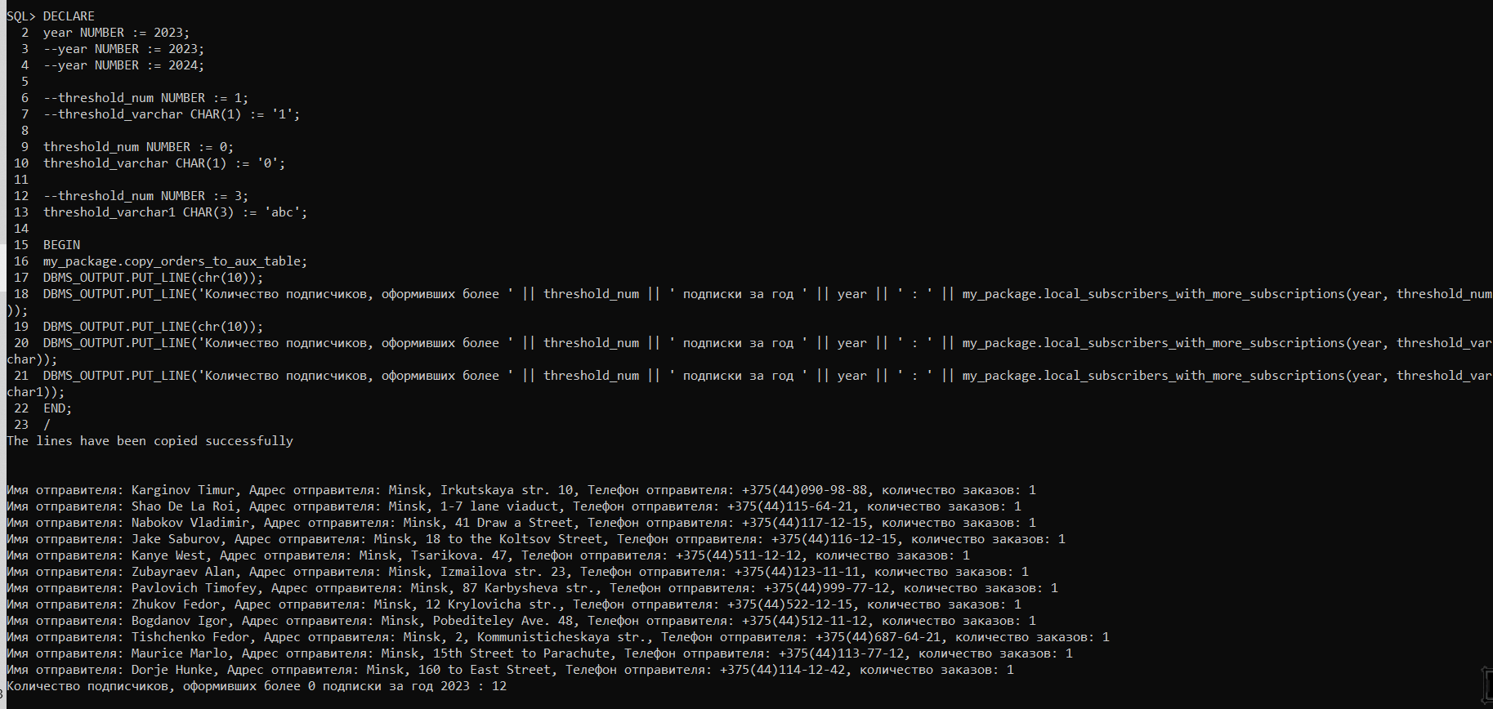 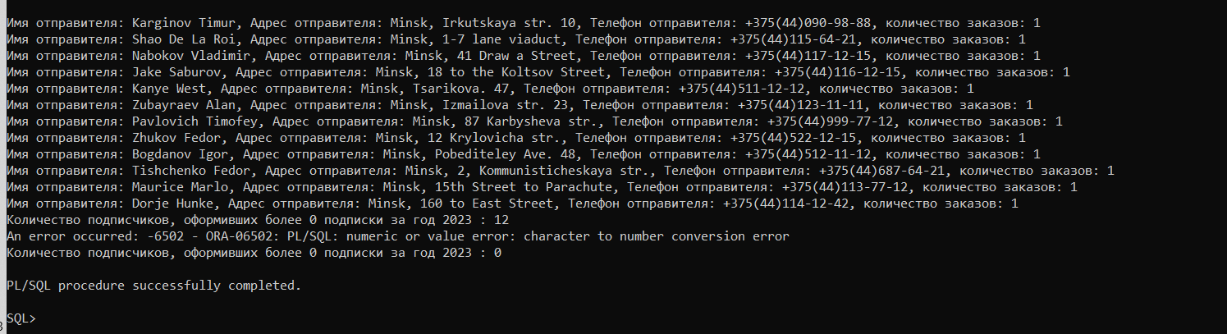

**Лабораторная работа № 5**

# Триггеры

**_Задача:**

1. Написать DML-триггер, регистрирующий изменение данных (вставку, обновление, удаление) в одной из таблиц БД. Во вспомогательную таблицу LOG1 записывать, кто, когда (дата и время) и какое именно изменение произвел, для одного из столбцов сохранять старые и новые значения.

**_Код:**

**CREATE TABLE log1 (**

**user_name VARCHAR2(255),**

**change_type VARCHAR2(255),**

**change_date TIMESTAMP,**

**change_column VARCHAR2(255),**

**old_value VARCHAR2(255),**

**new_value VARCHAR2(255)**

**);**

**CREATE OR REPLACE TRIGGER log_orders_changes**

**AFTER INSERT OR UPDATE OR DELETE ON orders**

**FOR EACH ROW**

**DECLARE**

**username VARCHAR2(255);**

**current_timestamp TIMESTAMP;**

**defined_column CHAR(15);**

**changetype VARCHAR2(255);**

**BEGIN**

**-- Получаем имя пользователя, который произвел изменение**

**SELECT user INTO username**

**FROM dual**

**WHERE user = USER;**

**-- Получаем дату и время изменения**

**SELECT sysdate INTO current_timestamp**

**from dual;**

**-- Определяем тип изменения**

**IF INSERTING THEN**

**changetype := 'INSERT';**

**ELSIF UPDATING THEN**

**changetype := 'UPDATE';**

**ELSE**

**changetype := 'DELETE';**

**END IF;**

**-- Определяем столбец, для которого нужно сохранить старые и новые значения**

**defined_column := 'ORD_sender_name';**

**-- Сохраняем данные в вспомогательную таблицу**

**INSERT INTO log1 (**

**user_name,**

**change_type,**

**change_date,**

**change_column,**

**old_value,**

**new_value**

**) VALUES (**

**username,**

**changetype,**

**current_timestamp,**

**defined_column,**

**:OLD.ORD_sender_name,**

**:NEW.ORD_sender_name**

**);**

**END;**

**/**

**_Результат:**

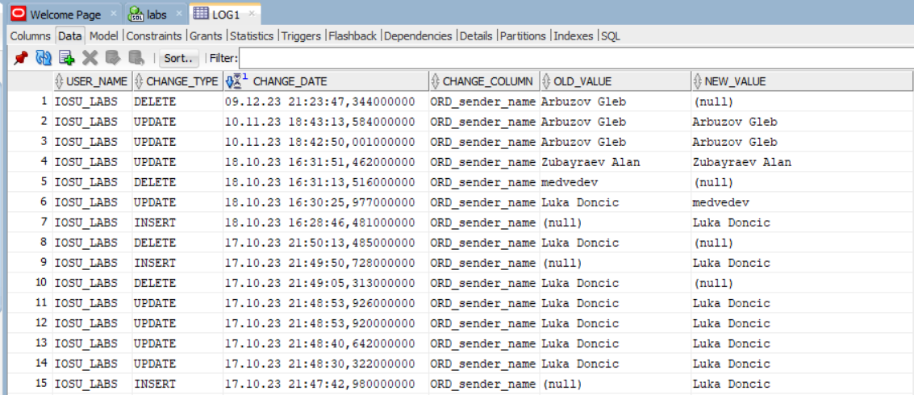

**_Задача:**

1. Написать DDL-триггер, протоколирующий действия пользователей по созданию, изменению и удалению таблиц в схеме во вспомогательную таблицу LOG2 в определенное время и запрещающий эти действия в другое время.

**_Код:**

**GRANT CREATE TRIGGER, ALTER TRIGGER TO iosu_labs;**

**-- CREATE TABLE log2 (**

**-- id_log2 number GENERATED BY DEFAULT AS IDENTITY (START WITH 1 INCREMENT BY 1 NOCACHE),**

**-- username VARCHAR2(255),**

**-- action VARCHAR2(255),**

**-- change_date TIMESTAMP,**

**-- table_name VARCHAR2(255),**

**-- statements varchar2(1000),**

**-- primary key(id_log2)**

**-- );**

**CREATE TABLE log2 (**

**id_log2 number GENERATED BY DEFAULT AS IDENTITY (START WITH 1 INCREMENT BY 1 NOCACHE),**

**username VARCHAR2(255),**

**action VARCHAR2(255),**

**change_date TIMESTAMP,**

**table_name VARCHAR2(255),**

**primary key(id_log2)**

**);**

**CREATE OR REPLACE TRIGGER log_ddl_actions**

**BEFORE CREATE OR ALTER OR DROP ON SCHEMA**

**DECLARE**

**user_name VARCHAR2(255);**

**current_timestamp TIMESTAMP;**

**allowed_hours NUMBER;**

**tble_name VARCHAR2(255);**

**act VARCHAR2(255);**

**-- sql_text ora_name_list_t;**

**-- v_stmt VARCHAR2(2000);**

**-- n PLS_INTEGER;**

**-- correct_time exception;**

**-- PRAGMA EXCEPTION_INIT (correct_time, -20000);**

**BEGIN**

**-- n := ora_sql_txt(sql_text);**

**-- FOR i IN 1 .. n LOOP**

**-- v_stmt := v_stmt || sql_text(i);**

**-- END LOOP;**

**-- v_stmt :=regexp_replace(v_stmt,**

**-- 'rename[[:space:]]+.*[[:space:]]+to[[:space:]]+([a-z0-9_]+)',**

**-- '\1',**

**-- 1,**

**-- 1,**

**-- 'i');**

**-- Получаем имя пользователя, который произвел изменение**

**SELECT USER**

**INTO user_name**

**FROM dual;**

**SELECT CURRENT_TIMESTAMP INTO current_timestamp**

**from dual;**

**SELECT ORA_SYSEVENT INTO act FROM dual;**

**-- Получаем имя изменяемой таблицы**

**SELECT ORA_DICT_OBJ_NAME INTO tble_name FROM dual;**

**-- Проверяем, находится ли текущее время в разрешенном интервале**

**SELECT TO_NUMBER(TO_CHAR(SYSDATE, 'HH24')) INTO allowed_hours FROM dual;**

**IF allowed_hours NOT BETWEEN 8 AND 22 THEN**

**RAISE_APPLICATION_ERROR(-20000, 'DDL is not permitted during this time');**

**END IF;**

**-- Регистрируем действие в вспомогательной таблице**

**INSERT INTO log2 (**

**username,**

**action,**

**change_date,**

**table_name**

**) VALUES (**

**user_name,**

**act,**

**current_timestamp,**

**tble_name**

**);**

**-- EXCEPTION**

**-- -- Обработка ошибки -20001**

**-- WHEN correct_time THEN**

**-- DBMS_OUTPUT.PUT_LINE('Операция DDL запрещена в нерабочее время.');**

**-- DBMS_OUTPUT.PUT_LINE('Пользователь: ' || user_name);**

**-- DBMS_OUTPUT.PUT_LINE('Время: ' || current_timestamp);**

**-- DBMS_OUTPUT.PUT_LINE('Таблица: ' || tble_name);**

**-- DBMS_OUTPUT.PUT_LINE('Тип действия: ' || act);**

**END;**

**/**

**_Результат:**

**CREATE TABLE log4 (**

**username VARCHAR2(255),**

**action VARCHAR2(255),**

**change_date TIMESTAMP,**

**table_name VARCHAR2(255)**

**);**

**ALTER TABLE LOG4**

**ADD new_column varchar2(255);**

**DROP TABLE LOG4;**

**-- DROP TABLE your_table PURGE;**

**-- SHOW RECYCLEBIN**

**alter trigger log_ddl_actions disable;**

**alter trigger log_ddl_actions enable;**

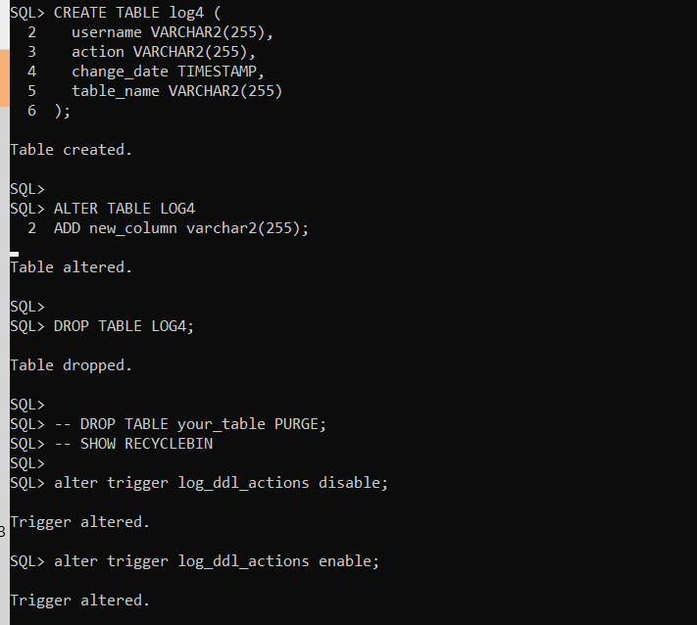 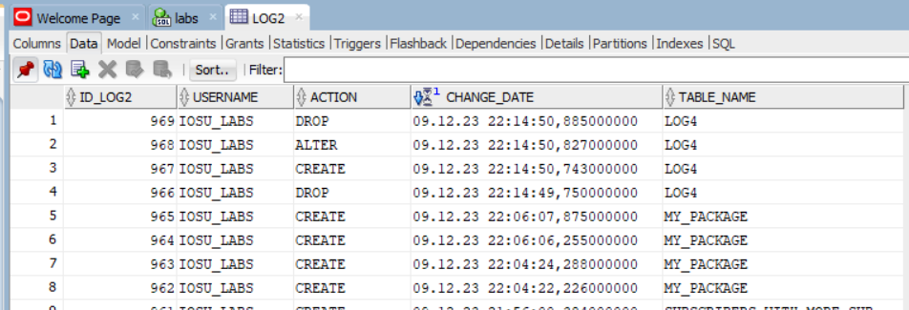

**_Задача:**

1. Написать системный триггер, добавляющий запись во вспомогательную таблицу LOG3, когда пользователь подключается или отключается. В таблицу логов записывается имя пользователя (USER), тип активности (LOGON или LOGOFF), дата (SYSDATE), количество записей в основной таблице БД.

**_Код:**

**CREATE TABLE log3 (**

**id_log3 number GENERATED BY DEFAULT AS IDENTITY (START WITH 1 INCREMENT BY 1 NOCACHE),**

**usr_name VARCHAR2(30),**

**activity VARCHAR2(10),**

**cur_date TIMESTAMP,**

**records_count NUMBER**

**);**

**CREATE OR REPLACE TRIGGER LOG_USER_LOGON**

**AFTER LOGON ON DATABASE**

**DECLARE**

**username VARCHAR2(30);**

**activity VARCHAR2(10);**

**currentdate TIMESTAMP;**

**records_count NUMBER;**

**BEGIN**

**-- Получаем имя пользователя**

**username := USER;**

**-- Определяем тип активности**

**activity := 'LOGON';**

**-- Получаем текущую дату**

**SELECT CURRENT_TIMESTAMP INTO currentdate**

**from dual;**

**-- Получаем количество записей в основной таблице**

**SELECT COUNT(*) INTO records_count**

**FROM orders;**

**-- Регистрируем событие в вспомогательной таблице**

**INSERT INTO log3 (usr_name, activity, cur_date, records_count)**

**VALUES (username, activity, currentdate, records_count);**

**END;**

**/**

**-- Триггер отключения клиента**

**CREATE OR REPLACE TRIGGER LOG_USER_LOGOFF**

**BEFORE LOGOFF ON DATABASE**

**DECLARE**

**username VARCHAR2(30);**

**activity VARCHAR2(10);**

**currentdate TIMESTAMP;**

**records_count NUMBER;**

**BEGIN**

**-- Получаем имя пользователя**

**username := USER;**

**-- Определяем тип активности**

**activity := 'LOGOFF';**

**-- Получаем текущую дату**

**SELECT CURRENT_TIMESTAMP INTO currentdate**

**from dual;**

**-- Получаем количество записей в основной таблице**

**SELECT COUNT(*) INTO records_count**

**FROM orders;**

**-- Регистрируем событие в вспомогательной таблице**

**INSERT INTO log3 (usr_name, activity, cur_date, records_count)**

**VALUES (username, activity, currentdate, records_count);**

**END;**

**/**

**_Результат:**

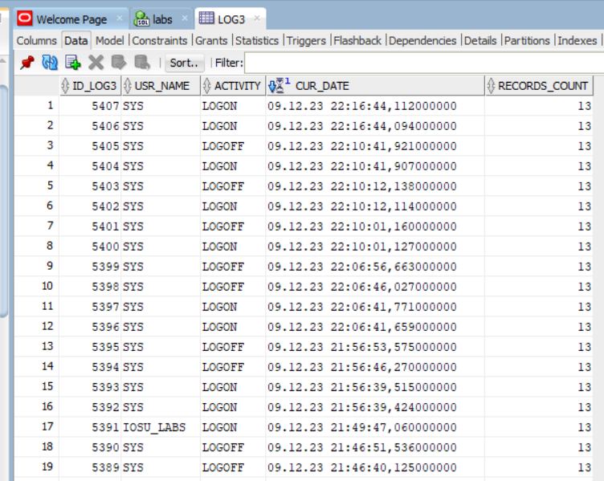

**_Задача:**

1. Написать триггеры, реализующие бизнес-логику (ограничения) в заданной вариантом предметной области. Три задания приведены в прил. 6. Количество и тип триггеров (строковый или операторный, выполняется AFTER или BEFORE) определять самостоятельно исходя из сути заданий и имеющейся схемы БД; учесть, что в некоторых вариантах первые два задания могут быть выполнены в рамках одного триггера, а также возможно возникновение мутации, что приведет к совмещению данного пункта лабораторной работы со следующим. Третий пункт задания предполагает использование планировщика задач, который обязательно должен быть настроен на многократный запуск с использованием частоты, интервала и спецификаторов.

____TASK____:

1+2. Расчет стоимости заказа исходя из переданных параметров заказа

+ скидка, если большой вес посылки

{

№1.осуществлять расчет стоимости заказа:

а)каждый килограмм = 1 руб, изначально (ограничение по весу от 0.1 до 700 кг

alter table orders

add constraint orders_package_weight

check (ORD_PACKAGE_WEIGHT < 700 and ORD_PACKAGE_WEIGHT > 0.1);

б)каждая тысячная метра кубического объема 0.001 = 0.5 руб

alter table orders

add constraint orders_package_scope

check (ORD_package_scope < 10 and ORD_package_scope > 0.001);

в)объявленная стоимость:

alter table orders

add constraint orders_package_declared_value

check (ORD_declared_value_amount < 10000 and ORD_declared_value_amount > 5);

> 100 рублей, то общая стоимость доставки увеличивается на 5% от объявленной стоимости

> 1000 рублей, то общая стоимость доставки увеличивается на 10% от объявленной стоимости

г)наложенный платеж: -

д)хрупкое:

если да, то + 10% от объявленной стоимости

если нет, то -

е)проверка получателем товара:

если да, то + 1 процент от объявленной стоимости

если нет, то -

ж)тип доставки:

если курьер, то + 5% от объявленной стоимости

если грузовик, то + 1% от объявленной стоимости

з)тип оплаты:

если безнал, то - 1% от объявленной стоимости

если нал, то -

ALTER TABLE orders

MODIFY ORD_declared_value_amount not NULL;

ALTER TABLE orders

MODIFY ORD_shipping_cost NULL;

alter table Orders

modify ORD_shipping_cost DECIMAL(30,2);

ALTER TRIGGER CALCULATE_SHIPPING_COST enable;

№2.при отправке товаров весом более 100 кг, дополнительные 5 килограмм можно отправить

бесплатно. То есть, если вес груза больше 100 килограмм, то мы делим стоимость доставки на

вес груза и умножаем это число на (масса груза – 5 киллограм).

если масса груза > 100 и < 200 кило, то бесплатно 5 кг

если масса груза > 200 и < 300 кило, то бесплатно 15 кг

если масса груза > 300 и < 400 кило, то бесплатно 25 кг

если масса груза > 500 и < 600 кило, то бесплатно 35 кг

если масса груза > 600 и < 700 кило, то бесплатно 45 кг

если груз больше 700 кило, то мы не принимаем такой заказ - ввести ограничение в таблицу.

}

**_Код:**

**---------------------------------------------------**

**---------------------------------------------------**

**-----ТРИГГЕР НА ФОРМИРОВАНИЕ СТОИМОСТИ ЗАКАЗА------**

**---------------------------------------------------**

**---------------------------------------------------**

**CREATE OR REPLACE TRIGGER CALCULATE_SHIPPING_COST**

**BEFORE INSERT OR UPDATE ON Orders**

**FOR EACH ROW**

**DECLARE**

**shipping_cost DECIMAL(30,2) default 0.0;**

**courier_code INTEGER;**

**truck_code INTEGER;**

**birth_day number;**

**birth_month number;**

**today_day number;**

**today_month number;**

**BEGIN**

**--------------------------**

**-- РАСЧЕТ СТОИМОСТИ ЗАКАЗА**

**--------------------------**

**-- а)каждый килограмм = 0.5 руб, изначально (ограничение по весу от 0.1 до 700 кг**

**shipping_cost := shipping_cost + :new.ORD_package_weight*0.5;**

**-- б)каждая тысячная метра кубического объема 0.001 = 0.1 руб**

**shipping_cost := shipping_cost + :new.ORD_package_scope*100;**

**-- в)объявленная стоимость:**

**if :new.ORD_declared_value_amount >= 100 and :new.ORD_declared_value_amount < 1000 then**

**shipping_cost := shipping_cost + :new.ORD_declared_value_amount*0.1;**

**elsif :new.ORD_declared_value_amount >= 1000 then**

**shipping_cost := shipping_cost + :new.ORD_declared_value_amount*0.2;**

**end if;**

**-- г)наложенный платеж: -**

**-- д)хрупкое:**

**-- если да, то + 10% от объявленной стоимости**

**-- если нет, то -**

**if :new.ORD_fragile = 'Yes' then**

**shipping_cost := shipping_cost + :new.ORD_declared_value_amount*0.1;**

**end if;**

**-- е)проверка получателем товара:**

**-- если да, то + 1 процент от объявленной стоимости**

**-- если нет, то -**

**if :new.ORD_completeness_check = 'Yes' then**

**shipping_cost := shipping_cost + :new.ORD_declared_value_amount*0.1;**

**end if;**

**-- ж)тип доставки:**

**-- если курьер, то + 5% от объявленной стоимости**

**-- если грузовик, то + 1% от объявленной стоимости**

**select DLV_code into courier_code**

**from Delivery_type where DLV_delivery_method = 'Courier';**

**select DLV_code into truck_code**

**from Delivery_type where DLV_delivery_method = 'Truck';**

**if :new.ORD_deliv_type_code = courier_code then**

**shipping_cost := shipping_cost + :new.ORD_declared_value_amount*0.1;**

**elsif :new.ORD_deliv_type_code = truck_code then**

**shipping_cost := shipping_cost + :new.ORD_declared_value_amount*0.05;**

**end if;**

**-- з)тип оплаты:**

**-- если безнал, то - 1% от объявленной стоимости**

**-- если нал, то -**

**if :new.ORD_cash_payment = 'No' then**

**shipping_cost := shipping_cost - :new.ORD_declared_value_amount*0.01;**

**end if;**

**--------------------------**

**-- СКИДКА ЗА ВЕС**

**--------------------------**

**IF :new.ORD_PACKAGE_WEIGHT > 99 and :new.ORD_PACKAGE_WEIGHT < 200 then**

**shipping_cost := shipping_cost/:new.ORD_PACKAGE_WEIGHT * (:new.ORD_PACKAGE_WEIGHT - 5);**

**elsif :new.ORD_PACKAGE_WEIGHT >= 200 and :new.ORD_PACKAGE_WEIGHT < 300 then**

**shipping_cost := shipping_cost/:new.ORD_PACKAGE_WEIGHT * (:new.ORD_PACKAGE_WEIGHT - 15);**

**elsif :new.ORD_PACKAGE_WEIGHT >= 300 and :new.ORD_PACKAGE_WEIGHT < 400 then**

**shipping_cost := shipping_cost/:new.ORD_PACKAGE_WEIGHT * (:new.ORD_PACKAGE_WEIGHT - 25);**

**elsif :new.ORD_PACKAGE_WEIGHT >= 400 and :new.ORD_PACKAGE_WEIGHT < 500 then**

**shipping_cost := shipping_cost/:new.ORD_PACKAGE_WEIGHT * (:new.ORD_PACKAGE_WEIGHT - 35);**

**elsif :new.ORD_PACKAGE_WEIGHT >= 500 and :new.ORD_PACKAGE_WEIGHT < 600 then**

**shipping_cost := shipping_cost/:new.ORD_PACKAGE_WEIGHT * (:new.ORD_PACKAGE_WEIGHT - 45);**

**elsif :new.ORD_PACKAGE_WEIGHT >= 600 and :new.ORD_PACKAGE_WEIGHT < 700 then**

**shipping_cost := shipping_cost/:new.ORD_PACKAGE_WEIGHT * (:new.ORD_PACKAGE_WEIGHT - 50);**

**end if;**

**select EXTRACT(DAY FROM :new.ord_sender_birth_day) into birth_day from dual;**

**select EXTRACT(MONTH FROM :new.ord_sender_birth_day) into birth_month from dual;**

**select EXTRACT(DAY FROM sysdate) into today_day from dual;**

**select EXTRACT(MONTH FROM sysdate) into today_month from dual;**

**--------------------------**

**-- ПРОВЕРКА НА ДЕНЬ РОЖДЕНИЯ**

**--------------------------**

**if birth_day = today_day and birth_month = today_month then**

**shipping_cost := shipping_cost * 0.8;**

**END IF;**

**--------------------------**

**-- Устанавливаем стоимость доставки**

**:new.ORD_shipping_cost := shipping_cost;**

**dbms_output.put_line('BIRTH: ' || :new.ord_sender_birth_day);**

**dbms_output.put_line('cost: ' || :new.ORD_shipping_cost);**

**dbms_output.put_line('CELEBRATE');**

**END;**

**/**

**_Результат:**

**Before:**

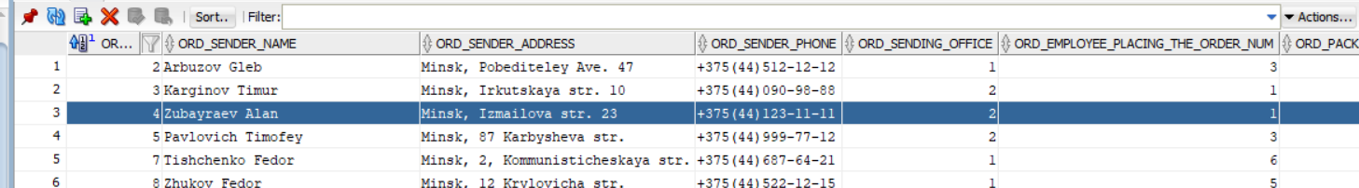 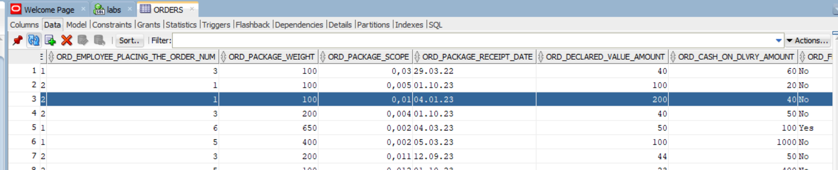 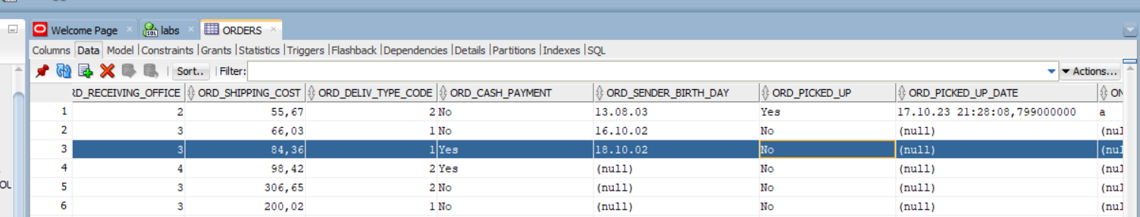

**After:**

**UPDATE orders**

**SET ORD_declared_value_amount = 300**

**WHERE order_num = 4;**

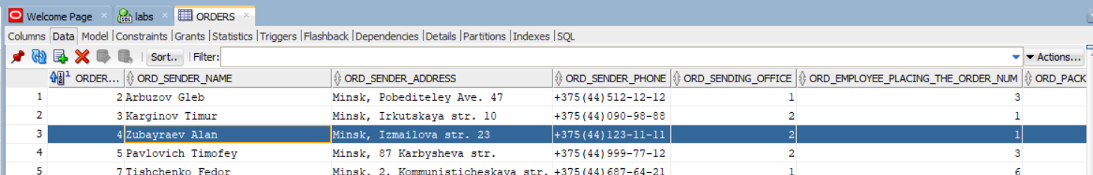 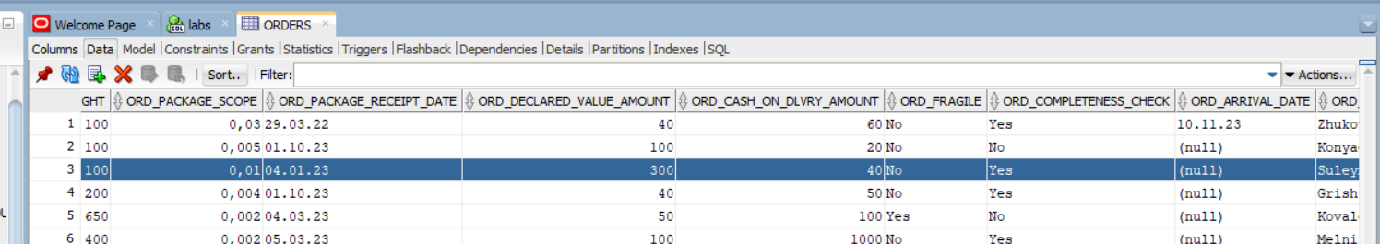 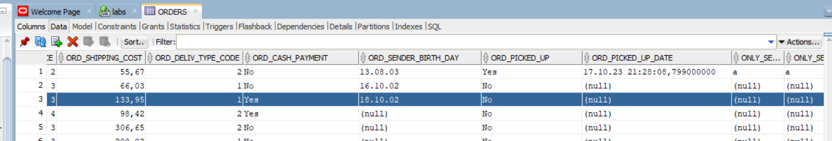 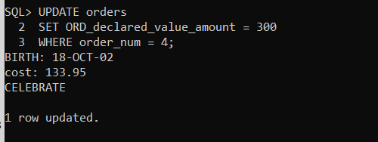

**_Задача:**

1. Самостоятельно или при помощи преподавателя составить задание на триггер, который будет вызывать мутацию таблиц, и решить эту проблему одним из двух способов (при помощи переменных пакета и двух триггеров или при помощи COMPAUND-триггера).

ЕСЛИ ПОСЫЛКУ ЗАБРАЛИ, ТО МЕНЯЕТСЯ ЗНАЧЕНИЕ КОЛОНКИ ord_picked_up ТОГДА ДОЛЖНА ОБНОВЛЯТЬСЯ КОЛОНКА С ДАТОЙ, КОГДА ЗАКАЗ ЗАБРАЛИ. РАБОТНИК НАЖИМАЕТ - "ЗАКАЗ ЗАБРАН", А В БАЗЕ СОХРАНЯЕТСЯ ДЕНЬ И ВРЕМЯ, КОГДА ЗАКАЗ БЫЛ ЗАБРАН

**_Код:**

**CREATE OR REPLACE PACKAGE pkg_around_mutation AS**

**pUpdPickUpState boolean default false;**

**order_number orders.Order_num%type;**

**procedure update_picked_up_state;**

**END;**

**/**

**create or replace package body pkg_around_mutation**

**is**

**procedure update_picked_up_state**

**is**

**begin**

**if pUpdPickUpState then**

**pUpdPickUpState := false;**

**update orders**

**set ord_picked_up_date = current_timestamp**

**where order_num = pkg_around_mutation.order_number;**

**end if;**

**end update_picked_up_state;**

**end pkg_around_mutation;**

**/**

**create or replace trigger trg1**

**before INSERT OR UPDATE of ord_picked_up**

**on orders**

**for each row**

**begin**

**if(:new.ord_picked_up = 'Yes') then**

**pkg_around_mutation.order_number := :new.Order_num;**

**pkg_around_mutation.pUpdPickUpState := true;**

**end if;**

**end trg1;**

**/**

**create or replace trigger trg2**

**after insert or update of ord_picked_up**

**on orders**

**begin**

**pkg_around_mutation.update_picked_up_state;**

**end trg2;**

**/**

**_Результат:**

**update orders**

**set ord_picked_up = 'Yes'**

**where order_num = 2;**

**before:**

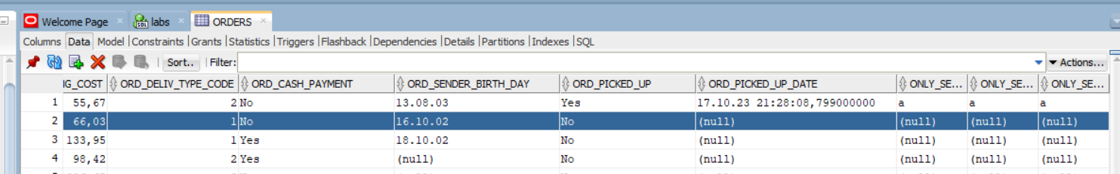

**after:**

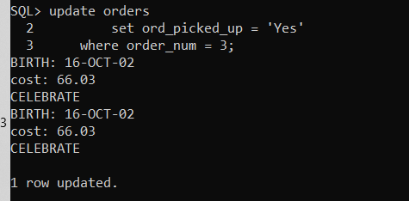

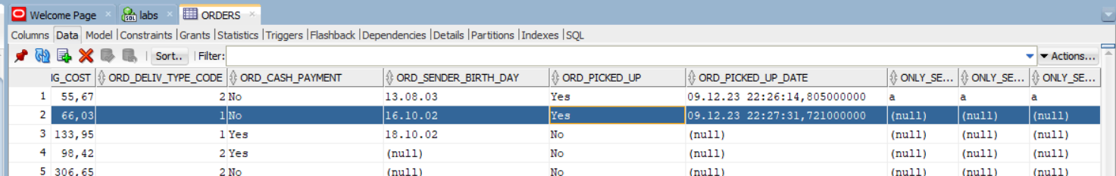

**_Задача:**

1. Планировщик задач, который обязательно должен быть настроен на многократный запуск с использованием частоты, интервала и спецификаторов. Раз в месяц копировать строки с заказами, которые забрали(галочка столбца с мутацией). Планировщика задач, который будет раз в месяц копировать строки с заказами, которые забрали и должен быть настроен на многократный запуск с использованием частоты, интервала и спецификаторов.

**_Код:**

**CREATE TABLE order_archive(**

**order_archive_id INTEGER generated by default as identity(nocache),**

**Order_num INTEGER,**

**ORD_sender_name VARCHAR2(40) NOT NULL,**

**ORD_sender_address VARCHAR2(50) NOT NULL,**

**ORD_sender_phone CHAR(17) NOT NULL,**

**ORD_sending_office INTEGER NOT NULL,**

**ORD_employee_placing_the_order_num INTEGER NOT NULL,**

**ORD_package_weight DECIMAL(20,3) NOT NULL,**

**ORD_package_scope DECIMAL(20,3) NOT NULL,**

**ORD_package_receipt_date DATE NOT NULL,**

**ORD_declared_value_amount DECIMAL(30,3),**

**ORD_cash_on_dlvry_amount DECIMAL(30,3),**

**ORD_fragile VARCHAR2(3) NOT NULL,**

**ORD_completeness_check VARCHAR2(3) NOT NULL,**

**ORD_arrival_date DATE,**

**ORD_recipient_name VARCHAR2(40) NOT NULL,**

**ORD_recipient_address VARCHAR2(50) NOT NULL,**

**ORD_recipient_phone CHAR(17) NOT NULL,**

**ORD_receiving_office INTEGER NOT NULL,**

**ORD_shipping_cost DECIMAL(30,3) NOT NULL,**

**ORD_deliv_type_code INTEGER NOT NULL,**

**ORD_cash_payment VARCHAR2(3) NOT NULL,**

**ord_sender_birth_day DATE,**

**ord_picked_up_date TIMESTAMP,**

**ord_picked_up VARCHAR2(3),**

**ONLY_SENDER_NAME VARCHAR2(50),**

**ONLY_SENDER_SURNAME VARCHAR2(50),**

**ONLY_SENDER_PATRONYMIC VARCHAR2(50),**

**PRIMARY KEY(order_archive_id));**

**CREATE OR REPLACE PROCEDURE copy_orders**

**AS**

**today_month number;**

**prev_month number;**

**BEGIN**

**select EXTRACT(MONTH FROM sysdate) into today_month from dual;**

**if today_month = 1 then**

**prev_month := 12;**

**else**

**prev_month := today_month - 1;**

**end if;**

**-- Копируем строки с заказами, которые забрали**

**INSERT INTO order_archive(Order_num,ORD_sender_name,**

**ORD_sender_address, ORD_sender_phone, ORD_sending_office,**

**ORD_employee_placing_the_order_num, ORD_package_weight,**

**ORD_package_scope, ORD_package_receipt_date,**

**ORD_declared_value_amount, ORD_cash_on_dlvry_amount,**

**ORD_fragile, ORD_completeness_check, ORD_arrival_date,**

**ORD_recipient_name, ORD_recipient_address, ORD_recipient_phone,**

**ORD_receiving_office, ORD_shipping_cost, ORD_deliv_type_code,**

**ORD_cash_payment, ord_sender_birth_day, ord_picked_up_date, ord_picked_up, ONLY_SENDER_NAME, ONLY_SENDER_SURNAME, ONLY_SENDER_PATRONYMIC)**

**SELECT Order_num,ORD_sender_name,**

**ORD_sender_address, ORD_sender_phone, ORD_sending_office,**

**ORD_employee_placing_the_order_num, ORD_package_weight,**

**ORD_package_scope, ORD_package_receipt_date,**

**ORD_declared_value_amount, ORD_cash_on_dlvry_amount,**

**ORD_fragile, ORD_completeness_check, ORD_arrival_date,**

**ORD_recipient_name, ORD_recipient_address, ORD_recipient_phone,**

**ORD_receiving_office, ORD_shipping_cost, ORD_deliv_type_code,**

**ORD_cash_payment, ord_sender_birth_day, ord_picked_up_date, ord_picked_up, ONLY_SENDER_NAME, ONLY_SENDER_SURNAME, ONLY_SENDER_PATRONYMIC**

**FROM orders**

**WHERE orders.ord_picked_up = 'Yes' and EXTRACT(MONTH FROM orders.ord_picked_up_date) = prev_month;**

**END;**

**/**

**_Результат:**

**BEGIN**

**DBMS_SCHEDULER.CREATE_JOB**

**( job_name => 'job_copy_orders',**

**job_type => 'STORED_PROCEDURE',**

**job_action => 'copy_orders',**

**repeat_interval => 'FREQ=MINUTELY;INTERVAL=1',**

**start_date => SYSTIMESTAMP,**

**end_date => NULL,**

**enabled => TRUE);**

**DBMS_SCHEDULER.ENABLE ('job_copy_orders');**

**END;**

**/** 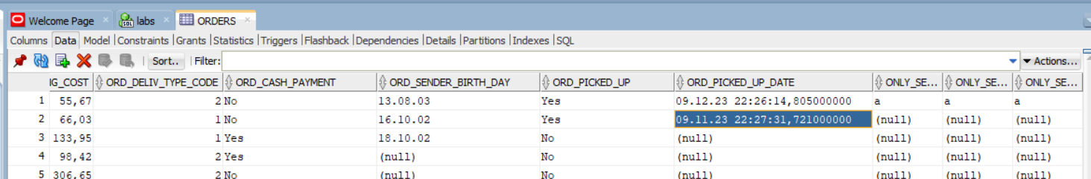

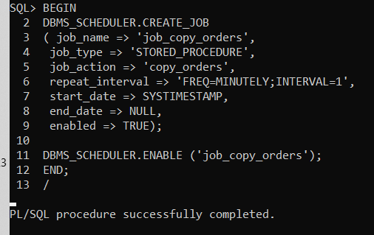

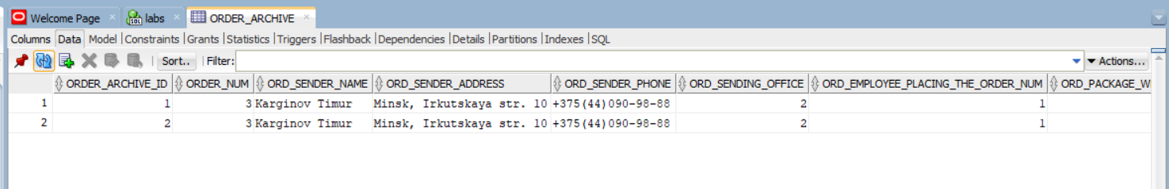

**BEGIN**

**dbms_scheduler.drop_job('job_copy_orders');**

**END;**

**/**

**BEGIN**

**DBMS_SCHEDULER.CREATE_JOB**

**( job_name => 'job_copy_orders',**

**job_type => 'STORED_PROCEDURE',**

**job_action => 'copy_orders',**

**repeat_interval => 'FREQ=MONTHLY;BYMONTHDAY=1',**

**start_date => SYSTIMESTAMP,**

**end_date => NULL,**

**enabled => TRUE);**

**DBMS_SCHEDULER.ENABLE ('job_copy_orders');**

**END;**

**/**

**_Задача:**

1. Написать триггер INSTEAD OF для работы с не обновляемым представлением, созданным после выполнения п. 2.4 задания к лабораторной работе №3, проверить DML-командами возможность обновления представления после включения триггера (логика работы триггера определяется спецификой предметной области варианта).

**_Код:**

**create or replace view view2_third AS**

**select distinct**

**orders.order_num as order_number,**

**orders.ORD_sender_name as order_sender_name,**

**orders.ORD_sender_address as order_sender_address,**

**orders.ORD_sender_phone as order_sender_phone,**

**orders.ORD_sending_office as order_sending_office,**

**orders.ORD_employee_placing_the_order_num as order_employe_placing_order,**

**orders.ORD_package_weight as order_package_weight,**

**orders.ORD_package_scope as order_package_scope,**

**orders.ORD_package_receipt_date as order_package_receipt_date,**

**orders.ORD_declared_value_amount as order_declared_value_amount,**

**orders.ORD_fragile as order_fragile,**

**orders.ORD_COMPLETENESS_CHECK as order_completeness,**

**orders.ORD_recipient_name as order_recipient_name,**

**orders.ORD_recipient_address as order_recipient_address,**

**orders.ORD_recipient_phone as order_recipient_phone,**

**orders.ORD_receiving_office as order_receiving_office,**

**orders.ORD_shipping_cost as order_shipping_cost,**

**orders.ORD_deliv_type_code as order_deliv_type_code,**

**orders.ORD_cash_payment as order_cash_payment,**

**orders.ORD_SENDER_BIRTH_DAY as order_sender_birth_date,**

**orders.ord_picked_up_date as order_picked_up_date,**

**orders.ord_picked_up as order_picked_up,**

**delivery_type.dlv_delivery_method as delivery_method,**

**branch.branch_num as branch_number,**

**branch.BR_address as branch_sending_office_address,**

**branch.BR_max_storage_capacity as branch_max_storage_capacity,**

**branch.BR_principal_employee_name as branch_princip_employee_name,**

**branch.BR_principal_employee_phone as branch_princip_employee_phone,**

**branch.BR_employee_num as branch_employee_num,**

**branch.BR_ceo_director as branch_ceo,**

**staff.stf_name as staff_name,**

**staff.STF_birth_date as staff_birth_date,**

**staff.STF_address as staff_address,**

**staff.STF_position_code as staff_pos_code,**

**staff.STF_email as staff_email,**

**staff.STF_passport_details as staff_passport_data,**

**staff.STF_branch_num as staff_branch_num,**

**staff.STF_phone_num as staff_phone_num**

**from orders**

**left join branch on orders.ORD_sending_office = branch.branch_num**

**left join delivery_type on orders.ORD_deliv_type_code = delivery_type.DLV_code**

**left join staff on orders.ORD_employee_placing_the_order_num = staff.Staff_num**

**where to_char(orders.ORD_package_receipt_date, 'MM') = '03';**

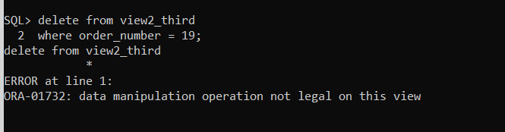 **delete from view2_third**

**where order_number = 19;**

**CREATE OR REPLACE TRIGGER order_info_insert**

**INSTEAD OF UPDATE OR INSERT OR DELETE ON view2_third**

**for each row**

**DECLARE**

**duplicate_info EXCEPTION;**

**PRAGMA EXCEPTION_INIT (duplicate_info, -00001);**

**uncorrect_date EXCEPTION;**

**PRAGMA EXCEPTION_INIT (uncorrect_date, -00002);**

**invalid_order_num EXCEPTION;**

**PRAGMA EXCEPTION_INIT (invalid_order_num, -00003);**

**t_branch_number integer;**

**t_delivery_method integer;**

**t_employee_number integer;**

**t_order_number integer;**

**t_temp_recieve_month char(2);**

**t_temp_recieve_date date;**

**BEGIN**

**CASE**

**WHEN INSERTING then**

**if to_char(:new.order_package_receipt_date, 'MM') != '03' then**

**RAISE uncorrect_date;**

**end if;**

**insert into Delivery_type(DLV_delivery_method)**

**values (:new.delivery_method);**

**select DLV_code into t_delivery_method from delivery_type where DLV_delivery_method = :new.delivery_method;**

**insert into branch(BR_max_storage_capacity,BR_principal_employee_name,**

**BR_principal_employee_phone,BR_address,BR_employee_num, BR_ceo_director)**

**values (:new.branch_max_storage_capacity, :new.staff_name, :new.staff_phone_num,**

**:new.branch_sending_office_address, :new.branch_employee_num, :new.branch_ceo);**

**select Branch_num into t_branch_number from Branch where BR_principal_employee_name = :new.staff_name;**

**--нужен номер отделения, чтобы сотруднику его определить**

**-- создаю работника, который будет главным в отделении и примет заказ**

**insert into staff(stf_name, STF_birth_date, STF_address,**

**stf_position_code,STF_email,STF_passport_details,**

**STF_branch_num,STF_phone_num) values (:new.staff_name,**

**:new.staff_birth_date, :new.staff_address, :new.staff_pos_code,**

**:new.staff_email, :new.staff_passport_data, t_branch_number,**

**:new.staff_phone_num);**

**select staff_num into t_employee_number from staff where stf_name = :new.staff_name;**

**insert into Orders(ORD_sender_name,ORD_sender_address,**

**ORD_sender_phone,ORD_sending_office,ORD_employee_placing_the_order_num,**

**ORD_package_weight,ORD_package_scope,ORD_package_receipt_date,**

**ORD_declared_value_amount,ORD_fragile,ORD_completeness_check,ORD_recipient_name,**

**ORD_recipient_address,ORD_recipient_phone,ORD_receiving_office,**

**ORD_deliv_type_code,ORD_cash_payment,ORD_SENDER_BIRTH_DAY)**

**values(:new.order_sender_name, :new.order_sender_address,**

**:new.order_sender_phone, t_branch_number, t_employee_number,**

**:new.order_package_weight, :new.order_package_scope,**

**:new.order_package_receipt_date, :new.order_declared_value_amount,**

**:new.order_fragile, :new.order_completeness, :new.order_recipient_name,**

**:new.order_recipient_address, :new.order_recipient_phone,**

**:new.order_receiving_office, t_delivery_method, :new.order_cash_payment,**

**:new.order_sender_birth_date);**

**when DELETING then**

**select to_char(ORD_package_receipt_date, 'MM') into t_temp_recieve_month**

**from orders where order_num = :old.order_number;**

**if t_temp_recieve_month != '03' then**

**RAISE uncorrect_date;**

**end if;**

**DELETE FROM ORDERS WHERE Order_num = :old.order_number;**

**when updating('order_sender_name') then**

**select to_char(ORD_package_receipt_date, 'MM') into t_temp_recieve_month**

**from orders where order_num = :new.order_number;**

**if t_temp_recieve_month != '03' then**

**RAISE uncorrect_date;**

**end if;**

**update orders**

**set ORD_sender_name = :new.order_sender_name**

**where order_num = :new.order_number;**

**when updating('order_sender_address') then**

**select to_char(ORD_package_receipt_date, 'MM') into t_temp_recieve_month**

**from orders where order_num = :new.order_number;**

**if t_temp_recieve_month != '03' then**

**RAISE uncorrect_date;**

**end if;**

**update orders**

**set ORD_sender_address = :new.order_sender_address**

**where order_num = :new.order_number;**

**when updating('order_sender_phone') then**

**select to_char(ORD_package_receipt_date, 'MM') into t_temp_recieve_month**

**from orders where order_num = :new.order_number;**

**if t_temp_recieve_month != '03' then**

**RAISE uncorrect_date;**

**end if;**

**update orders**

**set ORD_sender_phone = :new.order_sender_phone**

**where order_num = :new.order_number;**

**when updating('order_sending_office') then**

**select to_char(ORD_package_receipt_date, 'MM') into t_temp_recieve_month**

**from orders where order_num = :new.order_number;**

**if t_temp_recieve_month != '03' then**

**RAISE uncorrect_date;**

**end if;**

**update orders**

**set ORD_sending_office = :new.order_sending_office**

**where order_num = :new.order_number;**

**when updating('order_employe_placing_order') then**

**select to_char(ORD_package_receipt_date, 'MM') into t_temp_recieve_month**

**from orders where order_num = :new.order_number;**

**if t_temp_recieve_month != '03' then**

**RAISE uncorrect_date;**

**end if;**

**update orders**

**set ORD_employee_placing_the_order_num = :new.order_employe_placing_order**

**where order_num = :new.order_number;**

**when updating('order_package_weight') then**

**select to_char(ORD_package_receipt_date, 'MM') into t_temp_recieve_month**

**from orders where order_num = :new.order_number;**

**if t_temp_recieve_month != '03' then**

**RAISE uncorrect_date;**

**end if;**

**update orders**

**set ORD_package_weight = :new.order_package_weight**

**where order_num = :new.order_number;**

**when updating('order_package_scope') then**

**select to_char(ORD_package_receipt_date, 'MM') into t_temp_recieve_month**

**from orders where order_num = :new.order_number;**

**if t_temp_recieve_month != '03' then**

**RAISE uncorrect_date;**

**end if;**

**update orders**

**set ORD_package_scope = :new.order_package_scope**

**where order_num = :new.order_number;**

**when updating('order_package_receipt_date') then**

**select to_char(ORD_package_receipt_date, 'MM') into t_temp_recieve_month**

**from orders where order_num = :new.order_number;**

**if t_temp_recieve_month != '03' then**

**RAISE uncorrect_date;**

**end if;**

**update orders**

**set ORD_package_receipt_date = :new.order_package_receipt_date**

**where order_num = :new.order_number;**

**when updating('order_declared_value_amount') then**

**select to_char(ORD_package_receipt_date, 'MM') into t_temp_recieve_month**

**from orders where order_num = :new.order_number;**

**if t_temp_recieve_month != '03' then**

**RAISE uncorrect_date;**

**end if;**

**update orders**

**set ORD_declared_value_amount = :new.order_declared_value_amount**

**where order_num = :new.order_number;**

**when updating('order_fragile') then**

**select to_char(ORD_package_receipt_date, 'MM') into t_temp_recieve_month**

**from orders where order_num = :new.order_number;**

**if t_temp_recieve_month != '03' then**

**RAISE uncorrect_date;**

**end if;**

**update orders**

**set ORD_fragile = :new.order_fragile**

**where order_num = :new.order_number;**

**when updating('order_completeness') then**

**select to_char(ORD_package_receipt_date, 'MM') into t_temp_recieve_month**

**from orders where order_num = :new.order_number;**

**if t_temp_recieve_month != '03' then**

**RAISE uncorrect_date;**

**end if;**

**update orders**

**set ORD_COMPLETENESS_CHECK = :new.order_completeness**

**where order_num = :new.order_number;**

**when updating('order_recipient_name') then**

**select to_char(ORD_package_receipt_date, 'MM') into t_temp_recieve_month**

**from orders where order_num = :new.order_number;**

**if t_temp_recieve_month != '03' then**

**RAISE uncorrect_date;**

**end if;**

**update orders**

**set ORD_recipient_name = :new.order_recipient_name**

**where order_num = :new.order_number;**

**when updating('order_recipient_address') then**

**select to_char(ORD_package_receipt_date, 'MM') into t_temp_recieve_month**

**from orders where order_num = :new.order_number;**

**if t_temp_recieve_month != '03' then**

**RAISE uncorrect_date;**

**end if;**

**update orders**

**set ORD_recipient_address = :new.order_recipient_address**

**where order_num = :new.order_number;**

**when updating('order_recipient_phone') then**

**select to_char(ORD_package_receipt_date, 'MM') into t_temp_recieve_month**

**from orders where order_num = :new.order_number;**

**if t_temp_recieve_month != '03' then**

**RAISE uncorrect_date;**

**end if;**

**update orders**

**set ORD_recipient_phone = :new.order_recipient_phone**

**where order_num = :new.order_number;**

**when updating('order_receiving_office') then**

**select to_char(ORD_package_receipt_date, 'MM') into t_temp_recieve_month**

**from orders where order_num = :new.order_number;**

**if t_temp_recieve_month != '03' then**

**RAISE uncorrect_date;**

**end if;**

**update orders**

**set ORD_receiving_office = :new.order_receiving_office**

**where order_num = :new.order_number;**

**when updating('order_shipping_cost') then**

**select to_char(ORD_package_receipt_date, 'MM') into t_temp_recieve_month**

**from orders where order_num = :new.order_number;**

**if t_temp_recieve_month != '03' then**

**RAISE uncorrect_date;**

**end if;**

**update orders**

**set ORD_shipping_cost = :new.order_shipping_cost**

**where order_num = :new.order_number;**

**when updating('order_deliv_type_code') then**

**select to_char(ORD_package_receipt_date, 'MM') into t_temp_recieve_month**

**from orders where order_num = :new.order_number;**

**if t_temp_recieve_month != '03' then**

**RAISE uncorrect_date;**

**end if;**

**update orders**

**set ORD_deliv_type_code = :new.order_deliv_type_code**

**where order_num = :new.order_number;**

**when updating('order_cash_payment') then**

**select to_char(ORD_package_receipt_date, 'MM') into t_temp_recieve_month**

**from orders where order_num = :new.order_number;**

**if t_temp_recieve_month != '03' then**

**RAISE uncorrect_date;**

**end if;**

**update orders**

**set ORD_cash_payment = :new.order_cash_payment**

**where order_num = :new.order_number;**

**when updating('order_sender_birth_date') then**

**select to_char(ORD_package_receipt_date, 'MM') into t_temp_recieve_month**

**from orders where order_num = :new.order_number;**

**if t_temp_recieve_month != '03' then**

**RAISE uncorrect_date;**

**end if;**

**update orders**

**set ORD_SENDER_BIRTH_DAY = :new.order_sender_birth_date**

**where order_num = :new.order_number;**

**when updating('order_picked_up_date') then**

**select to_char(ORD_package_receipt_date, 'MM') into t_temp_recieve_month**

**from orders where order_num = :new.order_number;**

**if t_temp_recieve_month != '03' then**

**RAISE uncorrect_date;**

**end if;**

**update orders**

**set ord_picked_up_date = :new.order_picked_up_date**

**where order_num = :new.order_number;**

**when updating('order_picked_up') then**

**select to_char(ORD_package_receipt_date, 'MM') into t_temp_recieve_month**

**from orders where order_num = :new.order_number;**

**if t_temp_recieve_month != '03' then**

**RAISE uncorrect_date;**

**end if;**

**update orders**

**set ord_picked_up = :new.order_picked_up**

**where order_num = :new.order_number;**

**-- when updating(delivery_method) then**

**-- select to_char(ORD_package_receipt_date, 'MM') into t_temp_recieve_month**

**-- from orders where order_num = :new.order_number;**

**-- if t_temp_recieve_month != '03' then**

**-- RAISE uncorrect_date;**

**-- end if;**

**-- update orders**

**-- set ORD_sender_name = :new.order_sender_name**

**-- where order_num = :new.order_number;**

**-- when updating(branch_number) then**

**-- select to_char(ORD_package_receipt_date, 'MM') into t_temp_recieve_month**

**-- from orders where order_num = :new.order_number;**

**-- if t_temp_recieve_month != '03' then**

**-- RAISE uncorrect_date;**

**-- end if;**

**-- update orders**

**-- set ORD_sender_name = :new.order_sender_name**

**-- where order_num = :new.order_number;**

**-- when updating(branch_sending_office_address) then**

**-- select to_char(ORD_package_receipt_date, 'MM') into t_temp_recieve_month**

**-- from orders where order_num = :new.order_number;**

**-- if t_temp_recieve_month != '03' then**

**-- RAISE uncorrect_date;**

**-- end if;**

**-- update orders**

**-- set ORD_sender_name = :new.order_sender_name**

**-- where order_num = :new.order_number;**

**-- when updating(branch_max_storage_capacity) then**

**-- select to_char(ORD_package_receipt_date, 'MM') into t_temp_recieve_month**

**-- from orders where order_num = :new.order_number;**

**-- if t_temp_recieve_month != '03' then**

**-- RAISE uncorrect_date;**

**-- end if;**

**-- update orders**

**-- set ORD_sender_name = :new.order_sender_name**

**-- where order_num = :new.order_number;**

**-- when updating(branch_princip_employee_name) then**

**-- select to_char(ORD_package_receipt_date, 'MM') into t_temp_recieve_month**

**-- from orders where order_num = :new.order_number;**

**-- if t_temp_recieve_month != '03' then**

**-- RAISE uncorrect_date;**

**-- end if;**

**-- update orders**

**-- set ORD_sender_name = :new.order_sender_name**

**-- where order_num = :new.order_number;**

**-- when updating(branch_princip_employee_phone) then**

**-- select to_char(ORD_package_receipt_date, 'MM') into t_temp_recieve_month**

**-- from orders where order_num = :new.order_number;**

**-- if t_temp_recieve_month != '03' then**

**-- RAISE uncorrect_date;**

**-- end if;**

**-- update orders**

**-- set ORD_sender_name = :new.order_sender_name**

**-- where order_num = :new.order_number;**

**-- when updating(branch_employee_num) then**

**-- select to_char(ORD_package_receipt_date, 'MM') into t_temp_recieve_month**

**-- from orders where order_num = :new.order_number;**

**-- if t_temp_recieve_month != '03' then**

**-- RAISE uncorrect_date;**

**-- end if;**

**-- update orders**

**-- set ORD_sender_name = :new.order_sender_name**

**-- where order_num = :new.order_number;**

**-- when updating(branch_ceo) then**

**-- select to_char(ORD_package_receipt_date, 'MM') into t_temp_recieve_month**

**-- from orders where order_num = :new.order_number;**

**-- if t_temp_recieve_month != '03' then**

**-- RAISE uncorrect_date;**

**-- end if;**

**-- update orders**

**-- set ORD_sender_name = :new.order_sender_name**

**-- where order_num = :new.order_number;**

**-- when updating(staff_name) then**

**-- select to_char(ORD_package_receipt_date, 'MM') into t_temp_recieve_month**

**-- from orders where order_num = :new.order_number;**

**-- if t_temp_recieve_month != '03' then**

**-- RAISE uncorrect_date;**

**-- end if;**

**-- update orders**

**-- set ORD_sender_name = :new.order_sender_name**

**-- where order_num = :new.order_number;**

**-- when updating(staff_birth_date) then**

**-- select to_char(ORD_package_receipt_date, 'MM') into t_temp_recieve_month**

**-- from orders where order_num = :new.order_number;**

**-- if t_temp_recieve_month != '03' then**

**-- RAISE uncorrect_date;**

**-- end if;**

**-- update orders**

**-- set ORD_sender_name = :new.order_sender_name**

**-- where order_num = :new.order_number;**

**-- when updating(staff_address) then**

**-- select to_char(ORD_package_receipt_date, 'MM') into t_temp_recieve_month**

**-- from orders where order_num = :new.order_number;**

**-- if t_temp_recieve_month != '03' then**

**-- RAISE uncorrect_date;**

**-- end if;**

**-- update orders**

**-- set ORD_sender_name = :new.order_sender_name**

**-- where order_num = :new.order_number;**

**-- when updating(staff_pos_code) then**

**-- select to_char(ORD_package_receipt_date, 'MM') into t_temp_recieve_month**

**-- from orders where order_num = :new.order_number;**

**-- if t_temp_recieve_month != '03' then**

**-- RAISE uncorrect_date;**

**-- end if;**

**-- update orders**

**-- set ORD_sender_name = :new.order_sender_name**

**-- where order_num = :new.order_number;**

**-- when updating(staff_email) then**

**-- select to_char(ORD_package_receipt_date, 'MM') into t_temp_recieve_month**

**-- from orders where order_num = :new.order_number;**

**-- if t_temp_recieve_month != '03' then**

**-- RAISE uncorrect_date;**

**-- end if;**

**-- update orders**

**-- set ORD_sender_name = :new.order_sender_name**

**-- where order_num = :new.order_number;**

**-- when updating(staff_passport_data) then**

**-- select to_char(ORD_package_receipt_date, 'MM') into t_temp_recieve_month**

**-- from orders where order_num = :new.order_number;**

**-- if t_temp_recieve_month != '03' then**

**-- RAISE uncorrect_date;**

**-- end if;**

**-- update orders**

**-- set ORD_sender_name = :new.order_sender_name**

**-- where order_num = :new.order_number;**

**-- when updating(staff_branch_num) then**

**-- select to_char(ORD_package_receipt_date, 'MM') into t_temp_recieve_month**

**-- from orders where order_num = :new.order_number;**

**-- if t_temp_recieve_month != '03' then**

**-- RAISE uncorrect_date;**

**-- end if;**

**-- update orders**

**-- set ORD_sender_name = :new.order_sender_name**

**-- where order_num = :new.order_number;**

**-- when updating(staff_phone_num) then**

**-- select to_char(ORD_package_receipt_date, 'MM') into t_temp_recieve_month**

**-- from orders where order_num = :new.order_number;**

**-- if t_temp_recieve_month != '03' then**

**-- RAISE uncorrect_date;**

**-- end if;**

**-- update orders**

**-- set ORD_sender_name = :new.order_sender_name**

**-- where order_num = :new.order_number;**

**end case;**

**EXCEPTION**

**WHEN duplicate_info THEN**

**RAISE_APPLICATION_ERROR (**

**num=> -20107,**

**msg=> 'Duplicate customer or order ID');**

**WHEN uncorrect_date THEN**

**RAISE_APPLICATION_ERROR (**

**num=> -20107,**

**msg=> 'Uncorrect date');**

**WHEN invalid_order_num THEN**

**RAISE_APPLICATION_ERROR (**

**num=> -20107,**

**msg=> 'There is no order with that number');**

**END order_info_insert;**

**/**

**_Результат:** 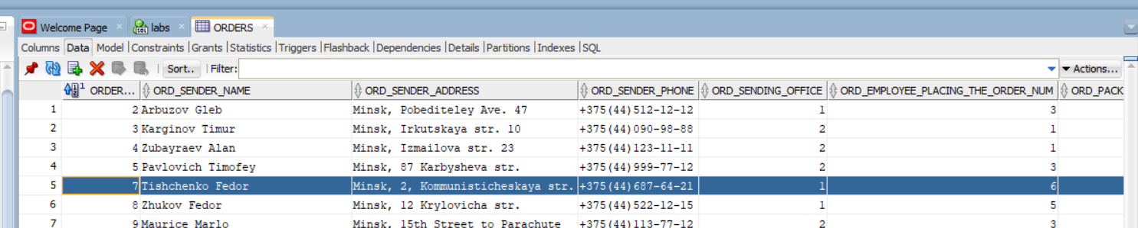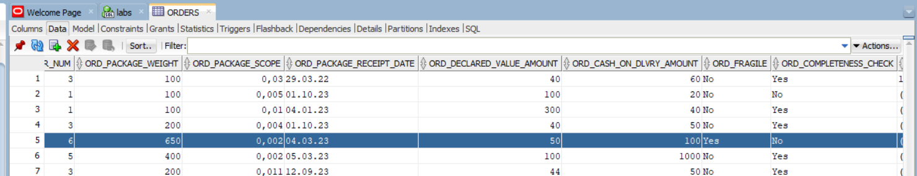

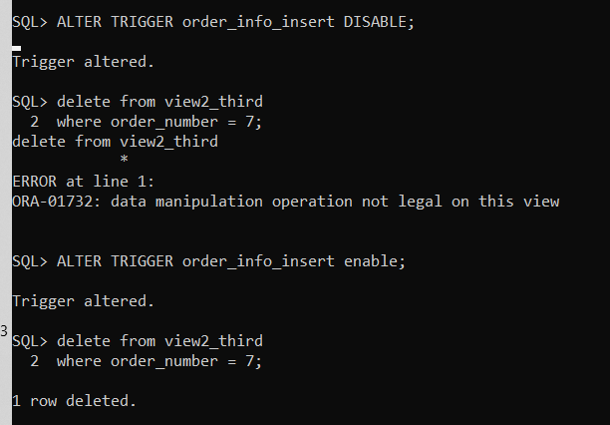

**_Задача:**

1. Compound trigger

когда главный отделения становится главный отделением 2 категории,

то сотрудники становятся сотрудниками 2 категории

**_Код:**

**insert INTO Positions(PST_name,PST_min_level_of_education_code,PST_min_salary,PST_employee_availability,PST_driver_license,PST_english_A2_required) VALUES**

**('Employee_second_category', 1, 1000, 'No', 'No', 'No');**

**insert INTO Positions(pst_name,PST_min_level_of_education_code,PST_min_salary,PST_employee_availability,PST_driver_license,PST_english_A2_required) VALUES**

**('Branch_chief_second_category', 3, 1700, 'Yes', 'No', 'Yes');**

**create or replace trigger trigger_mut**

**for update of STF_position_code**

**on staff**

**compound trigger**

**bUpdPainters boolean;**

**before each row is**

**begin**

**if :new.STF_name = 'Shobic I.P.' and :old.STF_position_code = 2 and :new.STF_position_code = 7 then**

**bUpdPainters := true;**

**end if;**

**end before each row;**

**after statement is**

**begin**

**if bUpdPainters then**

**update staff**

**set STF_position_code = 6**

**where STF_position_code = 1;**

**end if;**

**end after statement;**

**end trigger_mut;**

**/**

**_Результат:**

**update staff**

**set STF_position_code = 7**

**where STF_name = 'Shobic I.P.' and stf_branch_num = 1;**

**before:**

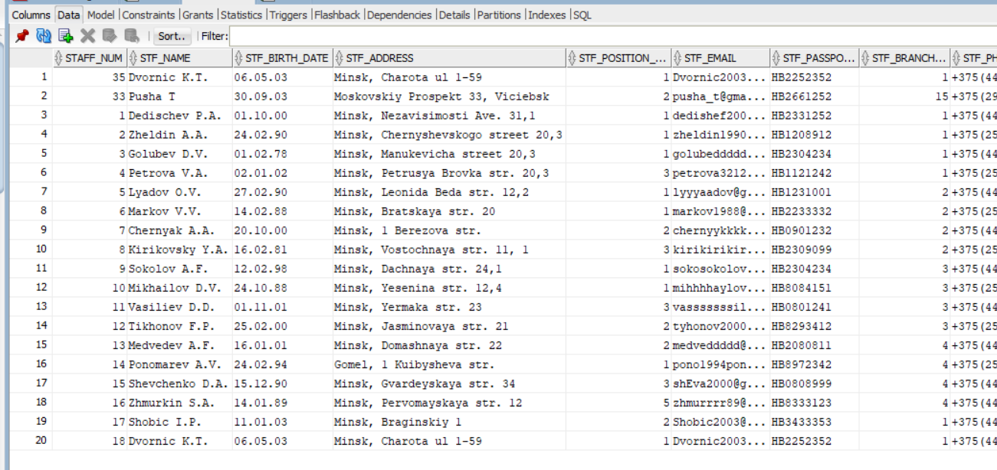

**After:**

**update staff**

**set STF_position_code = 7**

**where STF_name = 'Shobic I.P.' and stf_branch_num = 1;** 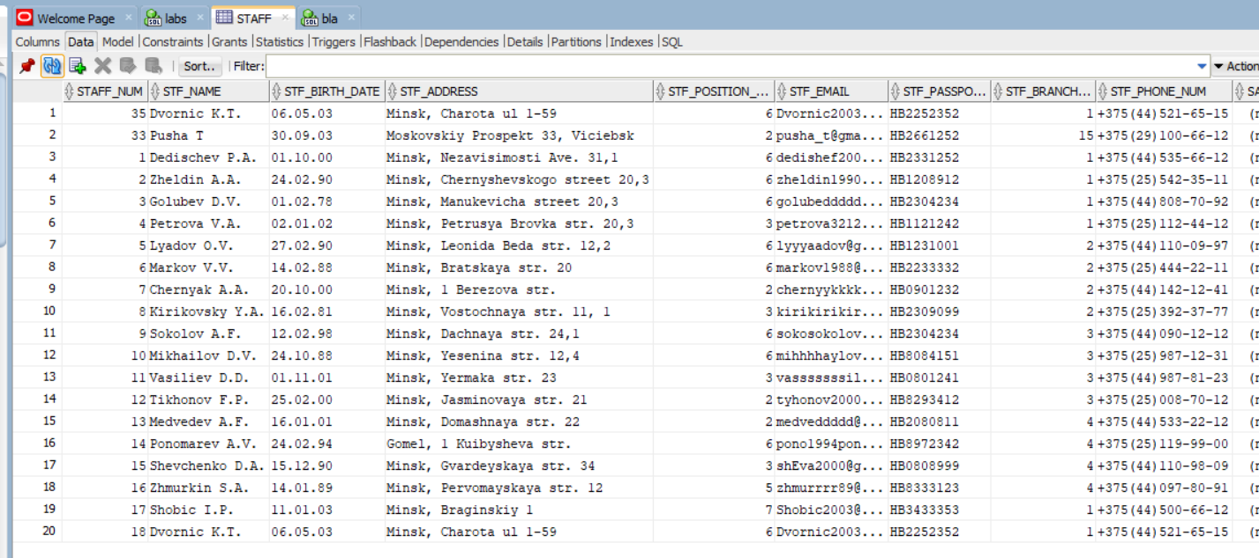

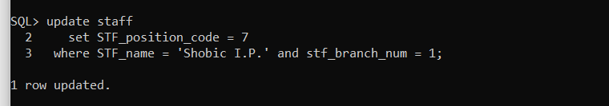

**Лабораторная работа № 6**

# Динамический SQL

**_Задача:**

1. Написать с помощью пакета DBMS_SQL динамическую процедуру или функцию, в которой заранее неизвестен текст команды SELECT. Предусмотреть возможность вывода разных результатов, в зависимости от количества передаваемых параметров.

**_Код:**

**create or replace procedure select_dynamic_sql(**

**p_column_to_select IN six_one_columns_to_select_type,**

**p_from_table IN varchar2,**

**p_type_of_join IN six_one_join_type,**

**p_tables_to_join_type IN six_one_tables_to_join_type,**

**p_on_conditions IN six_one_on_conditions_type,**

**p_number_of_count_column_in_select in NUMBER,**

**p_order_by_column IN NUMBER,**

**p_having_condition IN six_one_having_condition_type**

**)**

**IS**

**sqltext varchar2(2000) := 'SELECT';**

**space_comma varchar2(2) := ' ';**

**from_word varchar2(10) := 'FROM';**

**join_word varchar2(10) := 'JOIN';**

**on_word varchar2(10) := 'ON';**

**groupby_word varchar2(10) := 'GROUP BY';**

**having_word varchar2(15) := 'HAVING COUNT(';**

**count_word varchar2(10) := 'COUNT(';**

**right_bracket varchar2(10) := ')';**

**orderby_word char(9) := 'ORDER BY';**

**p_column_to_select_index number;**

**p_type_of_join_index number;**

**p_column_to_group_by_index number;**

**p_having_column_index number;**

**p_order_by_column_index number;**

**p_on_conditions_index number;**

**p_columns_counter number;**

**p_having_counter number;**

**p_asterisk_flag number;**

**s VARCHAR2 (250);**

**table_cursor number;**

**cnt INTEGER;**

**TYPE col_inf_type IS RECORD (name VARCHAR2 (50),**

**value VARCHAR2 (1000));**

**TYPE list_col_type IS TABLE OF col_inf_type;**

**list_col list_col_type := list_col_type ();**

**asterisk_and_smthng_else_in_select EXCEPTION;**

**PRAGMA EXCEPTION_INIT (asterisk_and_smthng_else_in_select, -00001);**

**begin**

**dbms_output.enable(100000);**

**p_column_to_select_index := p_column_to_select.FIRST;**

**p_type_of_join_index := p_type_of_join.FIRST;**

**p_column_to_group_by_index := p_column_to_select.FIRST;**

**p_having_column_index := p_column_to_select.FIRST;**

**p_order_by_column_index := p_column_to_select.FIRST;**

**p_on_conditions_index := p_on_conditions.FIRST;**

**p_asterisk_flag := 0;**

**p_having_counter := 0;**

**p_columns_counter := 1;**

**dbms_output.PUT_LINE(p_column_to_group_by_index);**

**-- ПРОВЕРКА, НЕ ПЕРЕДАНА ЛИ ТОЛЬКО ЗВЕЗДОЧКА**

**WHILE p_column_to_select_index IS NOT NULL LOOP**

**IF p_column_to_select(p_column_to_select_index) = '*' AND p_asterisk_flag = 0 THEN**

**p_asterisk_flag := 1;**

**ELSIF p_asterisk_flag = 1 THEN**

**RAISE asterisk_and_smthng_else_in_select;**

**END IF;**

**p_column_to_select_index := p_column_to_select.NEXT(p_column_to_select_index);**

**END LOOP;**

**IF p_asterisk_flag = 1 THEN**

**-- ЗВЕЗДОЧКА В SELECT**

**FOR c IN (SELECT column_name FROM all_tab_columns**

**WHERE owner = UPPER (USER)**

**AND table_name = UPPER (p_from_table))**

**LOOP**

**IF p_columns_counter = p_number_of_count_column_in_select THEN**

**sqltext:= sqltext || space_comma || count_word || c.column_name || right_bracket;**

**space_comma := ', ';**

**ELSE**

**sqltext:=**

**sqltext || space_comma || c.column_name;**

**space_comma:= ',';**

**END IF;**

**p_columns_counter := p_columns_counter + 1;**

**list_col.EXTEND;**

**list_col (list_col.LAST).name := c.column_name;**

**END LOOP;**

**ELSE**

**-- НЕ ЗВЕЗДОЧКА В SELECT**

**p_column_to_select_index := p_column_to_select.FIRST;**

**-----SELECT**

**WHILE p_column_to_select_index IS NOT NULL LOOP**

**-- access the array element**

**-- ПРИ ПОМОЩИ dbms_output ПРОВЕРИТЬ С КАКОГО ЧИСЛА НАЧИНАЕТСЯ ОТСЧЕТ: начало с единицы**

**IF p_column_to_select_index = p_number_of_count_column_in_select then**

**sqltext:= sqltext || space_comma || count_word || p_column_to_select(p_column_to_select_index) || right_bracket;**

**space_comma := ', ';**

**ELSE**

**sqltext := sqltext || space_comma || p_column_to_select(p_column_to_select_index);**

**space_comma := ', ';**

**END IF;**

**list_col.EXTEND;**

**list_col(list_col.LAST).name := p_column_to_select(p_column_to_select_index);**

**p_column_to_select_index := p_column_to_select.NEXT(p_column_to_select_index);**

**END LOOP;**

**END IF;**

**space_comma:= ' ';**

**-----FROM**

**-- access the array element**

**sqltext:= sqltext || space_comma || from_word || space_comma || p_from_table;**

**space_comma := ' ';**

**-----... JOIN ON**

**WHILE p_type_of_join_index IS NOT NULL LOOP**

**dbms_output.put_line('TATATAT');**

**-- access the array element**

**IF p_on_conditions_index IS NOT NULL THEN**

**dbms_output.put_line('BABABABAB');**

**sqltext:= sqltext || space_comma || p_type_of_join(p_type_of_join_index) || space_comma ||**

**join_word || space_comma || p_tables_to_join_type(p_type_of_join_index) || space_comma || on_word ||**

**space_comma || p_on_conditions(p_type_of_join_index) || space_comma;**

**-- now we will open array that contain ON conditions**

**ELSE**

**dbms_output.put_line('HAHAHHAHAAH');**

**sqltext:= sqltext || space_comma || p_type_of_join(p_type_of_join_index) || space_comma ||**

**join_word || space_comma || p_tables_to_join_type(p_type_of_join_index) || space_comma;**

**END IF;**

**p_type_of_join_index := p_type_of_join.NEXT(p_type_of_join_index);**

**END LOOP;**

**space_comma := ' ';**

**------GROUP BY**

**p_columns_counter := 1;**

**IF p_asterisk_flag = 1 THEN**

**-- ЗВЕЗДОЧКА В SELECT**

**FOR c IN (SELECT column_name FROM all_tab_columns**

**WHERE owner = UPPER (USER)**

**AND table_name = UPPER (p_from_table))**

**LOOP**

**IF p_columns_counter != p_number_of_count_column_in_select THEN**

**if groupby_word != ' ' then**

**sqltext := sqltext || space_comma || groupby_word;**

**groupby_word := ' ';**

**end if;**

**sqltext:= sqltext || space_comma || c.column_name;**

**space_comma := ', ';**

**END IF;**

**p_columns_counter := p_columns_counter + 1;**

**END LOOP;**

**ELSE**

**WHILE p_column_to_group_by_index IS NOT NULL LOOP**

**-- access the array element**

**IF p_column_to_group_by_index != p_number_of_count_column_in_select then**

**IF groupby_word != ' ' THEN**

**sqltext := sqltext || groupby_word;**

**groupby_word := ' ';**

**END IF;**

**sqltext := sqltext || space_comma || p_column_to_select(p_column_to_group_by_index);**

**space_comma := ', ';**

**END IF;**

**p_column_to_group_by_index := p_column_to_select.NEXT(p_column_to_group_by_index);**

**END LOOP;**

**END IF;**

**space_comma := ' ';**

**-----HAVING COUNT**

**p_columns_counter := 1;**

**IF p_asterisk_flag = 1 THEN**

**-- ЗВЕЗДОЧКА В SELECT**

**FOR c IN (SELECT column_name FROM all_tab_columns**

**WHERE owner = UPPER (USER)**

**AND table_name = UPPER (p_from_table))**

**LOOP**

**IF p_columns_counter = p_number_of_count_column_in_select THEN**

**p_having_counter := p_having_counter + 1;**

**sqltext := sqltext || space_comma || having_word || c.column_name || right_bracket ||**

**space_comma || p_having_condition(p_having_counter);**

**END IF;**

**p_columns_counter := p_columns_counter + 1;**

**END LOOP;**

**ELSE**

**WHILE p_having_column_index IS NOT NULL LOOP**

**-- access the array element**

**if p_having_column_index = p_number_of_count_column_in_select then**

**p_having_counter := p_having_counter + 1;**

**sqltext := sqltext || space_comma || having_word || p_column_to_select(p_having_column_index) || right_bracket ||**

**space_comma || p_having_condition(p_having_counter);**

**end if;**

**p_having_column_index := p_column_to_select.NEXT(p_having_column_index);**

**END LOOP;**

**END IF;**

**space_comma := ' ';**

**-----ORDER BY**

**p_columns_counter := 1;**

**IF p_asterisk_flag = 1 THEN**

**-- ЗВЕЗДОЧКА В SELECT**

**FOR c IN (SELECT column_name FROM all_tab_columns**

**WHERE owner = UPPER (USER)**

**AND table_name = UPPER (p_from_table))**

**LOOP**

**IF p_columns_counter = p_order_by_column THEN**

**p_having_counter := p_having_counter + 1;**

**sqltext := sqltext || space_comma || orderby_word || c.column_name;**

**END IF;**

**p_columns_counter := p_columns_counter + 1;**

**END LOOP;**

**ELSE**

**WHILE p_order_by_column_index IS NOT NULL LOOP**

**-- access the array element**

**IF p_order_by_column_index = p_order_by_column THEN**

**sqltext := sqltext || space_comma || orderby_word || p_column_to_select(p_order_by_column_index);**

**END IF;**

**p_order_by_column_index := p_column_to_select.NEXT(p_order_by_column_index);**

**END LOOP;**

**END IF;**

**dbms_output.put_line(sqltext);**

**-- here we will parsing sqltext=select**

**table_cursor := DBMS_SQL.open_cursor;**

**DBMS_SQL.parse (table_cursor, sqltext, DBMS_SQL.native);**

**FOR i IN list_col.FIRST ..list_col.LAST**

**LOOP**

**DBMS_SQL.DEFINE_COLUMN (table_cursor, i, list_col(i).VALUE, 1000);**

**END LOOP;**

**cnt := DBMS_SQL.EXECUTE (table_cursor);**

**-- DBMS_OUTPUT.put_line ('Введенный запрос '**

**-- || ' содержит '**

**-- || cnt**

**-- || ' строк.');**

**cnt := 0;**

**LOOP**

**IF DBMS_SQL.fetch_rows(table_cursor) = 0 THEN**

**EXIT;**

**END IF;**

**cnt := cnt + 1;**

**s := cnt || '.';**

**FOR i IN list_col.FIRST ..list_col.LAST**

**LOOP**

**DBMS_SQL.column_value(table_cursor, i, list_col(i).VALUE);**

**s := s || ' ' || list_col(i).VALUE;**

**END LOOP;**

**DBMS_OUTPUT.put_line (SUBSTR (s, 1, 255));**

**END LOOP;**

**DBMS_SQL.close_cursor (table_cursor);**

**EXCEPTION**

**WHEN asterisk_and_smthng_else_in_select THEN**

**DBMS_OUTPUT.PUT_LINE('В Select передана не только звездочка "*"');**

**when others then**

**IF SQLCODE = -936 THEN**

**DBMS_OUTPUT.PUT_LINE('Ошибка: ORA-00936: Некорректные данные при перечислении стобцов в SELECT');**

**ELSIF SQLCODE = -903 THEN**

**DBMS_OUTPUT.PUT_LINE('Ошибка: ORA-00903: Некорректные имена таблиц');**

**ELSIF SQLCODE = -933 THEN**

**DBMS_OUTPUT.PUT_LINE('Ошибка: ORA-00933: Некорректно определен тип соединения таблиц');**

**ELSIF SQLCODE = -920 THEN**

**DBMS_OUTPUT.PUT_LINE('Ошибка: ORA-00936: Некорректно введены условия');**

**ELSE**

**DBMS_OUTPUT.PUT_LINE('Ошибка: ' || SQLERRM);**

**END IF;**

**end;**

**/**

**_Результат:**

**CREATE OR REPLACE TYPE six_one_columns_to_select_type IS TABLE OF varchar2(100);**

**/**

**CREATE OR REPLACE TYPE six_one_join_type IS TABLE OF varchar2(100);**

**/**

**CREATE OR REPLACE TYPE six_one_on_conditions_type IS TABLE OF varchar2(100);**

**/**

**CREATE OR REPLACE TYPE six_one_tables_to_join_type IS TABLE OF varchar2(100);**

**/**

**CREATE OR REPLACE TYPE six_one_having_condition_type IS TABLE OF varchar2(100);**

**/**

**DECLARE**

**six_one_columns_to_select six_one_columns_to_select_type := six_one_columns_to_select_type();**

**six_one_from_table varchar2(100);**

**six_one_type_of_join six_one_join_type := six_one_join_type();**

**six_one_on_conditions six_one_on_conditions_type := six_one_on_conditions_type();**

**six_one_number_of_count_column_in_select number;**

**six_one_order_by_column number;**

**six_one_tables_to_join six_one_tables_to_join_type := six_one_tables_to_join_type();**

**six_one_having_condition six_one_having_condition_type := six_one_having_condition_type();**

**BEGIN**

**-- six_one_columns_to_select := six_one_columns_to_select_type('ORDER_NUM',**

**-- 'ORD_SENDER_NAME', 'ORD_SENDER_ADDRESS', 'ORD_SENDER_PHONE');**

**six_one_columns_to_select := six_one_columns_to_select_type('*');**

**six_one_from_table := 'ORDERS';**

**-- six_one_type_of_join := six_one_join_type('CROSS');**

**-- six_one_type_of_join := six_one_join_type('INNER');**

**six_one_tables_to_join := six_one_tables_to_join_type('BRANCH');**

**-- six_one_tables_to_join := six_one_tables_to_join_type('POSITIONS');**

**-- six_one_on_conditions := six_one_on_conditions_type('ORD_SENDING_OFFICE = BRANCH_NUM AND BRANCH_NUM = 1');**

**-- six_one_on_conditions := six_one_on_conditions_type('ORD_SENDING_OFFICE = POSITION_CODE AND POSITION_CODE = 1');**

**-- six_one_number_of_count_column_in_select := 1;**

**six_one_order_by_column := 1;**

**-- six_one_having_condition := six_one_having_condition_type('> 0');**

**-- now we will call procedure**

**select_dynamic_sql(six_one_columns_to_select, six_one_from_table,**

**six_one_type_of_join, six_one_tables_to_join, six_one_on_conditions, six_one_number_of_count_column_in_select,**

**six_one_order_by_column, six_one_having_condition);**

**END;**

**/**

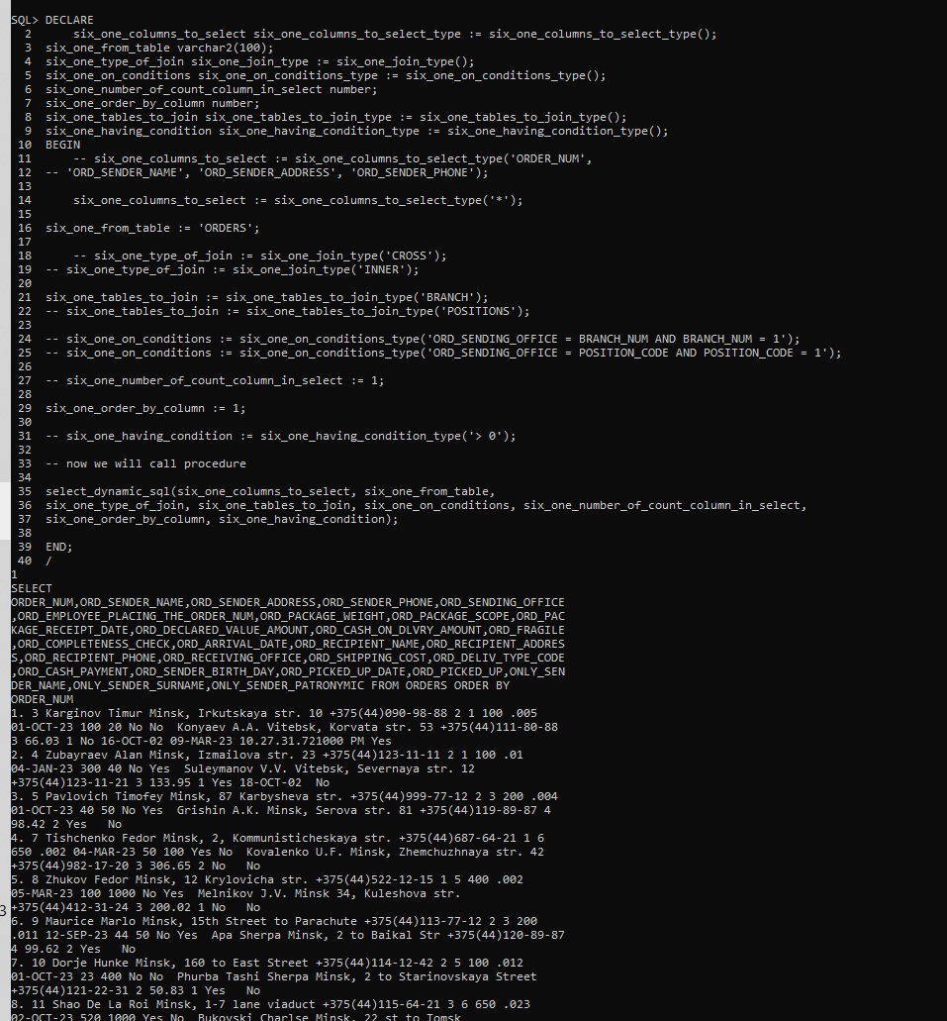

**_Задача:**

1. Написать, используя встроенный динамический SQL, процедуру

создания в БД нового объекта (представления или таблицы) на основе существующей таблицы. Имя нового объекта должно формироваться динамически и проверяться на существование в словаре данных. В качестве входных параметров указать тип нового объекта, исходную таблицу, столбцы и количество строк, которые будут использоваться в запросе.

**_Код:**

**CREATE OR REPLACE PROCEDURE six_two_CreateNewObject(**

**p_object_type IN VARCHAR2,**

**p_source_table IN VARCHAR2,**

**p_columns IN VARCHAR2,**

**p_row_count IN NUMBER**

**) AS**

**v_new_object_name VARCHAR2(50);**

**v_sql VARCHAR2(4000);**

**v_count INTEGER;**

**v_current_datetime VARCHAR2(30);**

**BEGIN**

**-- Формирование имени нового объекта**

**SELECT TO_CHAR(SYSDATE, 'YYYY_MM_DD_HH24_MI_SS') INTO v_current_datetime FROM DUAL;**

**v_new_object_name := p_source_table || '_' || p_object_type || '_' || v_current_datetime;**

**DBMS_OUTPUT.PUT_LINE(v_new_object_name);**

**-- Проверка существования объекта в словаре данных**

**BEGIN**

**EXECUTE IMMEDIATE 'SELECT COUNT(*) FROM user_objects WHERE object_name = UPPER(:1)' INTO v_count USING v_new_object_name; -- :1 - IT'S PLACEHOLDER FOR VARIABLE v_new_object_name**

**EXCEPTION**

**WHEN OTHERS THEN**

**DBMS_OUTPUT.PUT_LINE('Ошибка при проверке существования объекта: ' || SQLERRM);**

**RETURN;**

**END;**

**IF v_count > 0 THEN**

**DBMS_OUTPUT.PUT_LINE('Объект с именем ' || v_new_object_name || ' уже существует.');**

**RETURN;**

**END IF;**

**-- Создание нового объекта**

**v_sql := 'CREATE ' || p_object_type || ' ' || v_new_object_name || ' AS SELECT ' || p_columns || ' FROM ' || p_source_table || ' WHERE ROWNUM <= ' || TO_CHAR(p_row_count);**

**BEGIN**

**EXECUTE IMMEDIATE v_sql;**

**EXCEPTION**

**WHEN OTHERS THEN**

**DBMS_OUTPUT.PUT_LINE('Ошибка при создании объекта: ' || SQLERRM);**

**RETURN;**

**END;**

**DBMS_OUTPUT.PUT_LINE('Объект ' || v_new_object_name || ' успешно создан.');**

**END;**

**/**

**_Результат:**

**BEGIN**

**six_two_CreateNewObject('TABLE', 'Orders', 'ORD_SHIPPING_COST, ONLY_SENDER_NAME, ONLY_SENDER_SURNAME, ONLY_SENDER_PATRONYMIC', 10);**

**END;**

**/**

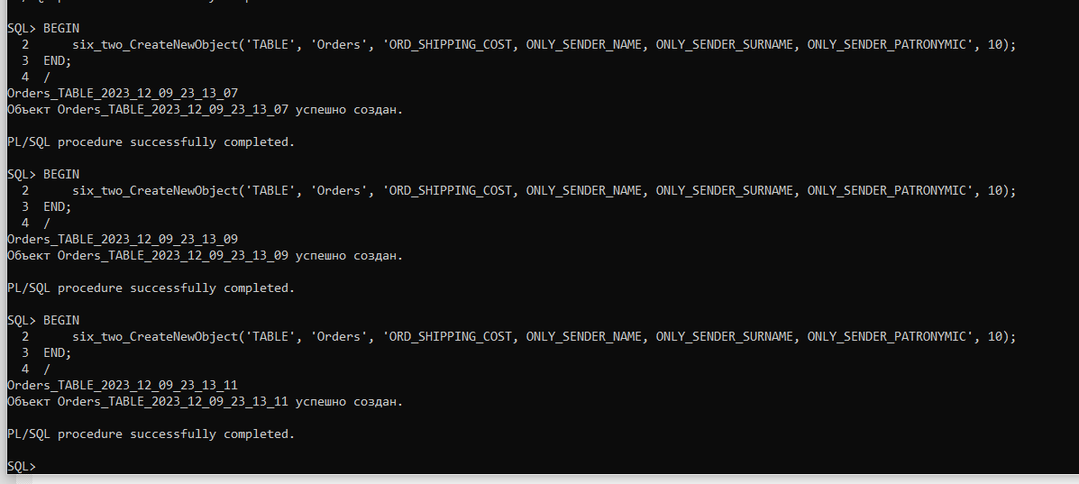

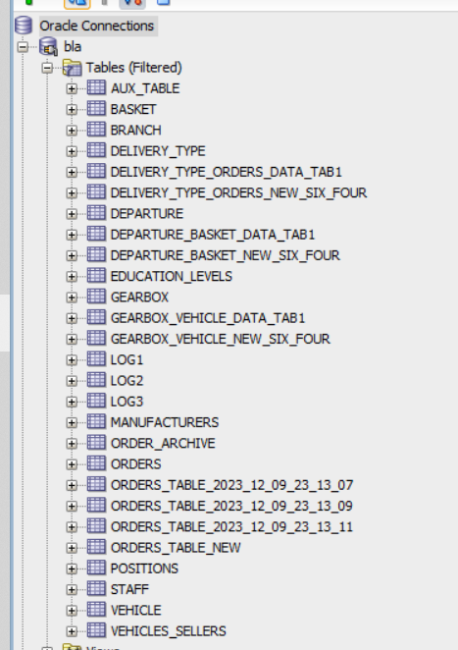

**_Задача:**

1. Выполнить, используя динамический SQL, одно из предложенных заданий, предварительно согласовав выбор задания с преподавателем:

3.1. Создать процедуру, которая принимает в качестве параметров имя таблицы и имена четырех полей в этой таблице. Первое поле она интерпретирует как ФИО, разбивает его на составляющие и заполняет три оставшихся поля. Если значение первого поля не может быть правильно проинтерпретировано как ФИО (отсутствует отчество, имя и отчество или в строке встречаются недопустимые символы), она помещает в первое поле из трех оставшихся значения ключа (ROWID) этой записи, а во втором и третьем выводит соответствующее сообщение об ошибке строчными и прописными буквами.

**_Код:**

**ALTER TABLE orders**

**ADD ( only_sender_name VARCHAR2(50),**

**only_sender_surname VARCHAR2(50),**

**only_sender_patronymic VARCHAR2(50));**

**---my---**

**CREATE OR REPLACE PROCEDURE SplitFullName(**

**p_table_name IN VARCHAR2,**

**p_full_name_field IN VARCHAR2,**

**p_first_name_field IN VARCHAR2,**

**p_last_name_field IN VARCHAR2,**

**p_patronymic_field IN VARCHAR2**

**) AS**

**v_sql VARCHAR2(4000);**

**BEGIN**

**v_sql := 'DECLARE**

**CURSOR c IS SELECT ROWID, ' || p_full_name_field || ' FROM ' || p_table_name || ';**

**v_full_name VARCHAR2(100);**

**v_first_name VARCHAR2(100);**

**v_last_name VARCHAR2(100);**

**v_patronymic VARCHAR2(100);**

**v_rowid ROWID;**

**BEGIN**

**FOR r IN c LOOP**

**v_full_name := r.' || p_full_name_field || ';**

**IF REGEXP_SUBSTR(v_full_name, ''[^a-zA-Z ]+'', 1, 1) IS NULL AND REGEXP_SUBSTR(v_full_name, ''[a-zA-Z]+'', 1, 4) IS NULL AND**

**REGEXP_SUBSTR(v_full_name, ''[a-zA-Z]+'', 1, 1) IS NOT NULL AND REGEXP_SUBSTR(v_full_name, ''[a-zA-Z]+'', 1, 2) IS NOT NULL AND**

**REGEXP_SUBSTR(v_full_name, ''[a-zA-Z]+'', 1, 3) IS NOT NULL AND LENGTH(REGEXP_SUBSTR(v_full_name,''[^ ]+'', 1, 1)) > 3 AND**

**LENGTH(REGEXP_SUBSTR(v_full_name,''[^ ]+'', 1, 2)) > 3 AND LENGTH(REGEXP_SUBSTR(v_full_name,''[^ ]+'', 1, 3)) > 3 THEN**

**v_first_name := REGEXP_SUBSTR(v_full_name, ''[a-zA-Z]+'', 1, 1);**

**v_last_name := REGEXP_SUBSTR(v_full_name, ''[a-zA-Z]+'', 1, 2);**

**v_patronymic := REGEXP_SUBSTR(v_full_name, ''[a-zA-Z]+'', 1, 3);**

**ELSIF REGEXP_SUBSTR(v_full_name, ''[^a-zA-Z ]+'', 1, 1) IS NOT NULL THEN**

**v_first_name := v_rowid;**

**v_last_name := ''there are invalid characters in the fio'';**

**v_patronymic := ''THERE ARE INVALID CHARACTERS IN THE FIO'';**

**ELSIF REGEXP_SUBSTR(v_full_name, ''[a-zA-Z]+'', 1, 4) IS NOT NULL THEN**

**v_first_name := v_rowid;**

**v_last_name := ''the fio contains more than 3 words'';**

**v_patronymic := ''THE FIO CONTAINS MORE THAN 3 WORDS'';**

**ELSIF REGEXP_SUBSTR(v_full_name, ''[a-zA-Z]+'', 1, 3) IS NULL THEN**

**v_first_name := v_rowid;**

**v_last_name := ''the fio contains less than 3 words'';**

**v_patronymic := ''THE FIO CONTAINS LESS THAN 3 WORDS'';**

**ELSIF LENGTH(REGEXP_SUBSTR(v_full_name,''[^ ]+'', 1, 1)) < 4 THEN**

**v_first_name := v_rowid;**

**v_last_name := ''name is too short'';**

**v_patronymic := ''NAME IS TOO SHORT'';**

**ELSIF LENGTH(REGEXP_SUBSTR(v_full_name,''[^ ]+'', 1, 2)) < 4 THEN**

**v_first_name := v_rowid;**

**v_last_name := ''surname is too short'';**

**v_patronymic := ''SURNAME IS TOO SHORT'';**

**ELSIF LENGTH(REGEXP_SUBSTR(v_full_name,''[^ ]+'', 1, 3)) < 4 THEN**

**v_first_name := v_rowid;**

**v_last_name := ''patronymic is too short'';**

**v_patronymic := ''PATRONYMIC IS TOO SHORT'';**

**ELSE**

**v_first_name := v_rowid;**

**v_last_name := ''invalid value of full name'';**

**v_patronymic := ''INVALID VALUE OF FULL NAME'';**

**END IF;**

**v_rowid := r.ROWID;**

**EXECUTE IMMEDIATE ''UPDATE ' || p_table_name || ' SET ' || p_first_name_field || ' = :1, ' || p_last_name_field || ' = :2, ' || p_patronymic_field || ' = :3 WHERE ROWID = :4'' USING v_first_name, v_last_name, v_patronymic, v_rowid;**

**END LOOP;**

**END;';**

**EXECUTE IMMEDIATE v_sql;**

**EXCEPTION**

**WHEN OTHERS THEN**

**DBMS_OUTPUT.PUT_LINE('Ошибка: ' || SQLERRM);**

**END;**

**/**

**_Результат:**

**BEGIN**

**SplitFullName('Orders_TABLE_New', 'ORD_SENDER_NAME', 'ONLY_SENDER_NAME', 'ONLY_SENDER_SURNAME', 'ONLY_SENDER_PATRONYMIC');**

**END;**

**/**

**COMMIT;**

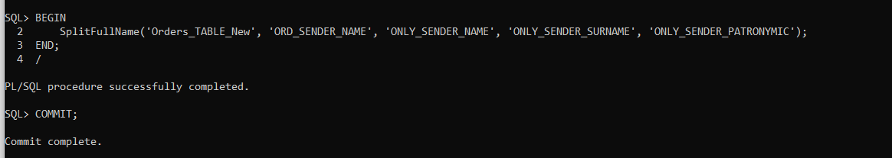

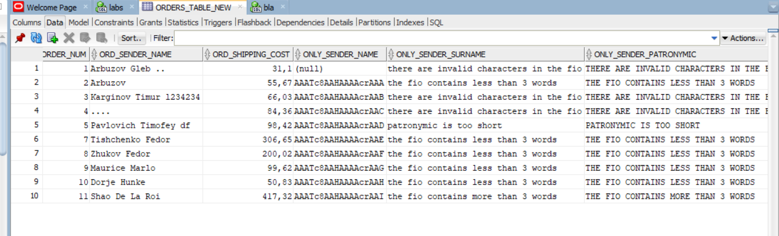

**_Задача:**

1. Написать программу, которая позволит для двух указанных в

параметрах таблиц существующей БД определить, есть ли между ними связь «один ко многим». Если связь есть, то на основе родительской таблицы создать новую, в которой будут присутствовать все поля старой и одно новое поле с типом коллекции, в котором при переносе данных помещаются все связанные записи из дочерней таблицы.

**_Код:**

**DECLARE**

**first_table_name VARCHAR2(100) := 'BASKET';**

**second_table_name VARCHAR2(100) := 'DEPARTURE';**

**one_to_many_flag number := 0;**

**parent_table_name VARCHAR2(100);**

**child_table_name VARCHAR2(100);**

**child_table_type VARCHAR2(100);**

**v_ddl_for_object VARCHAR2(4000); -- Здесь укажите максимальную длину вашего DDL-текста**

**v_ddl_for_table VARCHAR2(4000); -- Здесь укажите максимальную длину вашего DDL-текста**

**new_table_name varchar2(100);**

**child_r_constraint_name varchar2(100);**

**-- child_table_column_conn varchar2(100);**

**parent_table_column_conn varchar2(100);**

**-- child_constraint_name varchar2(100);**

**parent_constraint_name varchar2(100);**

**object_type varchar2(100);**

**type_to_check varchar2(100);**

**check_value integer := 0;**

**check_sql varchar2(300);**

**drop_sql varchar2(300);**

**sql_transfer varchar2(1000);**

**nested_table_sql varchar2(1000);**

**nested_check_value integer := 0;**

**list_of_columns varchar2(1000);**

**TYPE varchar2_collection IS TABLE OF VARCHAR2(4000); -- Используйте подходящий размер для вашего случая**

**child_r_constraint_names varchar2_collection;**

**child_constraint_name varchar2_collection;**

**child_table_column_conn varchar2_collection := varchar2_collection();**

**BEGIN**

**-- Проверка наличия связи "один ко многим"**

**BEGIN**

**SELECT r_constraint_name**

**BULK COLLECT INTO child_r_constraint_names**

**FROM all_constraints**

**WHERE r_constraint_name IN (**

**SELECT constraint_name**

**FROM all_constraints**

**WHERE table_name = first_table_name**

**)**

**AND table_name = second_table_name AND OWNER = USER;**

**FOR i IN 1..child_r_constraint_names.COUNT LOOP**

**one_to_many_flag := 1;**

**END LOOP;**

**EXCEPTION**

**when no_data_found then**

**null;**

**END;**

**if one_to_many_flag = 0 then**

**SELECT r_constraint_name**

**BULK COLLECT INTO child_r_constraint_names**

**FROM all_constraints**

**WHERE r_constraint_name IN (**

**SELECT constraint_name**

**FROM all_constraints**

**WHERE table_name = second_table_name**

**)**

**AND table_name = first_table_name AND OWNER = USER;**

**FOR i IN 1..child_r_constraint_names.COUNT LOOP**

**one_to_many_flag := 2;**

**END LOOP;**

**end if;**

**if one_to_many_flag = 0 then**

**RAISE no_data_found;**

**end if;**

**FOR i IN 1..child_r_constraint_names.COUNT LOOP**

**DBMS_OUTPUT.PUT_LINE(child_r_constraint_names(i));**

**END LOOP;**

**if one_to_many_flag = 1 then**

**parent_table_name := first_table_name;**

**child_table_name := second_table_name;**

**else**

**parent_table_name := second_table_name;**

**child_table_name := first_table_name;**

**end if;**

**dbms_output.PUT_LINE('PARENT:');**

**dbms_output.PUT_LINE(parent_table_name);**

**dbms_output.PUT_LINE('CHILD:');**

**dbms_output.PUT_LINE(child_table_name);**

**IF child_r_constraint_names is not null THEN**

**object_type := child_table_name || '_OBJ';**

**-- проверка существования типа(типа таблицы), т.к. если он есть, нельзя будет replace-нуть orders_obj**

**type_to_check := child_table_name || '_TAB';**

**check_sql := 'SELECT 1**

**FROM ALL_OBJECTS**

**WHERE OWNER = USER AND OBJECT_NAME = ''' || type_to_check || '''';**

**BEGIN**

**EXECUTE IMMEDIATE check_sql into check_value;**

**EXCEPTION**

**when no_data_found then**

**check_value := 0;**

**END;**

**dbms_output.PUT_LINE(check_value);**

**IF check_value = 0 THEN**

**-- drop_sql := 'DROP TYPE ' || type_to_check;**

**-- DBMS_OUTPUT.PUT_LINE(drop_sql);**

**-- EXECUTE IMMEDIATE drop_sql;**

**-- END IF;**

**-- создаем тип данных типа дочерней таблицы, чтобы его можно было вставить в новую таблицу родителя**

**SELECT**

**'CREATE OR REPLACE TYPE ' || table_name || '_OBJ IS OBJECT (' ||**

**LISTAGG(**

**column_name || ' ' ||**

**CASE data_type**

**WHEN 'NUMBER' THEN 'NUMBER(' || data_length || ',' || data_scale || ')'**

**WHEN 'VARCHAR2' THEN 'VARCHAR2(' || data_length || ')'**

**WHEN 'CHAR' THEN 'CHAR(' || data_length || ')'**

**ELSE data_type**

**END, ',' || chr(10)**

**) WITHIN GROUP (ORDER BY column_id) || ');'**

**INTO v_ddl_for_object**

**FROM user_tab_cols**

**WHERE table_name = child_table_name AND column_name NOT LIKE 'SYS_%'**

**GROUP BY table_name;**

**SELECT**

**'CREATE OR REPLACE TYPE ' || table_name || '_TAB IS TABLE OF ' || table_name || '_OBJ;'**

**INTO v_ddl_for_table**

**FROM user_tab_cols**

**WHERE table_name = child_table_name**

**GROUP BY table_name;**

**-- Теперь можно выполнить DDL-запросы**

**EXECUTE IMMEDIATE v_ddl_for_object;**

**EXECUTE IMMEDIATE v_ddl_for_table;**

**END IF;**

**child_table_type := child_table_name || '_TAB';**

**-- Если связь есть, создаем новую таблицу**

**new_table_name := parent_table_name || '_' || child_table_name || '_new_six_four';**

**--Надо проверить, если таблица с таким названием, если да, то..., если нет, то ... удалять ничего не надо**

**check_sql := 'SELECT 1**

**FROM ALL_OBJECTS**

**WHERE OWNER = USER AND OBJECT_NAME = ''' || UPPER(new_table_name) || '''';**

**BEGIN**

**EXECUTE IMMEDIATE check_sql into check_value;**

**EXCEPTION**

**when no_data_found then**

**check_value := 0;**

**END;**

**dbms_output.PUT_LINE(check_value);**

**dbms_output.PUT_LINE(new_table_name);**

**dbms_output.PUT_LINE('CREATE TABLE ' || UPPER(new_table_name) || ' AS SELECT * FROM ' || parent_table_name);**

**dbms_output.PUT_LINE('ALTER TABLE ' || UPPER(new_table_name) || ' ADD (' || child_table_name || '_data ' || child_table_type || ') NESTED TABLE ' || child_table_name || '_data STORE AS ' || child_table_name || '_' || parent_table_name || '_data_tab');**

**IF check_value = 0 THEN**

**EXECUTE IMMEDIATE 'CREATE TABLE ' || UPPER(new_table_name) || ' AS SELECT * FROM ' || parent_table_name;**

**-- Добавляем новое поле с типом коллекции**

**-- EXECUTE IMMEDIATE 'ALTER TABLE ' || UPPER(new_table_name) || ' ADD (' || child || '_data ' || child_table_type || ')'; -- возможно здесь будет oracle ругаться на тип данных**

**-- ПОКА НЕ ДОШЛИ ДО ПОСЛЕДНЕГО ОГРАНИЧЕНИЯ, ДОБАВЛЯЕМ СТОЛБЦЫ**

**FOR i IN 1..child_r_constraint_names.COUNT LOOP**

**EXECUTE IMMEDIATE 'ALTER TABLE ' || UPPER(new_table_name) || ' ADD (' || parent_table_name || '_' || child_table_name || '_data_' || i || ' ' || child_table_type || ') NESTED TABLE ' || parent_table_name || '_' || child_table_name || '_data_' || i || ' STORE AS ' || parent_table_name || '_' || child_table_name || '_data_tab' || i;**

**DBMS_OUTPUT.PUT_LINE(i);**

**END LOOP;**

**END IF;**

**SELECT**

**LISTAGG( column_name || ', ') WITHIN GROUP (ORDER BY column_id)**

**INTO list_of_columns**

**FROM user_tab_cols**

**WHERE table_name = child_table_name AND column_name NOT LIKE 'SYS_%'**

**GROUP BY table_name;**

**-- сейчас удалим последнюю запятую**

**list_of_columns := SUBSTR(list_of_columns, 1, LENGTH(list_of_columns) - 2);**

**DBMS_OUTPUT.PUT_LINE(list_of_columns);**

**-- мне осталось только на основании поиска foreign ограничений, вот этого, ты понял, найти столбцы, за которыми закреплены эти ограничения**

**-- Я МОГУ НАЙТИ ОДНО ОГРАНИЧЕНИЕ. НА ОСНОВАНИИ ЕГО НАЙТИ СТОЛБЕЦ В ТАБЛИЦЕ, ГДЕ ЭТО ОГРАНИЧЕНИЕ, А ПОТОМ НА ОСНОВАНИИ**

**-- ЭТОГО ЖЕ ОГРАНИЧЕНИЯ НАЙТИ СТОЛБЕЦ В ДРУГОЙ ТАБЛИЦЕ, ДЕТСКОЙ**

**SELECT distinct r_constraint_name**

**INTO parent_constraint_name**

**FROM all_constraints**

**WHERE r_constraint_name IN (**

**SELECT constraint_name**

**FROM all_constraints**

**WHERE table_name = parent_table_name**

**)**

**AND table_name = child_table_name AND OWNER = USER;**

**SELECT COLUMN_NAME**

**INTO parent_table_column_conn**

**FROM ALL_CONS_COLUMNS**

**WHERE TABLE_NAME = parent_table_name AND OWNER = USER AND CONSTRAINT_NAME = parent_constraint_name;**

**DBMS_OUTPUT.PUT_LINE(parent_table_column_conn);**

**SELECT constraint_name**

**BULK COLLECT INTO child_constraint_name**

**FROM all_constraints**

**WHERE r_constraint_name = parent_constraint_name AND OWNER = USER and table_name = child_table_name ;**

**FOR i IN 1..child_constraint_name.COUNT LOOP**

**DBMS_OUTPUT.PUT_LINE(child_constraint_name(i));**

**END LOOP;**

**FOR i IN 1..child_constraint_name.COUNT LOOP**

**child_table_column_conn.extend;**

**SELECT COLUMN_NAME**

**INTO child_table_column_conn(i)**

**FROM ALL_CONS_COLUMNS**

**WHERE TABLE_NAME = child_table_name AND OWNER = USER AND CONSTRAINT_NAME = child_constraint_name(i);**

**END LOOP;**

**FOR i IN 1..child_table_column_conn.COUNT LOOP**

**DBMS_OUTPUT.PUT_LINE(child_table_column_conn(i));**

**END LOOP;**

**-- я получил названия столбцов таблице orders, которые foreign key для branch, и я могу пушить данные**

**-- dbms_output.PUT_LINE(parent_table_column_conn);**

**-- dbms_output.PUT_LINE(child_table_column_conn);**

**-- надо сделать так, чтобы то, что после ковычек заработало, а потом уже составлять текст, чтобы можно было execute IMMEDIATE**

**--Переносим данные**

**FOR i IN 1..child_table_column_conn.COUNT LOOP**

**sql_transfer := 'DECLARE v_' || child_table_name || ' ' || type_to_check || ';**

**BEGIN**

**FOR r IN (SELECT ' || parent_table_column_conn || ' FROM ' || parent_table_name || ') LOOP**

**SELECT ' || object_type || '(' || list_of_columns || ')' || '**

**BULK COLLECT INTO v_' || child_table_name || '**

**FROM ' || child_table_name || '**

**WHERE ' || child_table_column_conn(i) || ' = r.' || parent_table_column_conn || ';**

**UPDATE ' || UPPER(new_table_name) || '**

**SET ' || parent_table_name || '_' || child_table_name || '_data_' || i || ' = v_' || child_table_name || '**

**WHERE ' || parent_table_column_conn || ' = r.' || parent_table_column_conn || ';**

**END LOOP;**

**END;';**

**dbms_output.PUT_LINE(sql_transfer);**

**EXECUTE IMMEDIATE sql_transfer;**

**END LOOP;**

**--Переносим данные**

**-- FOR r IN (SELECT * FROM parent_table_name) LOOP**

**-- SELECT \***

**-- BULK COLLECT INTO v_collection**

**-- FROM p_child_table_name**

**-- WHERE foreign_key = r.primary_key;**

**-- UPDATE new_table_name**

**-- SET child_records = v_collection**

**-- WHERE primary_key = r.primary_key;**

**-- END LOOP;**

**END IF;**

**EXCEPTION**

**when no_data_found then**

**dbms_output.PUT_LINE('there is no one-to-many relationship between the tables');**

**END;**

**/**

**_Результат:**

**1.**

**first_table_name VARCHAR2(100) := 'BASKET';**

**second_table_name VARCHAR2(100) := 'DEPARTURE';**

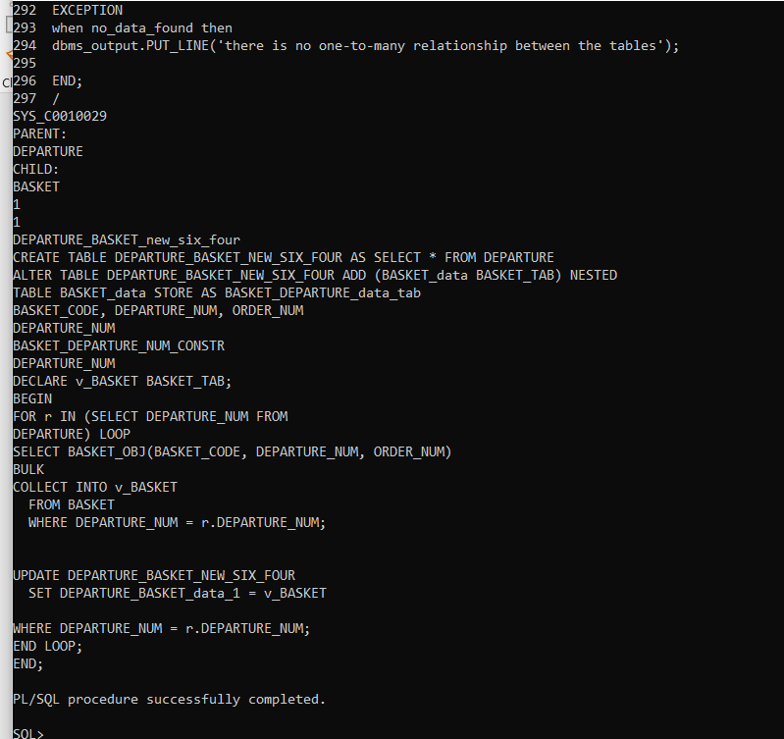 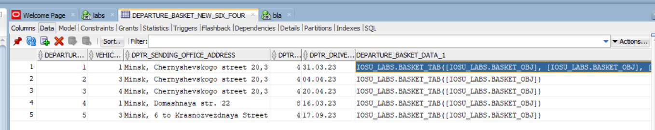 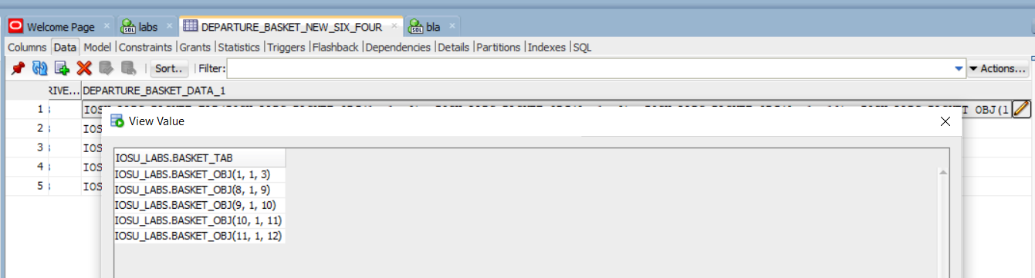

**2.**

**first_table_name VARCHAR2(100) := 'BASKET';**

**second_table_name VARCHAR2(100) := 'BASKET';**

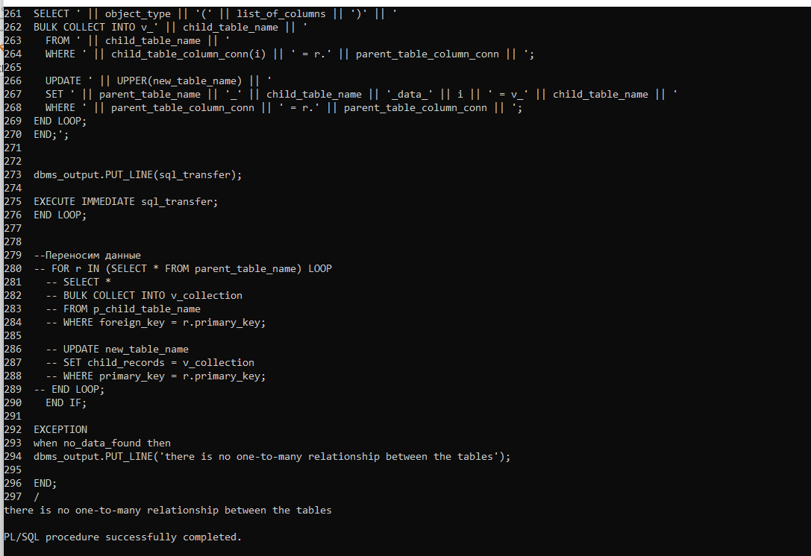

**3.**

**first_table_name VARCHAR2(100) := 'DEPARTURE';**

**second_table_name VARCHAR2(100) := 'BASKET';** 